NHS England & NHS Improvement

Safer Consulting in Minor Illness

Support Pack

Funded for Community Pharmacists by
NHS England Local Professional Networks
for Essex, East Anglia, Hertfordshire, Bedfordshire,
Luton and Milton Keynes

NHS England & NHS Improvement – East of England, Swift House, Chelmsford, CM2 5PF

Safer Consulting in Minor Illness – Support Pack
Issue Date: | 2 July 2018
Document Number: | 22062018
Version Number: | V1.6
Status: | FINAL
Prepared and created by: | Nicola Jones – Project Support Officer
 | Jane Newman – Essex LPN
 | Paul Duell – Anglia LPN
Reviewed by: | Jane Newman – Essex LPN
 | Paul Duell – Anglia LPN
Approved by: | Jane Newman – Essex LPN
 | Paul Duell – Anglia LPN
Next Review Date: | 2 July 2020

All links were correct at the time of printing and let us know if any links no longer work.
Programme Contents

1 | Programme Introduction…………………………………… | 3-4
2 | Reflection……………………………………………………. | 5-6
3 | Safer Consulting in Minor Illness Referral Form………… | 7
4 | Clinical Assessment in Minor Illness……………………… | 8-9
5 | Assessment of the Sick Child & Older Patient…………… | 10-13
6 | Documenting and Information Transfer in Minor Illness… | 14-16
7 | Is it Meningitis?................................................................. | 17-19
8 | Could it be Sepsis?........................................................... | 20-22
9 | “I’ve got conjunctivitis”………………………………………. | 23-24
10 | “I’ve got a headache”………………………………………... | 25-26
11 | Ear, Nose & Throat………………………………………….. | 27-28
12 | “I’ve got a cough”…………………………………………….. | 29-30
13 | Cystitis………………………………………………………… | 31-32
14 | Skin Conditions………………………………………………. | 33-34
15 | Fever and Flu………………………………………………… | 35-36
16 | Diarrhoea and Vomiting…………………………………….. | 37-38
17 | Antibiotics…………………………………………………….. | 39-40
18 | Analgesia…………………………………………………….. | 41-42
19 | Additional notes……………………………………………… | 43-44

1. Programme Introduction
Welcome to the Safer Consulting in Minor Illness Course. The Local Professional Networks in Essex and Anglia have commissioned this high quality training course from Anglia Ruskin University to provide community pharmacists with the same sort of training in recognising red flags and safety-netting that our local doctors access. This is something new and different, thinking about minor illness from a different perspective – safety first.
The course comprises:
- 16 online modules
- Prompts for reflection - ‘Think about….’
- Links to additional resources for each topic
- Attendance at one local peer learning set. This will be hosted by your CCG, at a convenient time for pharmacists to attend. It will give you an opportunity to discuss the course content and its local implementation with peers and collectively work through a case study.

Feedback from past course participants leads us to expect that you find the course invaluable in your day to day practice and may change the way you approach your consultations for ever.
This support pack is designed to give you written resources to facilitate you learning and to help you recognise how you need to modify your existing consultations.
The pack also provides you with some templates you may wish to use or adapt to record and report consultations. There is also information on the reflective process you will need to apply.
We welcome your feedback on the pack and remind you that it is very important to complete our survey at the end of the course.
We will contact you in a few weeks’ time to see how you are progressing and see if we can be of assistance.
Contact details
If you encounter any IT problems when accessing the course material contact Paul Driver by e-mail at paul.driver@anglia.ac.uk
For clinical queries with the course material please contact Paul Silverston by e-mail at paul.silverston@anglia.ac.uk
If you require support from the LPN teams please contact us at england.eastpharmacyLPNs@nhs.net
Regards
Jane & Paul
Jane Newman Essex Local Professional Network
Paul Duell East Anglia Local Professional Network
1. Programme Introduction – cont.
Video length 23:55
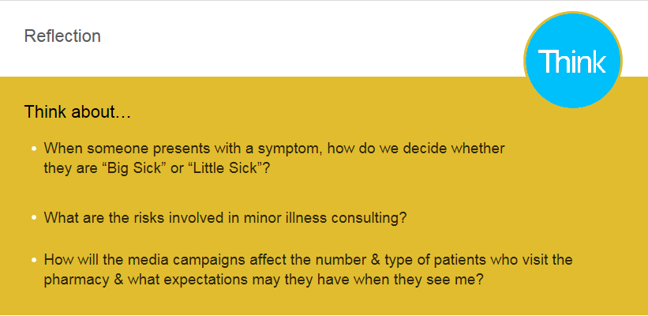
Learning Resources
Symptom Sorter:
http://bit.ly/2GBTSrX
https://amzn.to/2IsUjW6
Minor Illness & Beyond:
http://bit.ly/2GU8SVq
https://www.amazon.co.uk/Minor-Illness-Beyond-Handbook-Practice/dp/1846197678/ref=pd_sim_14_5?_encoding=UTF8&psc=1&refRID=78XBDSFTGDVRS33Z08DF
The Minor Illness Manual:
https://www.crcpress.com/The-Minor-Illness-Manual-4th-Edition/Gina-Ian/p/book/9781846195648
https://www.amazon.co.uk/Minor-Illness-Manual-4th/dp/1846195640/ref=sr_1_1?s=books&ie=UTF8&qid=1522053201&sr=1-1&keywords=minor+illness+manual+4th+edition
CPPE Minor Ailments:
https://www.cppe.ac.uk/gateway/minor
2. Reflection

Reflection is a useful tool for all pharmacists and is a key part of this course. It is recommended that you write reflective notes for each module and more in depth reflections for at least three of them.

Reflection has been part of CPD for many years for pharmacists and pharmacy technicians but the CPD template did not really help us to really appreciate the value of quality reflection.

From next year reflection will be a larger part of professional revalidation, techniques for reflecting are needed for the four CPD entries, the reflective account and the peer review.

So here is a brief ‘how to guide’ to reflection. Many thanks to Nottingham University for putting this information on their website for all to use. The full online guide to reflection available at:
https://www.nottingham.ac.uk/nmp/sonet/rlos/placs/critical_reflection/practical/index.html

What is Critical Reflection?
Reflective practice is something more than thoughtful practice. (Jarvis 1992)
It is the process of looking back on what has been done and pondering on it and learning lessons from what did or did not work. (Conway 1994)
Practitioners can continue to learn, grow and develop in and through their practice. (Jarvis 1992)

Models (or Frameworks) of Reflection
- Models, sometimes known as frameworks for reflection, encourage a structured process to guide the act of reflection. There is no right model.
- It is important to choose the one that feels most comfortable for you and best assists you to learn from your experience.
- Often it is appropriate to use one model of reflection as a basis, but use prompt questions from other models if they best fit your particular situation.

Common models include:

Gibbs'
Johns'
Driscoll (by Borton)

The Driscoll cycle (2007) based on the very simple: What? ⇒ So what? ⇒ What now? works very well in most situations
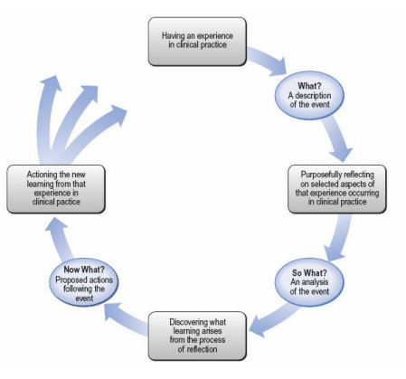
2. Reflection
Practical Skills

A reflector is able to:
- describe their perception of events
- provide a comprehensive account which captures the essence of the situation
- critically analyse the situation
- use insights to move forwards
- effectively action plan
- demonstrate ability to use models and frameworks

Skills required include:
- Writing
- Looking
- Thinking
- Doing
- Dialogue
- Keeping records

3. Safer Consulting in Minor Illness Referral Form

Dear Dr
Thank you for seeing ______________________________, aged _______.
They presented the following symptom(s) in my pharmacy:

They were concerned about:

I observed that:

I obtained the symptom history of:

I am referring this patient to you because:

Please can you:

Many thanks for your help.
Pharmacist name:
Pharmacy name:
Contact details:
4. Clinical Assessment in Minor Illness
Clinical assessment is the diagnostic process that links the symptom that the patient presents with to the diagnosis and management plan that they leave with

- Patient profile -

- Global survey –

A
B
C
D
E
F

- Symptom history –

P
Q
R
S
T
- Co-morbidities
- Past medical history
- Medications
- Allergies
- Social history
- Family history

4. Clinical Assessment in Minor Illness – cont.
Video length 47:32
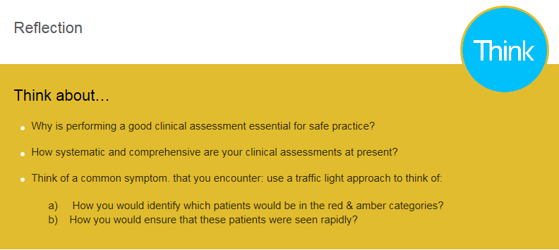

Learning Resources

Read Papers published by Prof Paul Silverston, which can be viewed at:
https://www.researchgate.net/project/Consultation-Skills-Teaching

Two books:

Nursing & Health Clinical Assessment Survival Guide:
https://www.amazon.co.uk/Clinical-Assessment-Nursing-Health-Survival/dp/0273763776/ref=sr_1_2?s=books&ie=UTF8&qid=1522222783&sr=1-2&keywords=clinical+assessment

McLeod’s Clinical Examination:
https://www.amazon.co.uk/Macleods-Clinical-Examination-STUDENT-CONSULT/dp/0702047287/ref=sr_1_1?s=books&ie=UTF8&qid=1522222783&sr=1-1&keywords=clinical+assessment

Notes:

5. Assessment of the Sick Child & Older Patient
Assessment of the sick child
Red Flag / Traffic light
Activity

Behaviour

Colour

Dehydration

Effort of breathing

Fever

Symptom specific findings

The three questions to always ask the patient:
1)
2)
3)
Safety-netting advice:
5. Additional Notes

5. Assessment of the Sick Child & Older Patient – cont.
Assessment of the older adult
Key points about older patients:

Risks:

Systematic approach to diagnosis (including history taking):

Red flags:

Written safety-netting advice to consider providing to the patient:

5. Assessment of the Sick Child & Older Patient – cont.
Video Length 65:09
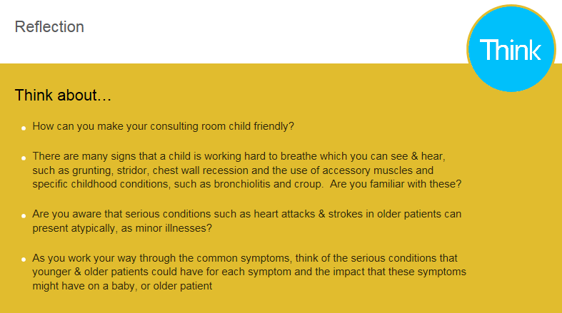

S2 Learning Resources

• Multimorbidity: https://www.nice.org.uk/guidance/ng56

• NICE CG160: https://www.nice.org.uk/Guidance/CG160

• DoH “Spotting the Sick Child”: https://www.spottingthesickchild.com

• Paediatric Care On-Line:
http://pcouk.org/Content.aspx?gbosid=215500#sec_167768825

- Parents may need advice on how to take a temperature: https://www.nhs.uk/conditions/pregnancy-and-baby/how-to-take-your-babys-temperature/

- They may also need advice on assessing, managing & monitoring a baby or
child with a fever:
https://www.nhs.uk/conditions/fever-in-children/

https://patient.info/health/fever-in-children-high-temperature

6. Documenting and Information Transfer in Minor Illness
Baseline
How are you documenting your consultations now? (Which consultation are you documenting, how are you documenting them, electronic or paper)

After watching the section on documenting (17.33 mins) you might want to pause the presentation to make some notes about how you prefer to document consultations
My preference and rationale for that choice
How will I record? (Electronic or hand written).
As I go along or at the end?
Does this impact the location for consultations (will they all need to be in a consultation room)
Which consultations will I record?

Will I use a template or aide memoire?

Anything else?

6. Documenting and Information Transfer in Minor Illness – cont.

Remember legally and professionally: if you don’t record it then it didn’t happen
Referring to another clinician
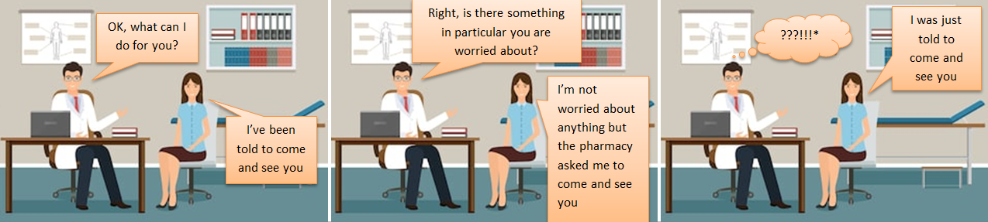

Notes:
6. Documenting and Information Transfer in Minor Illness – cont.
Video length 32:58
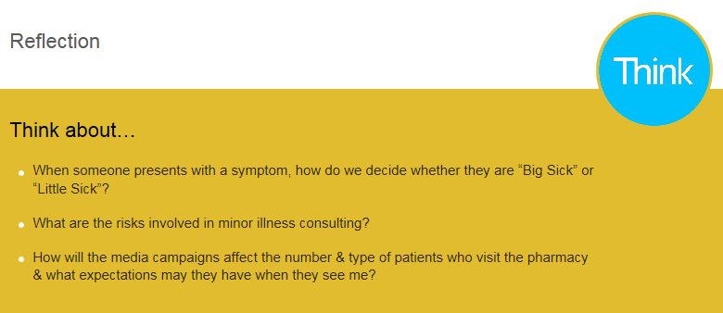

Learning Resources

This is a report from the ICO on documentation in community pharmacies:
https://ico.org.uk/media/action-weve-taken/audits-and-advisory-visits/2013919/community-pharmacy-outcomes-report.pdf

This was produced by the American Pharmacists Association:
http://www.pharmacist.com/sites/default/files/files/mtm_documentating_pc_services.pdf

Notes:

7. Is it Meningitis?
Is it Meningitis? Invasive meningococcal disease (IMD)

The Four big messages:
1)
2)
3)
4)

- Sepsis Symptoms = Shock symptoms
  - A&B = Restless, confused, drowsy
  - C = Pale, cold, mottled, ashen, non-blanching rash
  - D = Thirst, dehydrated, decreased urine output
  - E = Rapid breathing, laboured breathing
  - F = Fever, or normal, or low temperature
  - Other symptoms
    - Abdominal pain & diarrhoea
    - Rashes
      - None
      - Non-petechial, blanching
      - Petechial, non-blanching
- Meningitis Symptoms = Brain Symptoms
  - A & B =
    - Vacant, drowsy, abnormal cry
    - Sleepy, difficult to wake, can’t stay awake
  - C = Flushed
  - D = Not dehydrated
  - E = Unchanged
  - F = Fever present
  - Other symptoms
    - Headache
    - Photophobia
    - Neck stiffness
    - Seizures
    - Comatose
IMD: Meningitis & Sepsis

Important questions to ask:

7. Additional Notes

7. Is it Meningitis? – cont.
Video length 39:49
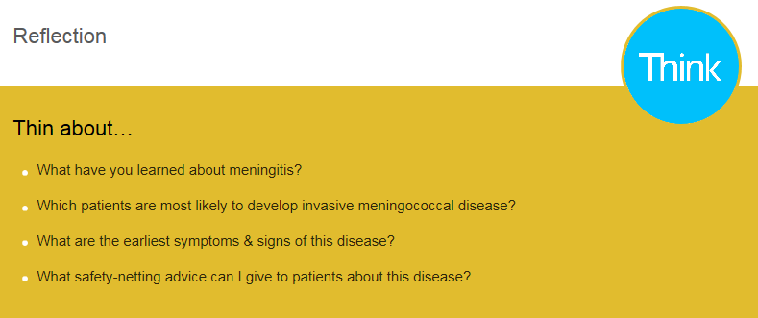

Learning Resources

There are some good learning tools & posters for your pharmacy at:

https://www.meningitis.org/meningitis/check-symptoms

https://www.meningitis.org/healthcare-professionals/resources

NICE CG102 & CKS:

https://cks.nice.org.uk/meningitis-bacterial-meningitis-and-meningococcal-disease

https://www.gov.uk/government/uploads/system/uploads/attachment_data/file/683641/hpr0718_IMD.pdf

https://www.gov.uk/government/collections/meningococcal-disease-guidance-data-and-analysis

https://www.gov.uk/government/uploads/system/uploads/attachment_data/file/655626/hrp3817_IMD.pdf

8. Could it be Sepsis?
Think Sepsis
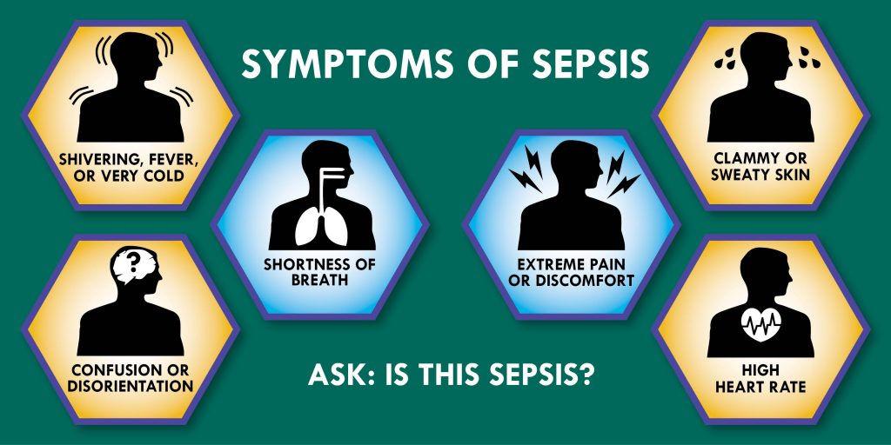

Risks:

8. Could it be Sepsis? – cont.
Video length 19:57
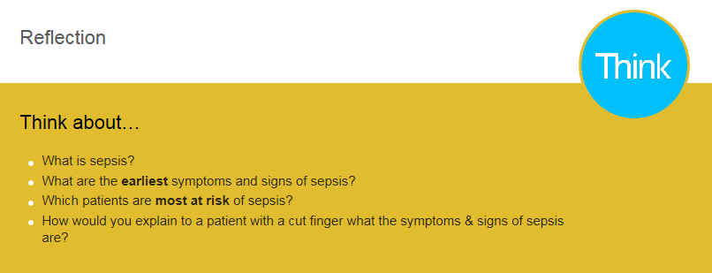

Learning Resources

You should review the CPPE website, which has a number of learning
Resources:
https://www.cppe.ac.uk/therapeutics/sepsis

There is a new (2017) NICE guideline on sepsis, which has risk stratification
Tables:
https://www.nice.org.uk/guidance/ng51/resources/algorithms-and-risk-stratification-tables-compiled-version-2551488301

Another good resource for sepsis information is the UK Sepsis Trust:
https://sepsistrust.org/education/educational-tools/

The UKST site has assessment algorithms for:

– Carers who are unable to perform a set of observations:
https://sepsistrust.org/wp-content/uploads/2017/08/Community-carers-NICE-Final-2.pdf

– Health care professionals who can perform a set of observations, such as
nurses, paramedics & GP’s:
https://sepsistrust.org/education/clinical-tools/

Please could you read this article on sepsis?

https://health.spectator.co.uk/the-nhs-has-undermined-its-own-advice-on-sepsis/

8. Could it be Sepsis? – cont.
Systematic approach to diagnosis (including history taking)
Red Flag / Traffic light
Activity

Behaviour

Colour

Dehydration

Effort of breathing

Fever

Symptom specific findings
Written safety-netting advice to consider providing to the patient:

9. “I’ve got conjunctivitis”

Key points about conjunctivitis:

Risks:

Systematic approach to diagnosis (including history taking):

Red flags:

Written safety-netting advice to consider providing to the patient:

9. “I’ve got conjunctivitis” – cont.
Video length 40:27
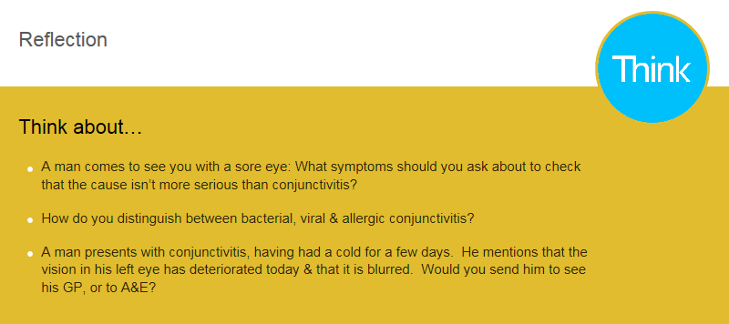

Learning Resources

Moorfields Eye Hospital has some excellent on-line learning & reference resources:

The Flipbook:

http://www.moorfields.nhs.uk/content/gp-handbook

Eye Conditions:

http://www.moorfields.nhs.uk/listing/conditions

Notes:

10. “I’ve got a headache”

Key points about headaches:

Risks:

Systematic approach to diagnosis (including history taking):

Red flags:

Written safety-netting advice to consider providing to the patient:

10. “I’ve got a headache” – cont.
Video length 25:53
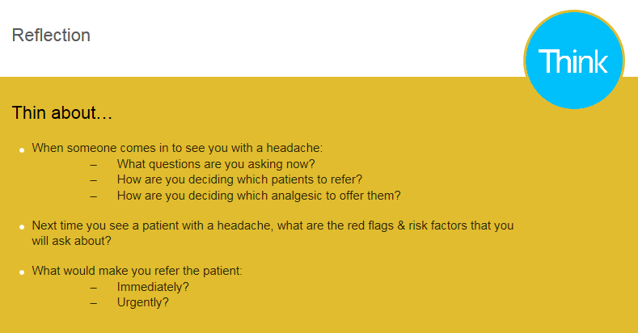

Learning Resources

NICE CG150 has a very good chart to help you with a structured approach to asking about the patient’s headaches:

https://www.nice.org.uk/guidance/cg150/chapter/Recommendations#diagnosis

https://cks.nice.org.uk/headache-assessment#!topicsummary

This is also a useful source of information:

https://medlineplus.gov/ency/patientinstructions/000424.htm

Notes:

11. Ear, Nose & Throat

Key points about Ear, Nose & Throat:

Risks:

Systematic approach to diagnosis (including history taking):

Red flags:

Written safety-netting advice to consider providing to the patient:

11. Ear, Nose & Throat – cont.
Video Length(s) 21:05 / 26:39 / 30:17

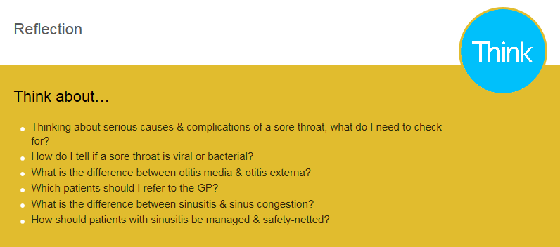

Learning Resources

PHE:

https://www.gov.uk/government/uploads/system/uploads/attachment_data/file/66472/Summary_tables_infections_in_primary_care.pdf

NICE:

https://pathways.nice.org.uk/pathways/self-limiting-respiratory-tract-infections---antibiotic-prescribing

https://www.nice.org.uk/guidance/NG91

https://www.nice.org.uk/guidance/ng79

https://www.nice.org.uk/guidance/ng84

RCGP:

http://www.rcgp.org.uk/TARGETantibiotics

12. “I’ve got a cough”

Key points about a cough:

Risks:

Systematic approach to diagnosis (including history taking):

Red flags:

Written safety-netting advice to consider providing to the patient:

12. “I’ve got a cough” – cont.
Video length(s) 50:34 / 28:02
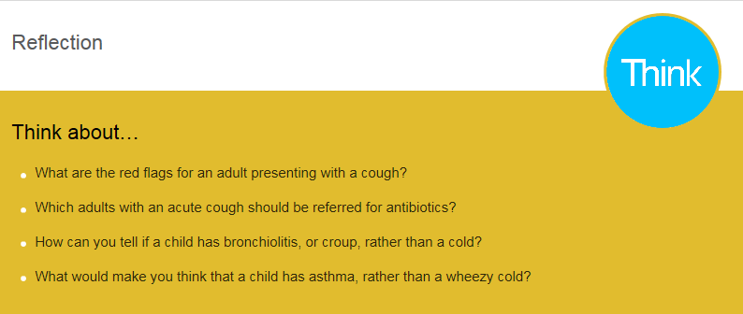

Learning Resources

Management of patients with influenza:

https://www.gov.uk/government/uploads/system/uploads/attachment_data/file/64878/PHE_guidance_antivirals_influenza_201718_FINAL.pdf

Cough in children:

https://cks.nice.org.uk/cough-acute-with-chest-signs-in-children

Cough in adults:

https://cks.nice.org.uk/chest-infections-adult

Notes:

13. Cystitis

Key points about Cystitis:

Risks:

Systematic approach to diagnosis (including history taking):

Red flags:

Written safety-netting advice to consider providing to the patient:

13. Cystitis – cont.
Video length 25:52

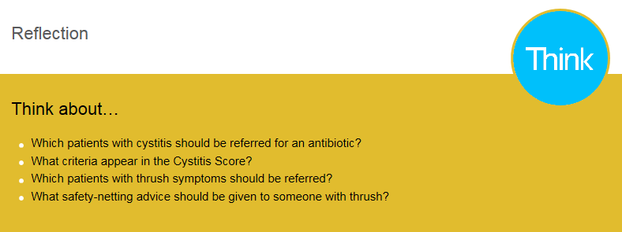

Learning Resources

Here are 3 really good resources:

NICE CKS: UTI (Lower) in Women:

https://cks.nice.org.uk/urinary-tract-infection-lower-women#!topicsummary

PHE Management of Common Infections:

https://www.gov.uk/government/uploads/system/uploads/attachment_data/file/66472Summary_tables_infections_in_primary_care.pdf

Target UTI’s:

http://www.target-webinars.com/wp-content/uploads/2016/08/UTI-Leaflet-V16.pdf

Notes:

14. Skin Conditions

Key points about Skin Conditions:

Risks:

Systematic approach to diagnosis (including history taking):

Red flags:

Written safety-netting advice to consider providing to the patient:

14. Skin Conditions – cont.
Video length(s) 37:31 / 21:50

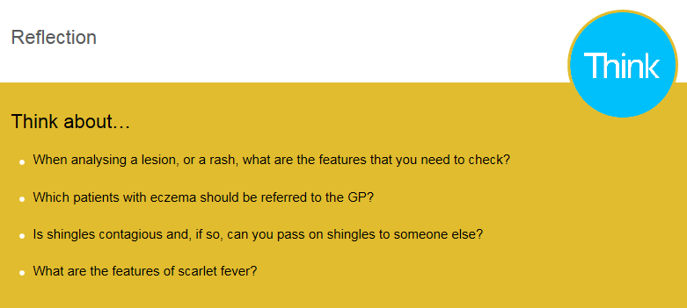

Learning Resources

There are 2 really good websites:

http://www.pcds.org.uk
http://www.bad.org.uk

There are also specific NICE guidelines on conditions such as:

Eczema:
https://cks.nice.org.uk/eczema-atopic

Psoriasis
https://cks.nice.org.uk/psoriasis

Viral exanthems:
http://www.pcds.org.uk/clinical-guidance/viral-exanthems
https://www.nhs.uk/conditions/rashes-babies-and-children/

There is also a good reference on viral rashes & pregnancy;
https://www.gov.uk/government/publications/viral-rash-in-pregnancy

Wound advice:
https://www.advancedtissue.com/6-signs-you-have-an-infected-wound/

15. Fever and Flu

Key points about Fever and Flu:

Risks:

Systematic approach to diagnosis (including history taking):

Red flags:

Written safety-netting advice to consider providing to the patient:

15. Fever and Flu – cont.
Video length 42:37
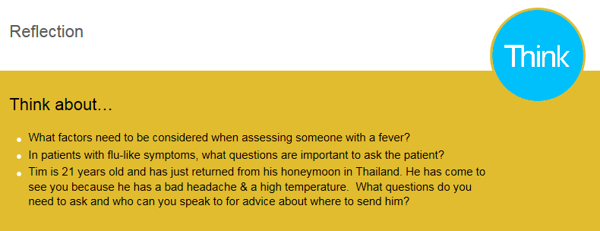

Learning Resources

Fever in children:
https://www.nice.org.uk/Guidance/CG160

Malaria:
https://cks.nice.org.uk/malaria#!background

TB:
https://cks.nice.org.uk/tuberculosis#!diagnosis

Lyme disease:
https://www.nice.org.uk/guidance/ng95

Tropical Diseases Hospital, London
http://www.thehtd.org

Notes:

16. Diarrhoea and Vomiting

Key points about Diarrhoea and Vomiting:

Risks:

Systematic approach to diagnosis (including history taking):

Red flags:

Written safety-netting advice to consider providing to the patient:

16. Diarrhoea and Vomiting – cont.
Video length 36:13
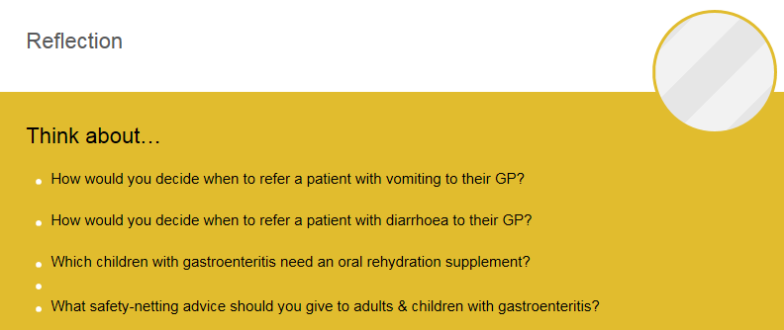

Learning Resources

Food handlers:
http://www.food.gov.uk/business-industry/guidancenotes/hygguid/foodhandlersguide

NICE CKS Gastroenteritis:
https://cks.nice.org.uk/gastroenteritis

NICE Gastroenteritis in children:
https://www.nice.org.uk/Guidance/CG84

Notes:

17. Antibiotics

Key points about Antibiotics:

Risks:

Systematic approach to diagnosis (including history taking):

Red flags:

Written safety-netting advice to consider providing to the patient:

17. Antibiotics – cont.
Video length 40:33
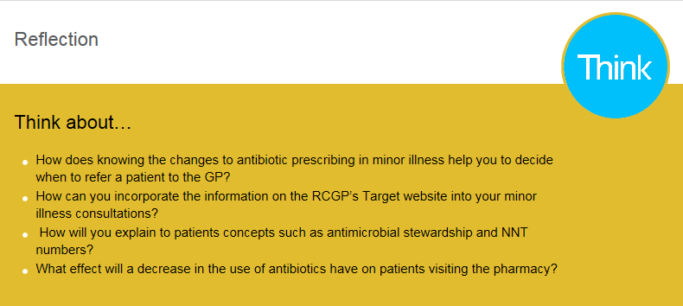

Learning resources

Recent article on antibiotic prescribing:
https://academic.oup.com/jac/issue/73/suppl_2

RCGP Target:
http://www.rcgp.org.uk/clinical-and-research/toolkits/target-antibiotics-toolkit.aspx

Webinars:
http://www.target-webinars.com

PHE “Managing Common Infections for Primary Care”
https://www.gov.uk/government/publications/managing-common-infectionsguidance-for-primary-care

Long Q-T causing drugs:
http://www.nhs.uk/conditions/long-QT-syndrome/Documents/Acquired-LQT-Brochure06.pdf

RCGP Target Guidelines:
http://www.rcgp.org.uk/TARGETantibiotics

PHE Antibiotic Prescribing Guideline:
https://www.gov.uk/government/uploads/system/uploads/attachment_data/file/664742/Summary_tables_infections_in_primary_care.pdf

NICE RTI’s & Antibiotics Guidelines:
https://www.nice.org.uk/Guidance/conditions-and-diseases/infections/antibiotic-use

https://www.nice.org.uk/guidance/NG15/chapter/1Recommendations#recommendations-for-prescribers

https://www.nice.org.uk/about/what-we-do/our-programmes/nice-guidance/antimicrobial-prescribing-guidelines

https://www.nice.org.uk/guidance/ng91/informationforpublic

18. Analgesia

Key points about Analgesia:

Risks:

Systematic approach to diagnosis (including history taking):

Red flags:

Written safety-netting advice to consider providing to the patient:

18. Analgesia – cont.
Video length 43:36 + Watch (Streamed) YouTube video
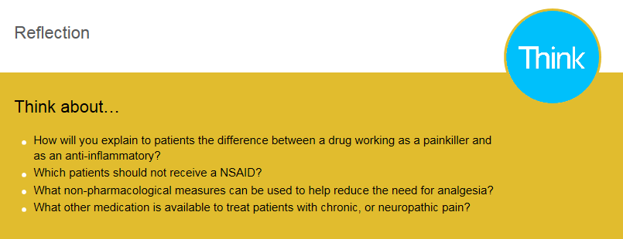

Learning resources

Recent article on antibiotic prescribing:
https://academic.oup.com/jac/issue/73/suppl_2

RCGP Target:
http://www.rcgp.org.uk/clinical-and-research/toolkits/targe-antibiotics-toolkit.aspx

Webinars:
http://www.target-webinars.com

PHE “Managing Common Infections for Primary Care”
https://www.gov.uk/government/publications/managing-common-infections-guidance-for-primary-care

Long Q-T causing drugs:
http://www.nhs.uk/conditions/long-QT-syndrome/Documents/Acquired-LQT-Brochure06.pdf

RCGP Target Guidelines:
http://www.rcgp.org.uk/TARGETantibiotics

PHE Antibiotic Prescribing Guidelines:
https://www.gov.uk/government/uploads/system/uploads/attachment_data/file/664742/Summary_tables_infections_in_primary_care.pdf

NICE RTI’s & Antibiotics Guidelines:
https://www.nice.org.uk/Guidance/condition-and-diseases/infections/antibiotic-use

https://www.nice.org.uk/guidance/NG15/chapter/1-Recommendations#recommendations-for-prescribers

https://www.nice.org.uk/about/what-we-do/our-programmes/nice-guidance/antimicrobial-prescribing-guidelines

https://www.nice.org.uk/guidance/ng91/informationforpublic
19. Additional notes

