Patient /Carer Information – Caring for your wound at home temporarily during the present COVID-19 pandemic.
Preparing to change the dressing and dress your wound
You will need:
- Sterile, clean dressing pack (provided) - include gauze, gloves, tray, apron and waste bag.
- wound dressings provided by nursing staff
- scissors (given by nurses) cleaned prior to use if needed
- creams/barrier creams for surrounding skin provided by nursing staff if required
- tape (if required)
- running tap water or saline sachet provided to clean wound and surrounding skin
Procedure:
- Ensure you have a cleaned area to work from, eg:, clean tea tray or a towel to put your equipment on. Remove any pets from the area before starting any dressing change
- Wash hands thoroughly especially between fingers and palms of hands for 20 seconds
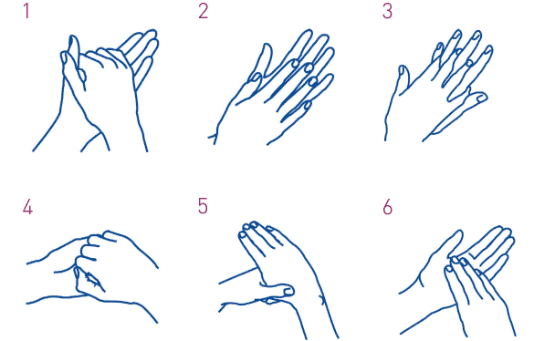
- Dry hands with a clean towel/kitchen roll
- Open dressing pack onto a clean tea tray or towel and apply apron provided if carer is doing the dressing.
- Remove waste bag used for dirty dressings
- Put your hand inside the waste bag and remove the old dressing without touching the inside of the dirty dressing or the wound surface.
- Holding the old dressing, turn the bag inside out so capturing the old dressing without touching it directly .You might have to wet the dressing with tap water/a normal saline sachet solution if the dressing is stuck to the wound; do NOT pull as this will damage the healing wound. Soak with the tap water or saline sachet if stuck and try again gently after a few minutes
- Wash hands again or use alcohol hand gel
- Open new wound dressings and place on the tray on the clean, sterile opened dressing pack.
- Apply clean gloves from the open dressing pack.
- Clean surrounding skin with tap water and gauze from the open dressing pack, dry surrounding skin with remaining gauze or towel from the open dressing pack
- Clean the wound with another sterile gauze dipped in tap water or saline sachet solution.
- Apply a small amount protective barrier film/creams/moisturiser around the wound edge if needed
- Apply new dressings as directed by the nurse who provided dressings.
- Discard any unused dressing items from pack in waste bag. Secure bag and dispose off
- Wash hands again

Please monitor for signs of infection!
Observe for:
- Redness to skin surrounding wound.
- Skin surrounding wound is warmer than normal.
- Wound and surrounding skin has become painful.
- Swelling and hardening.
- Increased wetness and leakage from wound.
- Offensive smell.
- Yellow or green pus.
- If wound deteriorates/gets larger or deeper.
- You feel unwell
If you have any of the above signs and you suspect you have an infection in your wound - please contact your community Nurse team

Name of patient

Specific instructions ( fluid to use , name of dressing , other instructions if needed) .

Name and signature

Contact number

