Skin tear simple dressing plan for carers to use as soon as skin injury has taken place.
Caring for skin tears temporally during the present Covid pandemic
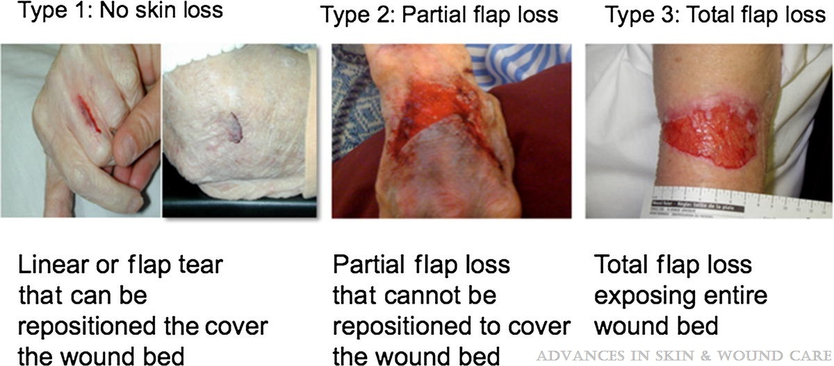
Type 2 and 3 skin tears need to be referred to your local Community nurses team or Surgery
Document all actions
Procedure | Rationale
Use clean gloves  Clean surrounding skin first and pat dry  Clean wound thoroughly and gently with tap water or saline and gauze or clean soft cloth ,towel, paper towel.  (use a sterile, clean dressing pack if you have access to one) | To ensure that dirt from surrounding skin does not contaminate the wound.  To remove all dirt and debris from the wound.
If bleeding, apply pressure with clean gauze/cloth | Continue until bleeding stops
There is no need to apply a steri-strip. If possible, slide the skin back into place (over the wound) without any force. | This action will potentially promote faster healing of the wound.  See dressing procedure
Apply an appropriate size Biatain silicone dressing to the wound (first choice) | The silicone layer reduces dressing sticking and support healing process.  Leave dressing for 3 or 4 days if no pain or problems reported
If no Biatain available:  2d choice: use Atrauman and Cosmopore  3d choice: If no Atrauman is available, use Cosmopore but inform the nurses for access to another dressing that will reduce sticking. | To avoid this adherence (sticking delay healing) check and renew dressing after 2 days ensuring that adhesive is removed gently (use water or saline to soak the dressing).
Please monitor for signs of infection
Redness to skin surrounding wound. | Wound and surrounding skin has become painful.
Skin surrounding wound is warmer than normal. | Swelling, hardening.
Offensive smell. | Yellow or green pus,
Increased wetness and leakage from wound. | Gets larger, deeper, deteriorates  Patient unwell
If you have any concerns regarding the patient’s wound or you suspect an infection in the wound - please contact the local community Nurse team or surgery

