GP Practice - #BeKind campaign communications toolkit
The following content can be used on practice websites and newsletters and across social media to help raise awareness of.
A selection of images are available to download from the CCG website that can be used alongside. If you require any further support, please contact the CCG Communications Team at capccg.contact@nhs.net

Overview:
In recent months Primary Care staff have been on the receiving end of increasing frustration from patients around access to GP services.
To help support practices the #BeKind campaign will focus on messaging about accessing GP services alongside reminding patients to be patient and kind when contacting their practice.
Practices are encouraged to use the following website/newsletter copy alongside posting information on their social media channels.
The CCG will be supporting this campaign and will also be posting across social media channels and updating via stakeholder newsletters.

Communications toolkit:
The following communications toolkit includes:
- Suggested website/newsletter copy for practices and stakeholder use
- Template social media posts
- Selection of images for social media and website
- Posters for surgeries

Suggested copy for practice websites or newsletters (to be tailored to practice)
Please be kind to our staff
Staff at our practice are working extremely hard and doing their best to make sure patients are safe.
Over the last 18 months, the practice has been supporting the pandemic response and ensuring our patients are able to get their COVID-19 vaccinations, at the same time as continuing to deliver primary care services.
This has made our GP practice very busy and our staff have been working incredibly hard to keep services open for patients.
We’re aware patients may have experienced longer wait times on the phone or for their appointment, but we have been working hard to ensure you receive the right treatment from the right person at the right time.
We have increased the number of telephone and online appointments available, so our patients don’t always have to come to the practice. We also employ a range of highly trained staff, including doctors, nurses, pharmacists, paramedics and healthcare assistants who are able to deal with a range of medical conditions, which will help patients get treated sooner.
Whether your appointment is over the telephone, via an online video consultation, or face-to-face, patients will always receive the same high quality standard of care from our practice team.
So please, if you contact our practice, be kind.
Thank you for your patience and support.

Suggested social media copy for practices
Suggested social media posts for twitter and Facebook to be used alongside campaign images.
- Our staff are here to help & to make sure you get the right treatment from the right professional. Please, if you contact your GP surgery, remember to #BeKind

- We’re here to help you see the right professional at the right time. You might not always need to see a GP, our professional nurses, pharmacists and healthcare assistants can treat a range of conditions. #BeKind

- We’re here to help you see the right professional at the right time. Our trained staff can treat a range of conditions. #BeKind

- We’re here to help. You don’t always need a face to face appointment – telephone and video consultations provide the same standard of advice you need sooner #BeKind

- Our staff are working extremely hard & doing their best, whilst keeping patients and the practice team safe. So please, if you contact your surgery, #BeKind

- We’re aware patients may have experienced longer wait times on the phone or for their appointment but we have been working hard to ensure you receive the right treatment from the right person at the right time. Thank you for your patience. #BeKind

- We’re here to help. Many common conditions can be assessed and diagnosed by a telephone or video consultation, helping you to get advice or treatment sooner. #BeKind

- Thank you to all patients for their patience when contacting us this week. Our staff have taken over xxx calls, and held xxx consultations with patients – xxx of which were face-to-face. Please, if you contact your GP surgery, remember to #BeKind

Images
A selection of images that can be used on websites and social media can be downloaded from the CCG website.
Examples of images include:

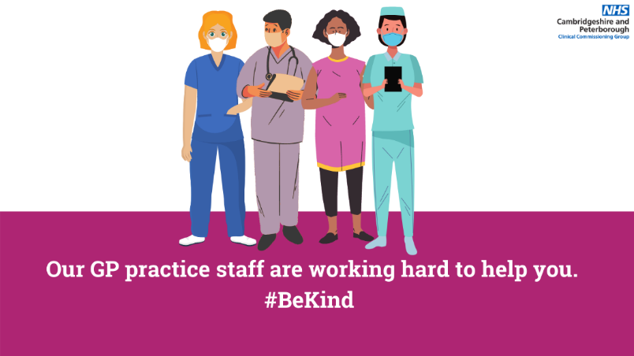

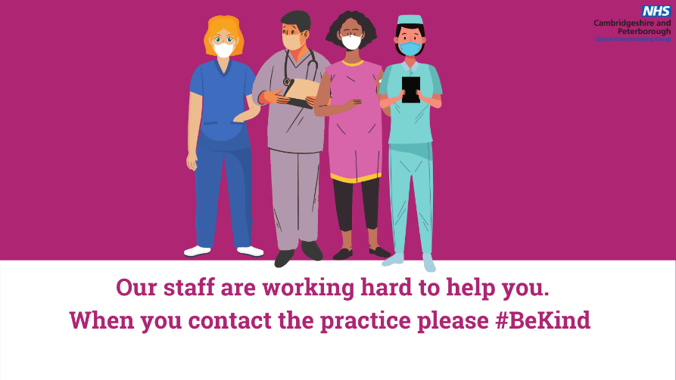

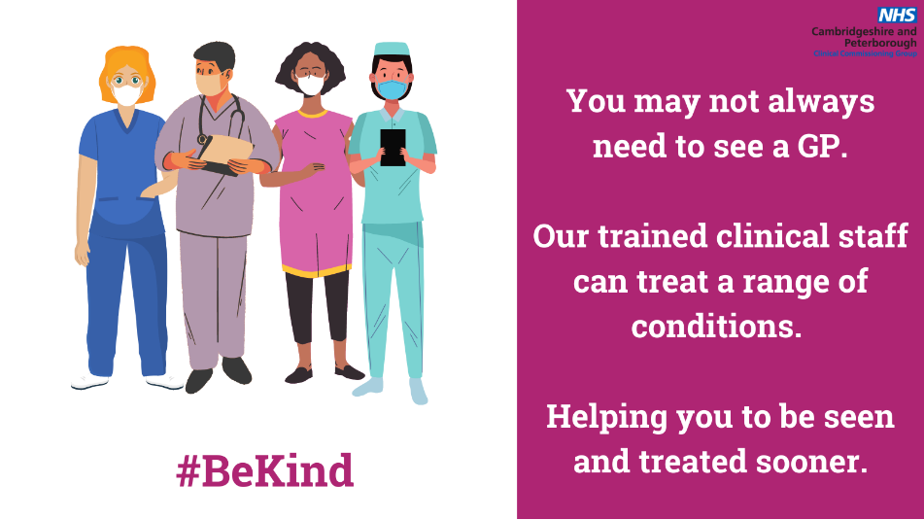

Example of poster

