Cambridgeshire & Peterborough ICS has partnered with Lantum to build a new, digital staff bank

Cambridgeshire and Peterborough ICS has chosen Lantum as a partner to create a system-wide, multidisciplinary staff bank.

The digital staff bank will transform how you manage your workforce by giving your practice access to a larger pool of staff from across your ICS, who can be booked wherever they’re needed. This bank will firstly include GPs but will be expanded to incorporate other clinical staff types in the future.

Your new digital staff bank will help build resilience, save time, and save money.
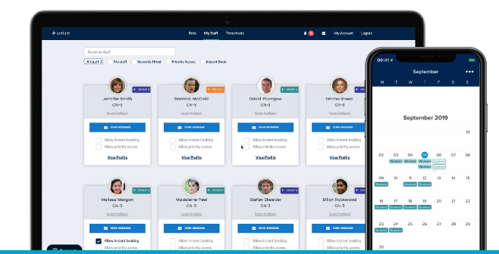
Who is funding the staff bank and what will it cost my practice?

Cambridgeshire and Peterborough ICS is covering the cost of creating the staff bank.
After that, you’ll just pay 1% fees for any bookings you make through the bank (which is much lower than locum agency fees!)

What is Lantum?
Lantum is a digital workforce platform that lets you manage staffing end-to-end with just one tool. ICSs like Greater Manchester and Our Dorset are already using it and seeing amazing results.

As well as a staff bank, Lantum offers access to a network of 30,000 nationwide clinicians available for locum bookings at 10% fees, as well as an integrated rota tool that makes scheduling staff quicker and easier. For now, your ICS is just funding the staff bank.

Why is your ICS creating a staff bank?

To build resilience
Having access to a staff bank will make it easier for you to fill shifts – even when cancellations are made at the last minute. This helps you to deliver services effectively, and takes some pressure off your existing staff. It will also make it easier to collaborate with nearby practices and PCNs, and share unused resources.

To save money
The staff bank will help reduce your spend, as you’ll no longer need to pay high agency fees to book locums – instead you can book trusted staff from your ICS for just a 1% fee.

To reduce time spent on admin
Having one platform to manage all bookings reduces administration time significantly. With verified clinical governance documents on staff profiles, compliance is much easier to track. With automatic notifications, you no longer need to contact staff individually about shifts. Lantum consolidates statements, so you make just one payment rather than multiple. And, with the direct messaging tool, you can keep communication in one place and ensure all rota managers have full visibility.

What are the benefits for your clinical workforce?

Access more working opportunities
Clinical staff will now have access to sessional work across the CCG to supplement normal working patterns. They’ll receive prompts about new opportunities and can filter for jobs that best suit their clinical profile and geographical preferences.

Paperless invoicing process
Lantum’s digital invoicing tool makes the billing process easier, greener and more efficient. Full financial records are kept for all clinical work, making it easy to see what’s been paid and what is still outstanding. Payments are remitted by Lantum and, until June 2021, all clinicians can enjoy free Rocketpay - meaning payments are made the next working day!

Clinical Passporting
GPs and Nursing staff can upload their clinical compliance documents onto the platform, which are then shared with Practice Managers. Other information, including qualifications, spoken languages and personal profiles, can also be added, which are available to other clinical and non-clinical staff types. And all of the above can be managed through Lantum’s app for clinicians.

How will the staff bank work?

- The staff bank includes profiles of staff across your ICS, complete with details about their experience, skills and clinical governance documents.
- Your practice posts vacant shifts on Lantum, and staff in your ICS apply for them on the Lantum app.
- Your practice accepts an application from the staff member you’d like to cover your shift, and they are automatically notified of the booking.
- After the shift, Lantum can automatically pay staff the next day. You can also set up automatic signing of digital pension forms for GPs.
- On a weekly or monthly basis, Lantum provides a consolidated statement and invoice for all sessions booked, so you have one simple payment to make.

What happens next?

In the next few weeks you’ll receive more details about the staff bank and we’ll invite you to virtual Q&A sessions and training sessions so you know exactly how to use it. Once onboarded, if you have any questions, our support team will be on hand to help.

We will be in contact with you once it’s time to create your Lantum account. Currently we are supporting the Phase 3 vaccination clinics and building up the bank of staff so there’s GPs to assist with your sessional cover.

