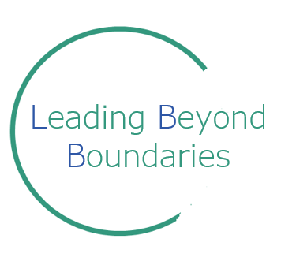
Leading Beyond Boundaries
Application Form

“Developing the Person, to improve the place, for the benefit of the whole Population”

Please complete the following information and check within your organisation you have their support to apply.

The following criteria will be used for selection:
- Demonstration of commitment to personal, organisational and Systems leadership development
- Acceptance of the commitment
- Support from your employer/organisation/partnership
**Please note the application is a vital part of our selection process, please make every effort to complete fully and with consideration.
**Your Line Manager must send a confidential reference via email to cpm-tr.workforce.programmes@nhs.net to endorse your application & list reasons why you should be accepted onto the programme. The reference must be received by submission date as it will be considered during selection panel. If not received, the applicant will not proceed to the selection panel.
Selection will be carried out by a panel of cross-organisational senior members of the Leading Beyond Boundaries Programme Board.
Please answer all the questions below – feel free to expand the form as required to suit your answers.
References must be submitted with this application
Name

Job Title(s) | 1.  2.
Organisation(s)

Email address

Work Phone
Mobile Phone
Home phone
Home Address

Please specify any special dietary requirements?
eg Gluten free/vegan/allergies/halal
Do you have any special requirements?

If you have any special requirements please describe how we may help and we will contact you

Action for Line Manager: Email a confidential reference form to endorse the applicant:
Send to cpm-tr.workforce.programmes@nhs.net

GPs should have a Primary Care colleague from their practice email the reference, rather than a CCG colleague.

Do you have the full support of your employer to attend this programme? | Employer’s name:
Employers/ GP partnership  Note to employer, by signing this you are agreeing to free up this individual for the time required for this programme and will ensure that appropriate backfill arrangements are made to cover any clinical commitments. | Employers Signature / GP partnership support (please sign below, do not type)  ………………………………………………………………….  Name:  Position:  Date:
Length of time in your current role:

Previous role(s):

Please outline what (if any) continuing professional development you have under taken in the last 3 years?

In no more than 200 words please provide a statement about why you want to join this programme.

What change [large or small] would like to see happen across our Cambridgeshire and Peterborough ICS?

IMPORTANT
BOOKING DETAILS & CONDITIONS

In order to successfully complete the Programme, you are expected to attend all the relevant Cohort modules below.

Please review the dates below and tick which Cohort you would prefer to attend and hold these dates in your diaries.

Please note, there are no overnight stays required.

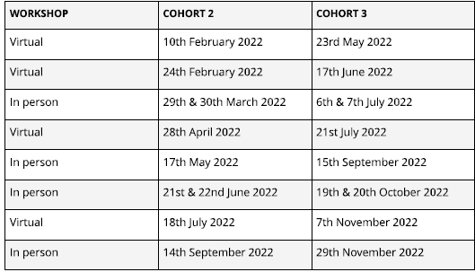

COHORT 2 ☐ OR COHORT 3 ☐

By submitting this form you agree to attend each of the dates in order to complete the programme. You understand your manager must also commit to releasing you for the dates listed.

Please ensure you are able to attend all of the dates, it is a requirement of the programme to attend all events listed above.

Thank you for completing this form, please return to:
cpm-tr.workforce.programmes@nhs.net

The Leading Beyond Boundaries Principles
- Partnership working – We need to role model the type of collaboration and partnership working at a programme level that we are asking of participants
- Courage to innovate – To get a different result we need a different approach to this programme
- Community voice – We need to involve the local community as a partner for change throughout the programme
- Compelling story for change – As humans we respond to stories. We need a compelling narrative that underpins the case for change
- Adaptive leadership – Whilst we need to offer enough structure and guidance to create confidence in LBB, we also require the freedom to respond to what emerges over the programme
- Values-based approach – When we reach decisions or conflict points, resolving them with a values-based approach will help us to navigate the challenges we encounter
- Alignment with frameworks – Reinforcing the right messages by aligning with system change initiatives, for example the Developing People, Improving Care framework
- A bias for action – Whilst theory and inspiration are vital ingredients for LBB, we ultimately need to move people to action in order to deliver lasting change.

