Category – GP Award

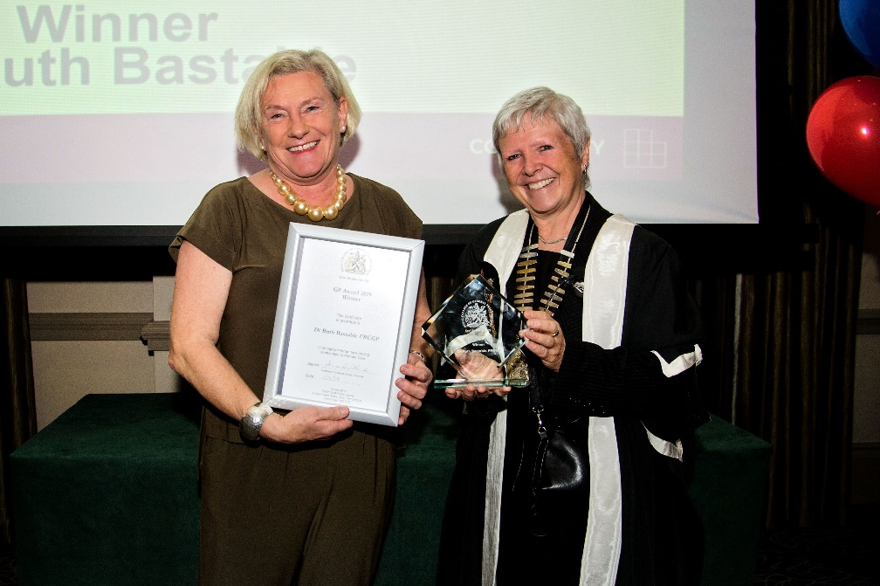
Prize Glass Engraved Plaque and Certificate

Please complete the application form below and email with attached evidence to: eanglia@rcgp.org.uk;
Closing date for entries – Friday 18 August 2023, 12 noon
This award is for the most outstanding contribution to Primary Care service provision or development by a GP in the preceding year and is open to all GPs, both RCGP members and non members
The Awards process is overseen by a panel of judges made up of members of the RCGP East Anglia Faculty Board, both GPs and lay members. The judges will be looking for evidence such as:
- An outstanding contribution to Primary Care (e.g. audits, papers, work for other GP organisations, teaching)
- Innovative ideas
- Commendation by patients and colleagues (e.g. patient surveys, letter, colleague feedback, formal and informal)
- Work carried out beyond the call of duty
- Details of personal qualities
Nominations will be judged against the duties of a doctor registered with the General Medical Council, as taken from GMC “Good Medical Practice (2006)”.
The duties of a doctor registered with the General Medical Council:
- Make the care of your patient your first concern
- Protect and promote the health of patients and the public
- Provide a good standard of practice and care
- Keep your professional skills up to date
- Recognise and work within the limits of your competence
- Work with colleagues in the ways that best serve patients’ interests
- Treat patients as individuals and respect their dignity
- Treat patients politely and considerately
- Respect patients’ right to confidentiality
- Work in partnership with patients
- Listen to patients and respond to their concerns and preferences
- Give patients the information they want or need in a way they can understand
- Respect patients right to reach decisions with you about their treatment and care
- Support patients in caring for themselves to improve and maintain their health
- Be honest and open and act with integrity
- Act without delay if you have good reason to believe that you are a colleague may be putting patients at risk
- Never discriminate unfairly against patients or colleagues
- Never abuse your patients trust in you or the publics trust in the profession
- You are personally accountable for your professional practice and must always be prepared to justify your decisions and actions.

Application Form 2023

Entry Details:

Category of Award GP AWARD 2023

Name (person nominated) _______________________________________________

Job Title (person nominated) _______________________________________________

Contact email (person nominated) _______________________________________________

Your name and contact details
Name

Email Address

Telephone Number

Written submission up to 500 words

Please provide up to 5 pieces of evidence to support application, these can by from colleagues, practice team staff or patients etc (see above for examples)

Please complete the application form and email with evidence to: eanglia@rcgp.org.uk;
Closing date for entries – Friday 18 August 2023, 12 noon

