Category – Practice Nurse Award
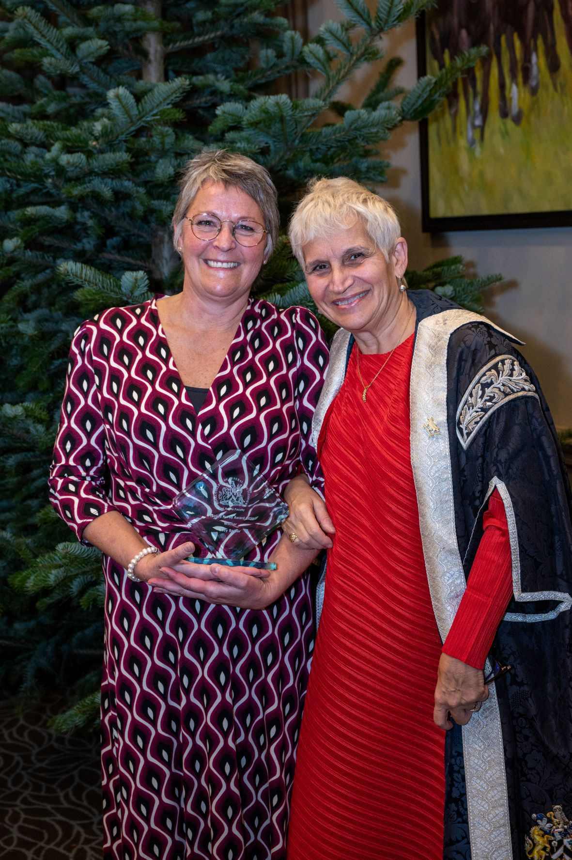
Prize Glass Engraved Plaque and Certificate

Please complete the application form below and email with attached evidence to: eanglia@rcgp.org.uk;
Closing date for entries – Friday 18 August 2023, 12 noon

This award is for the most outstanding contribution to Primary Care service provision or development by a Practice Nurse in the preceding year.
The Awards process is overseen by a panel of judges made up of members of the RCGP East Anglia Faculty Board, both GPs and lay members. The judges will be looking for evidence such as:
Submissions should include reference to and evidence (where possible) of one or more of the following criteria:
- Patient recommendation of a Practice Nursing intervention which has made a significant difference to their health. For example: support with management of a long term condition.
- Demonstrable improvement in health of population beyond QoF— namely to NICE targets.
Improvement in attendance and engagement with all aspects of the population. For example: housebound, homeless.
Examples of evidence include:
- Patient surveys, letters
- Feedback from colleagues, both in the practice and outside
- Hospital letters
- Audits especially of NICE targets
- Work with community or with minority groups of patients

Application Form 2023

Entry Details:
Category of Award PRACTICE NURSE AWARD 2023

Name (person nominated) _______________________________________________

Job Title (person nominated) _______________________________________________

Contact email (person nominated) _______________________________________________

Your name and contact details
Name

Email Address

Telephone Number

Written submission up to 500 words

Please provide up to 5 pieces of evidence to support application, these can by from colleagues, practice team staff or patients etc
Please complete the application form and email with attached evidence to: eanglia@rcgp.org.uk;
Closing date for entries – Friday 18 August 2023

