Category – Practice Team Award
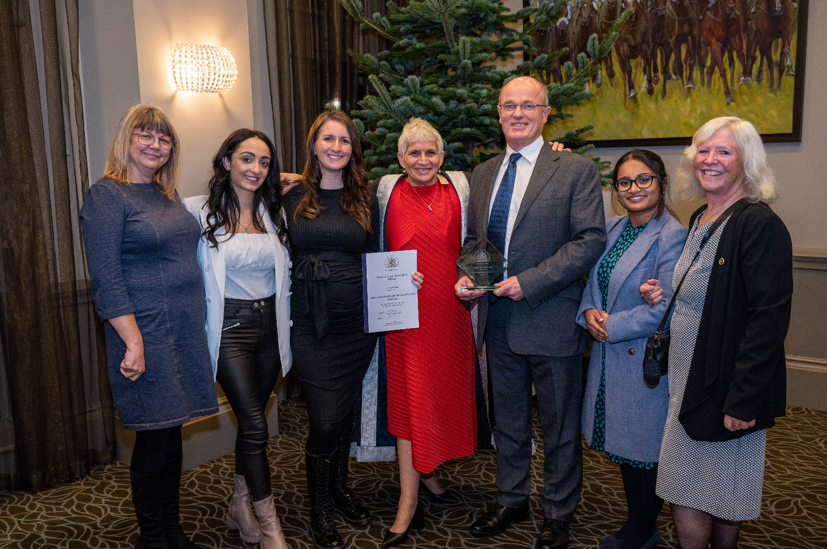
Prize Glass Engraved Plaque, Certificate and £200
Please complete the application form below and email with attached evidence to: eanglia@rcgp.org.uk;
Closing date for entries – Friday 18 August 2023, 12 noon
This award is for the most outstanding contribution to Primary Care service provision or development by a Practice Team in the preceding year.
The Awards process is overseen by a panel of judges made up of members of the RCGP East Anglia Faculty Board, both GPs and lay members. The judges will be looking for evidence such as:
- Commitment to patient care (eg patient feedback, letters, survey results)
- Innovative ideas (eg new services, ways to improve delivery)
- Evidence of team work (eg colleague feedback, successes as a team, which could be a sub-team)
- Details of personal qualities (eg personal statements from colleagues and patients)
- Commitment to work schedule and work colleagues. Commendation by patients and colleagues
- Evidence of work carried out beyond the call of duty

Application Form 2023

Entry Details:

Category of Award PRACTICE TEAM AWARD 2023

Name (team nominated) _______________________________________________

Contact email (team nominated) _______________________________________________

Your name and contact details
Name

Email Address

Telephone Number

Commitment to patient care (please give details below)

Innovative ideas (please give details below)

Evidence of team work (please give details below)

Details of personal qualities (please give details below)

Commitment to work schedule and work colleagues. Commendation by patients and colleagues (please give details below)

Evidence of work carried out beyond the call of duty (please give details below)

General Statement of Support (please give details below)

Please complete the application form and email with evidence to: eanglia@rcgp.org.uk;
Closing date for entries – Friday 18 August 2023, 12 noon

