eRD on system one – How to set-up

(taken from Prescqipp training slides)
https://www.prescqipp.info/learning/skills-webinars/tpp-systmone-gp-clinical-system-training-advanced-skills-repeat-dispensing/

Depending on the way the repeat template is set up depends on how this relates to setting up eRD on that medication

This Template has been set up for Review dates And maximum issues . It is recommended that the review dates are used rather than maximum issues so that the surgery are aware when a patient needs to be booked in for monitoring etc prior to their annual / biannual review of their medication .

- Set up for review date AND maximum issues .
This repeat is set up with both maximum issues and review date
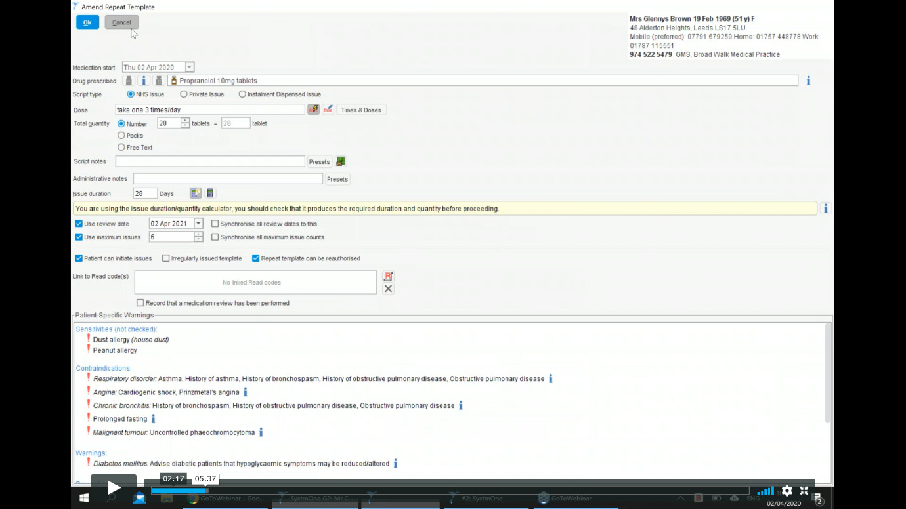
Fig 1 .

- Set up for just review date
Fig 2.
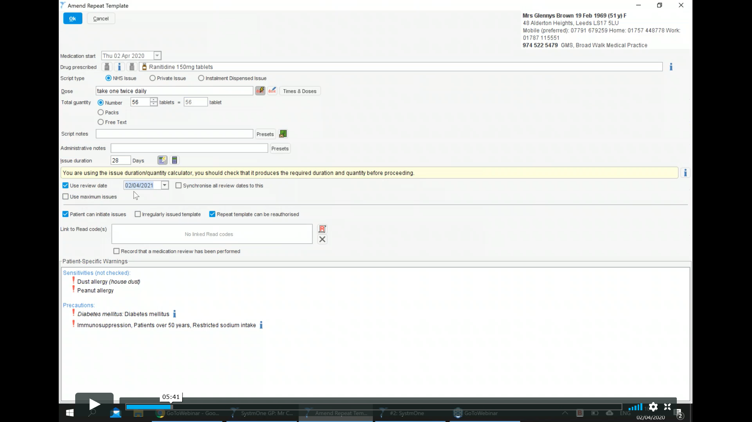
This repeat is set up with just review date
Select medications to issue as repeat dispensing
Green RD button in top menu bar
Fig 3.
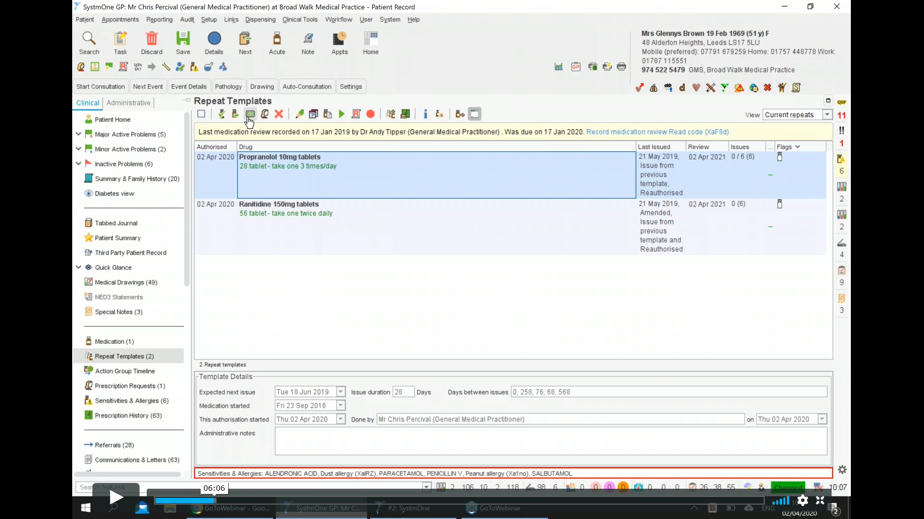
Green RD icon
As it was set up with a maximum number of 6 this message will appear when you select the RD button.
Fig 4 .
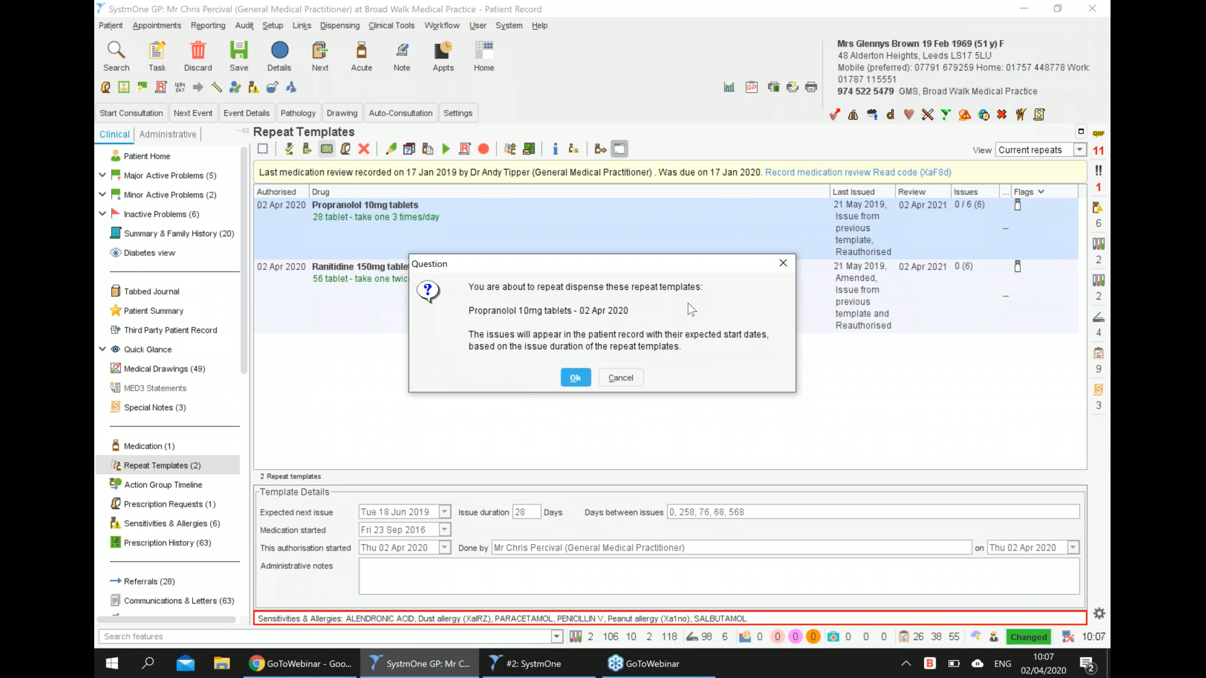
Fig 5.
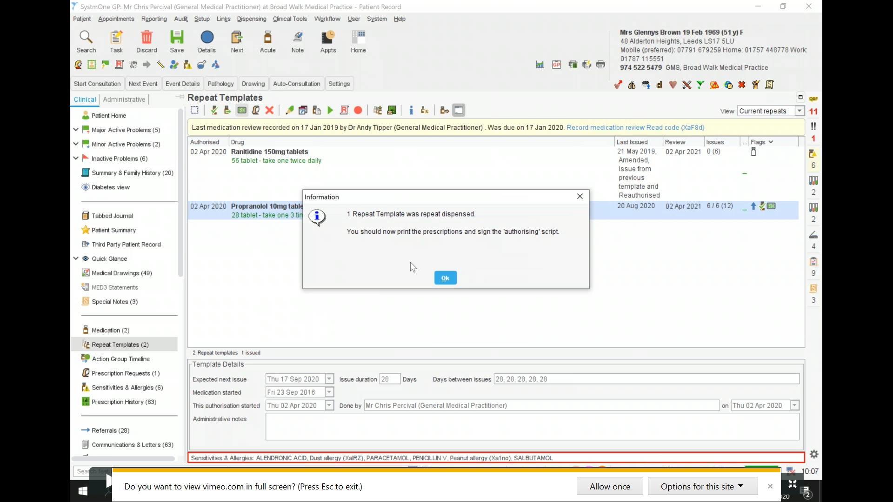
This then creates the scripts 6 as the maximum number of issues is 6

Fig 6.
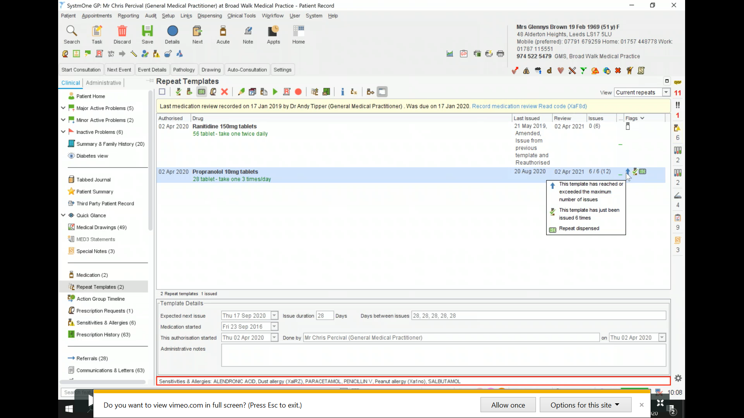
Repeat template now has indication it has reached max issue and eRD script
As you can now see it has taken the number of issues to 6/6 as in Fig 6.
Next to the issues there are a few icons .
- One to state reached max number of issues .
- One to state it has been issued 6 times
- Green RD tab appears to indicate it is a repeat dispensed item .

Fig 7.
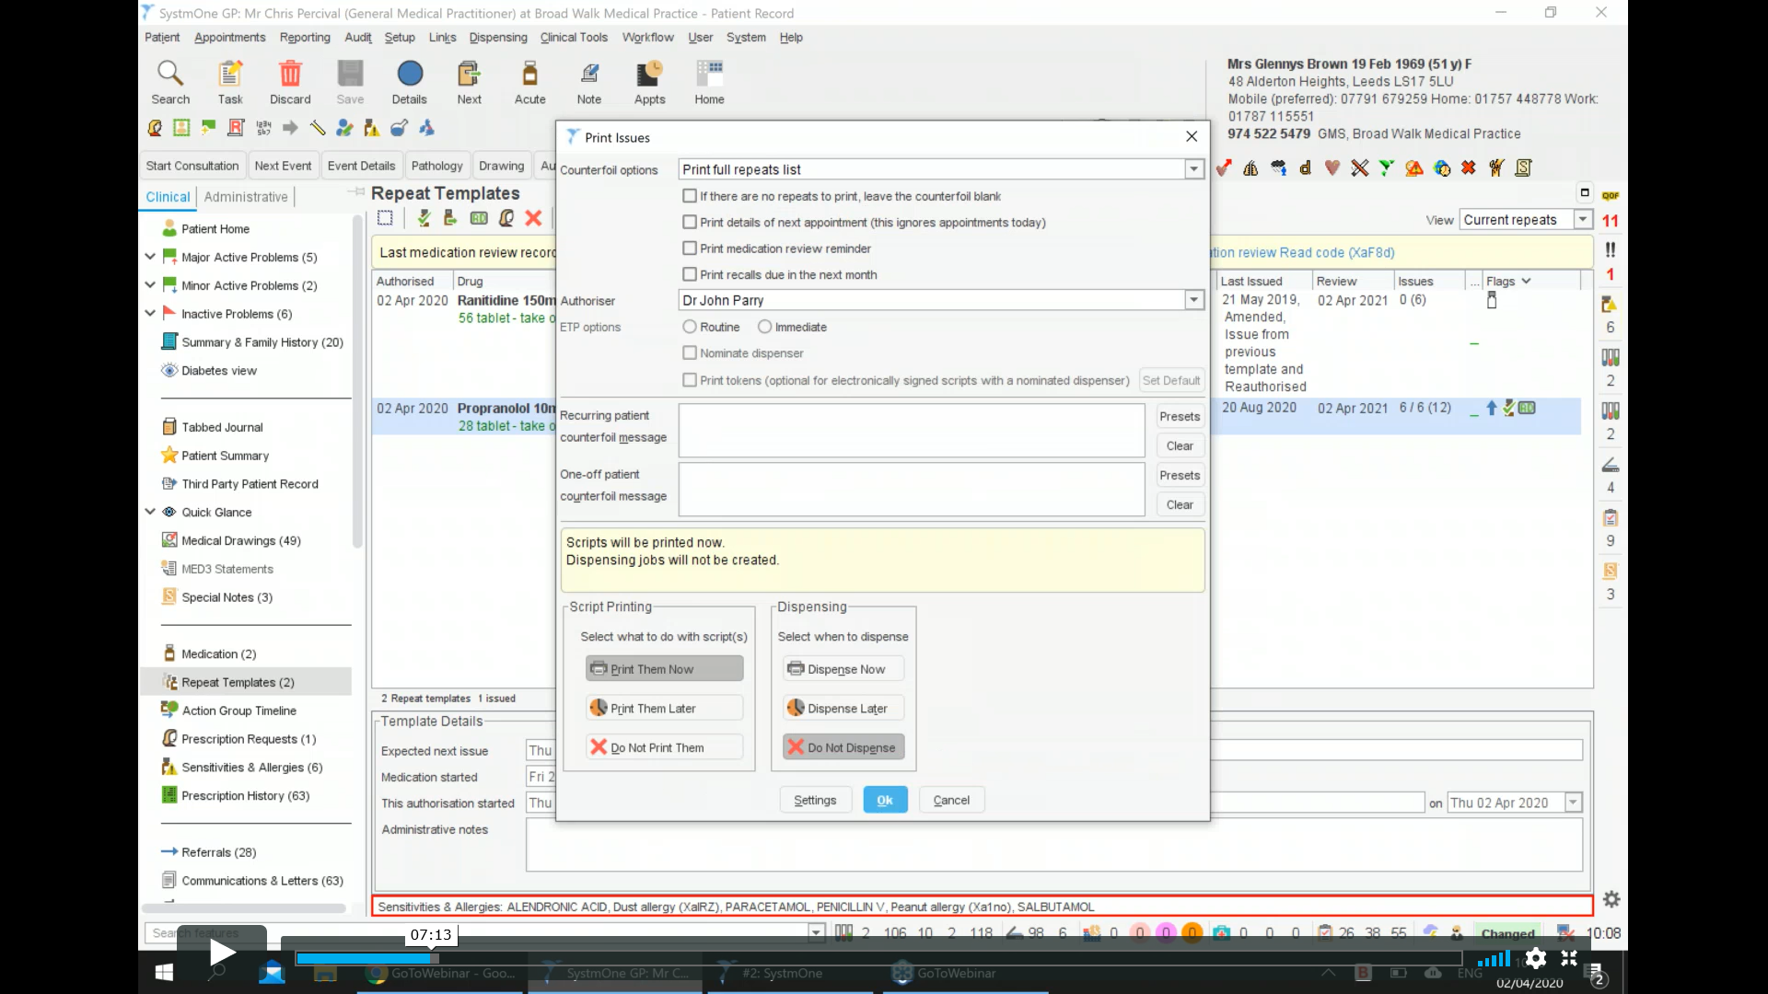
The script is then printed

Fig 8.
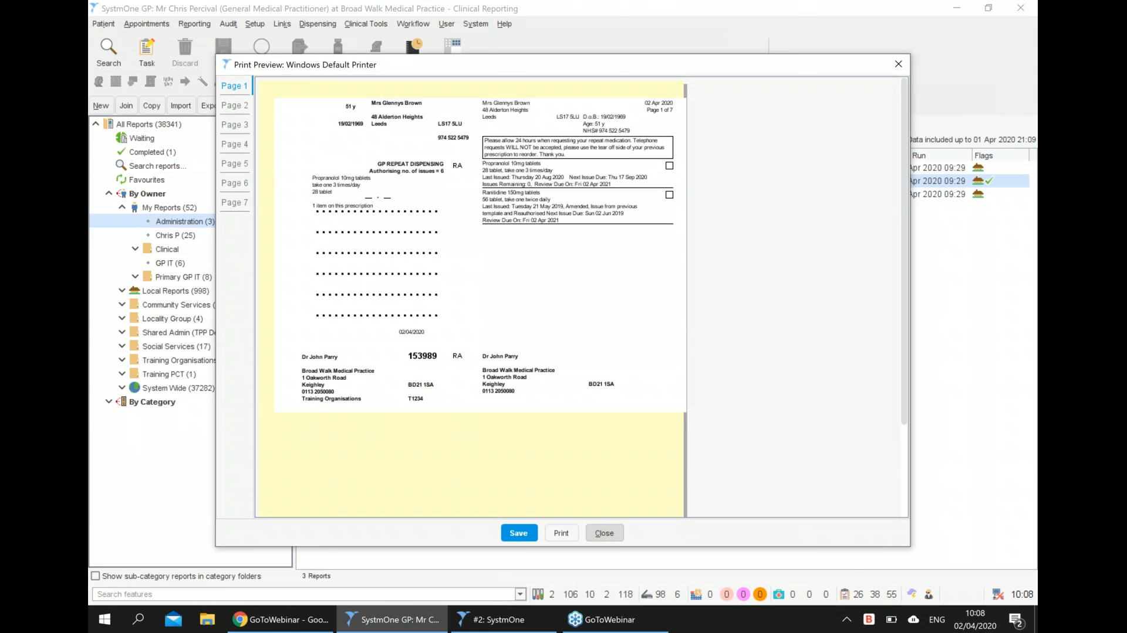
Actual scripts that are to be authorised
States authorised number of issues
This is the main script – contains authorised number of scripts -6 and the page tabs at the side show the actual scripts that are being authorised (original master script and a copy of the 6 repeats )

Fig 9.
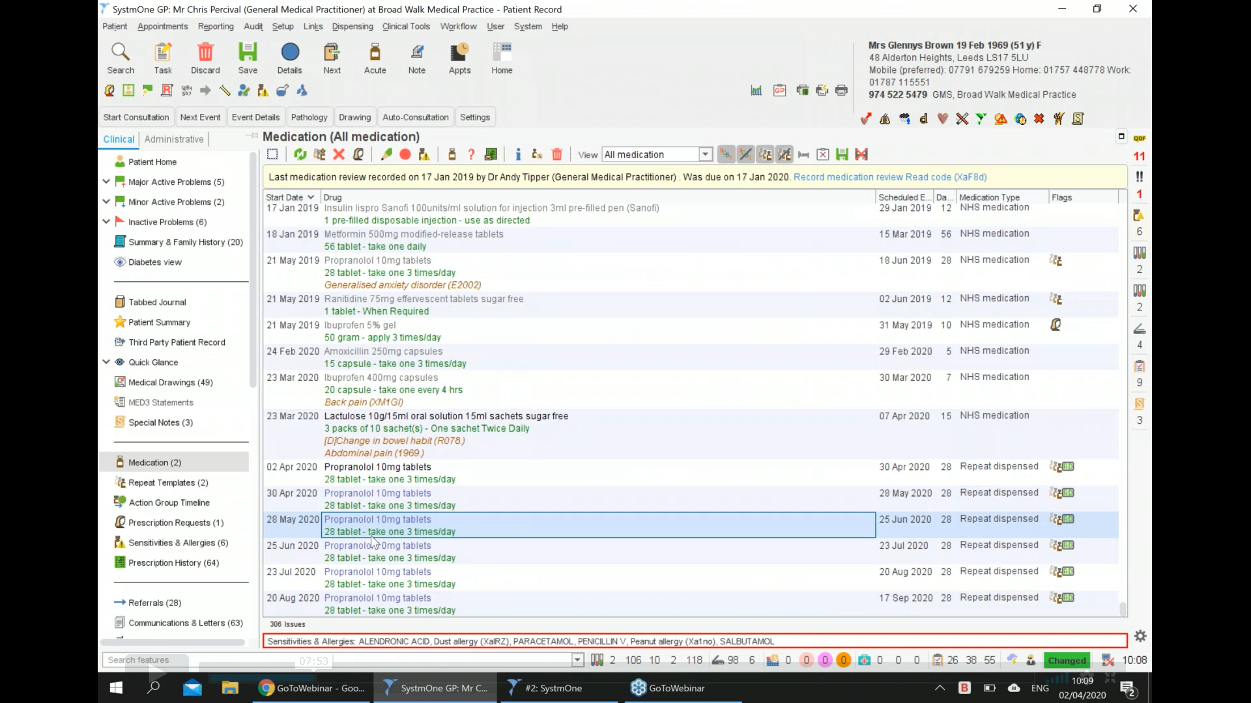
Then under medication tab you can see the 6 issues that have been authorised all listed separately in the medication screen . Each has the repeat template next to it and the RD icon next to it .

FOR ITEMS SET UP FOR REVIEW DATES ONLY :
Select item and click on the RD tab. The box as in Fig 10. will appear.
Fig 10.
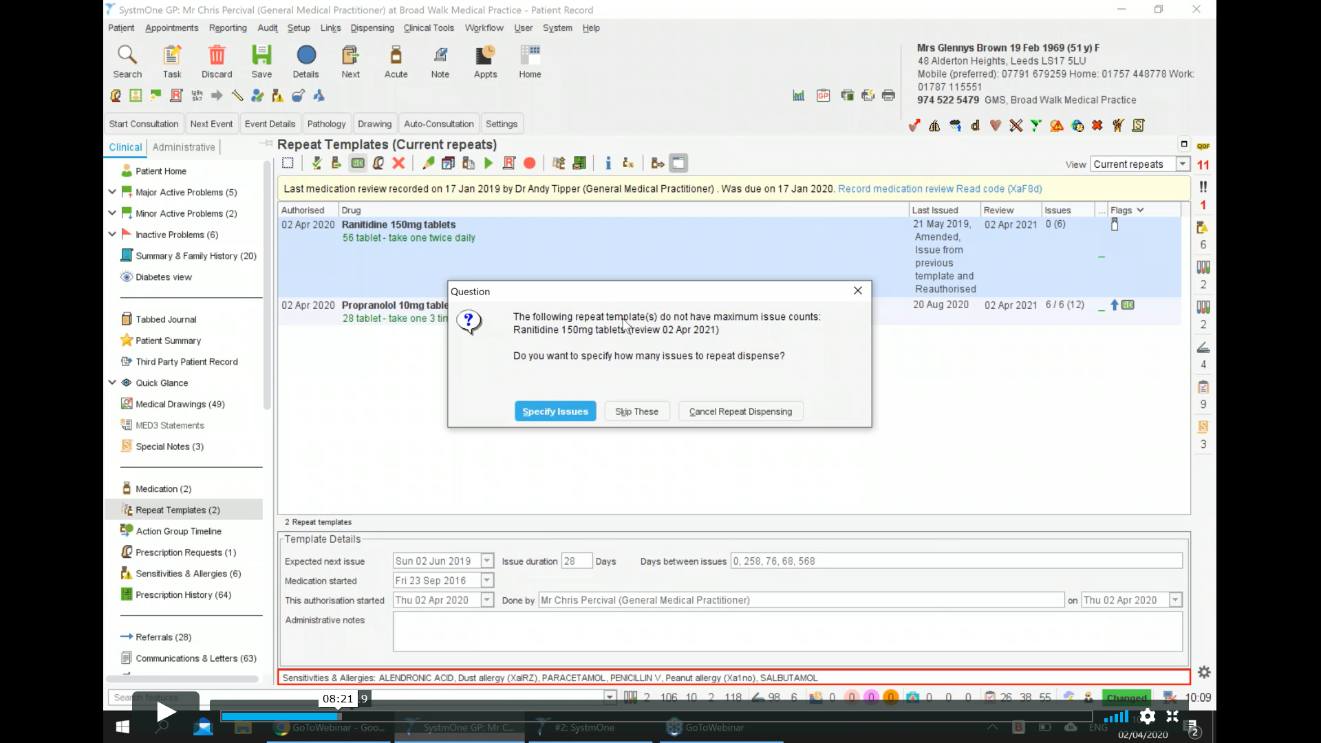
Click on specify issues : This next box will appear (Fig 11.) :
Fig 11.
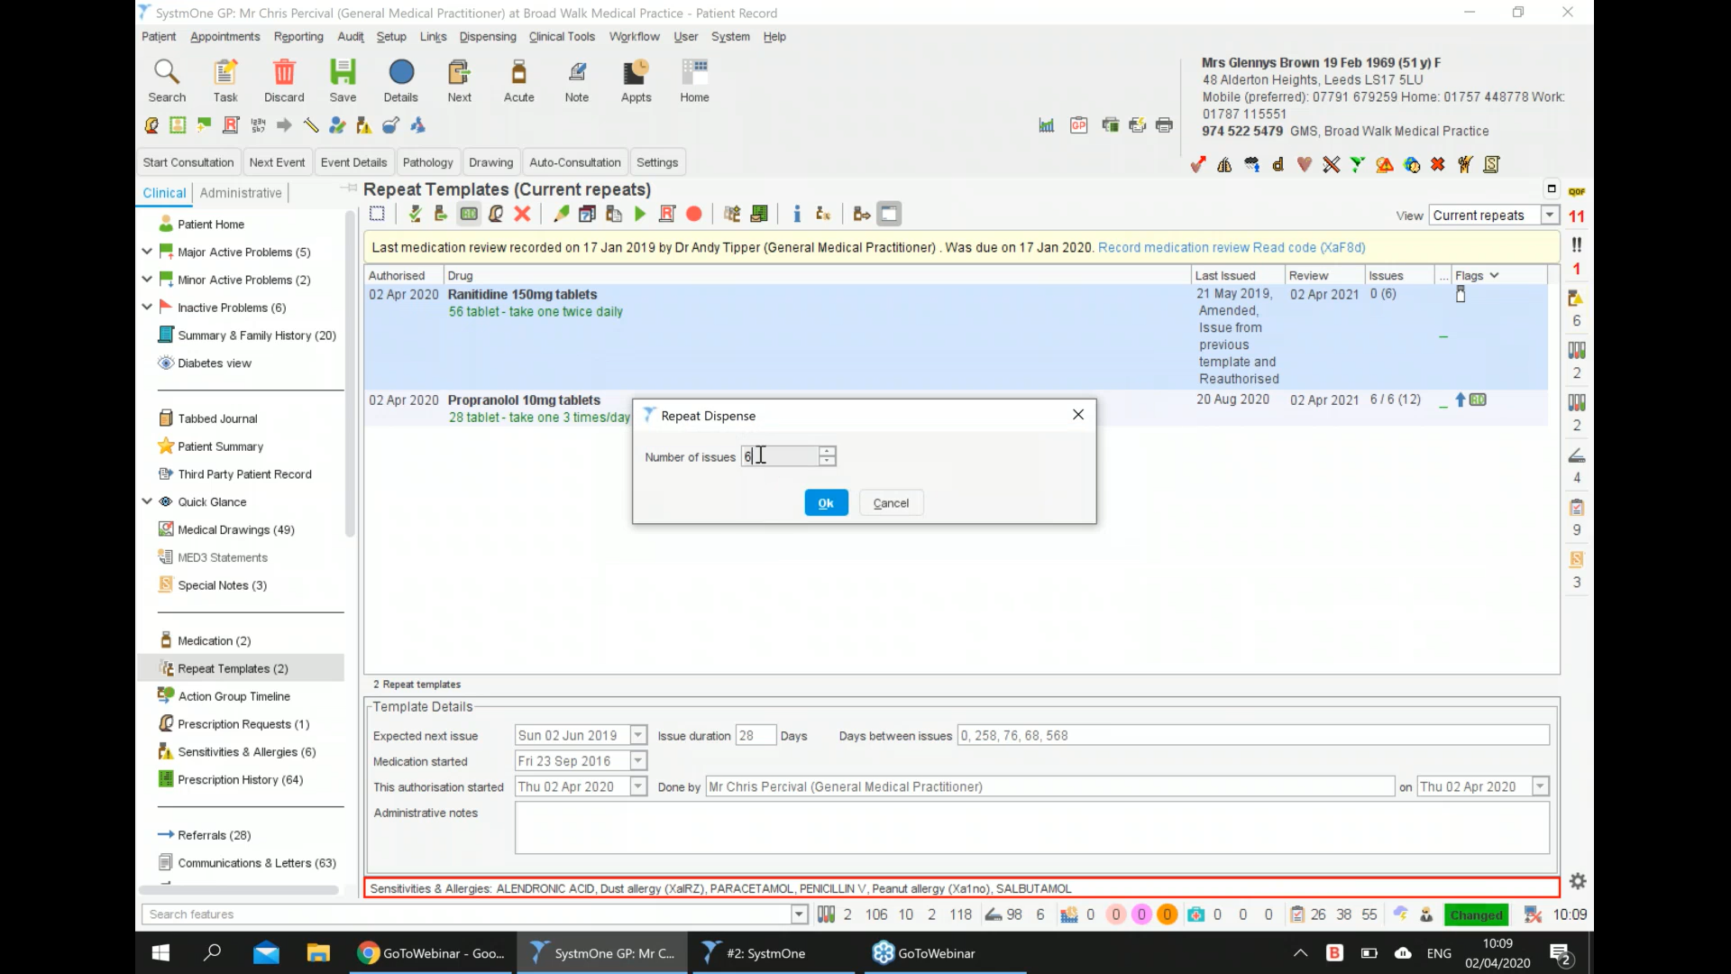
You can then enter the required amount of issues . Up to the review date . If there are not 6 issues between the date you are setting up the template an the review date it will not let you create 6 issues .
Fig 12.
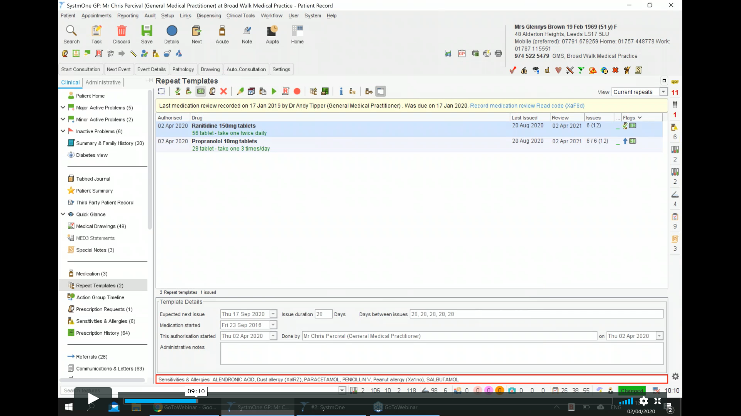
This repeat template has been taken to 6 and as before has the RD tab etc next to it.
Fig 13.
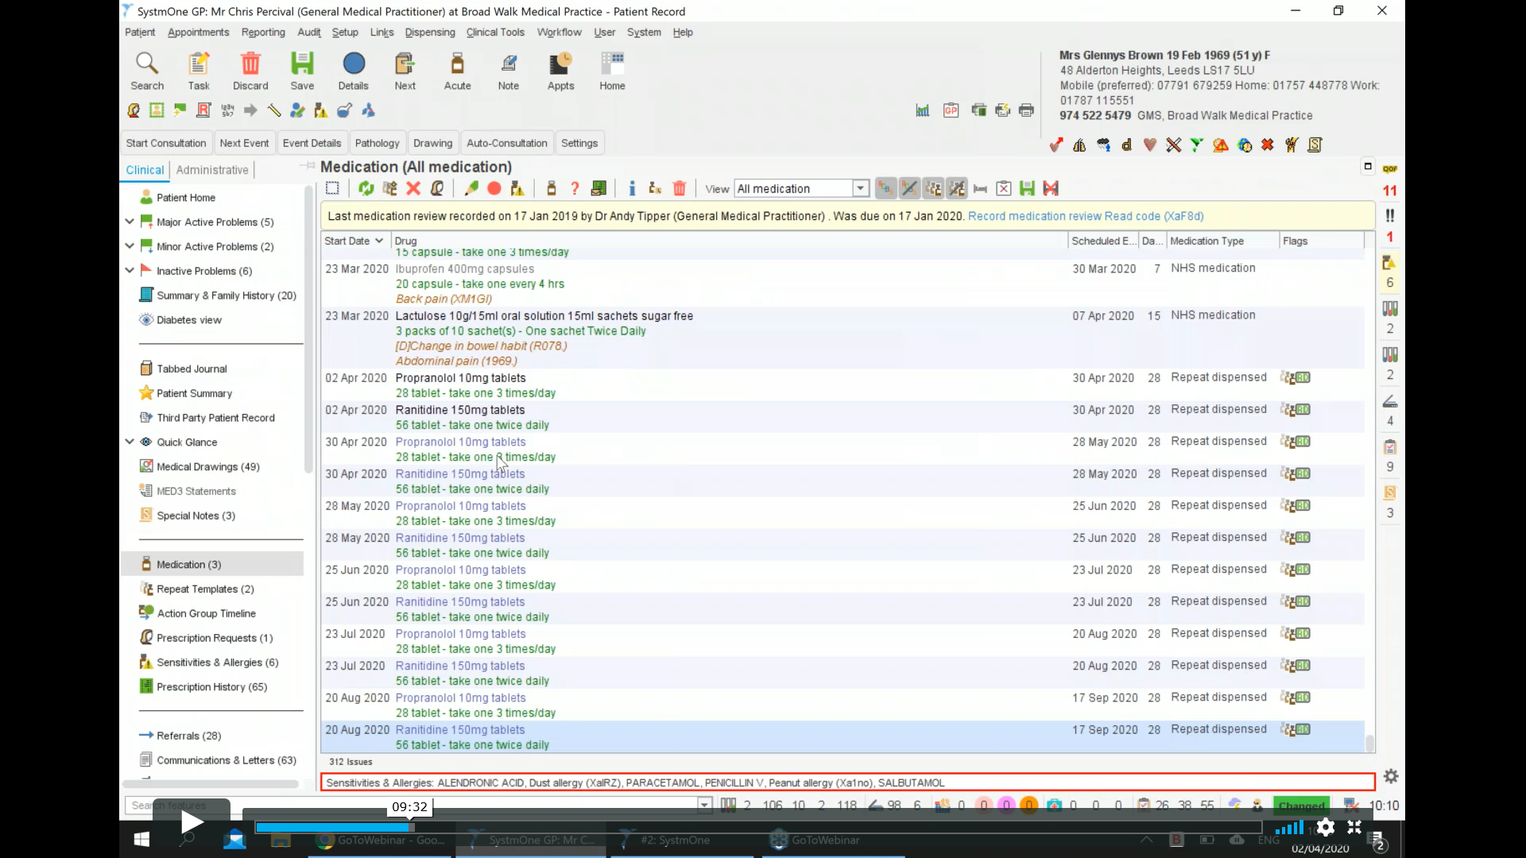
TO CANCEL eRD SCRIPTS
This depends on if you have an electronically transferred prescription or printed scripts

Fig 14.
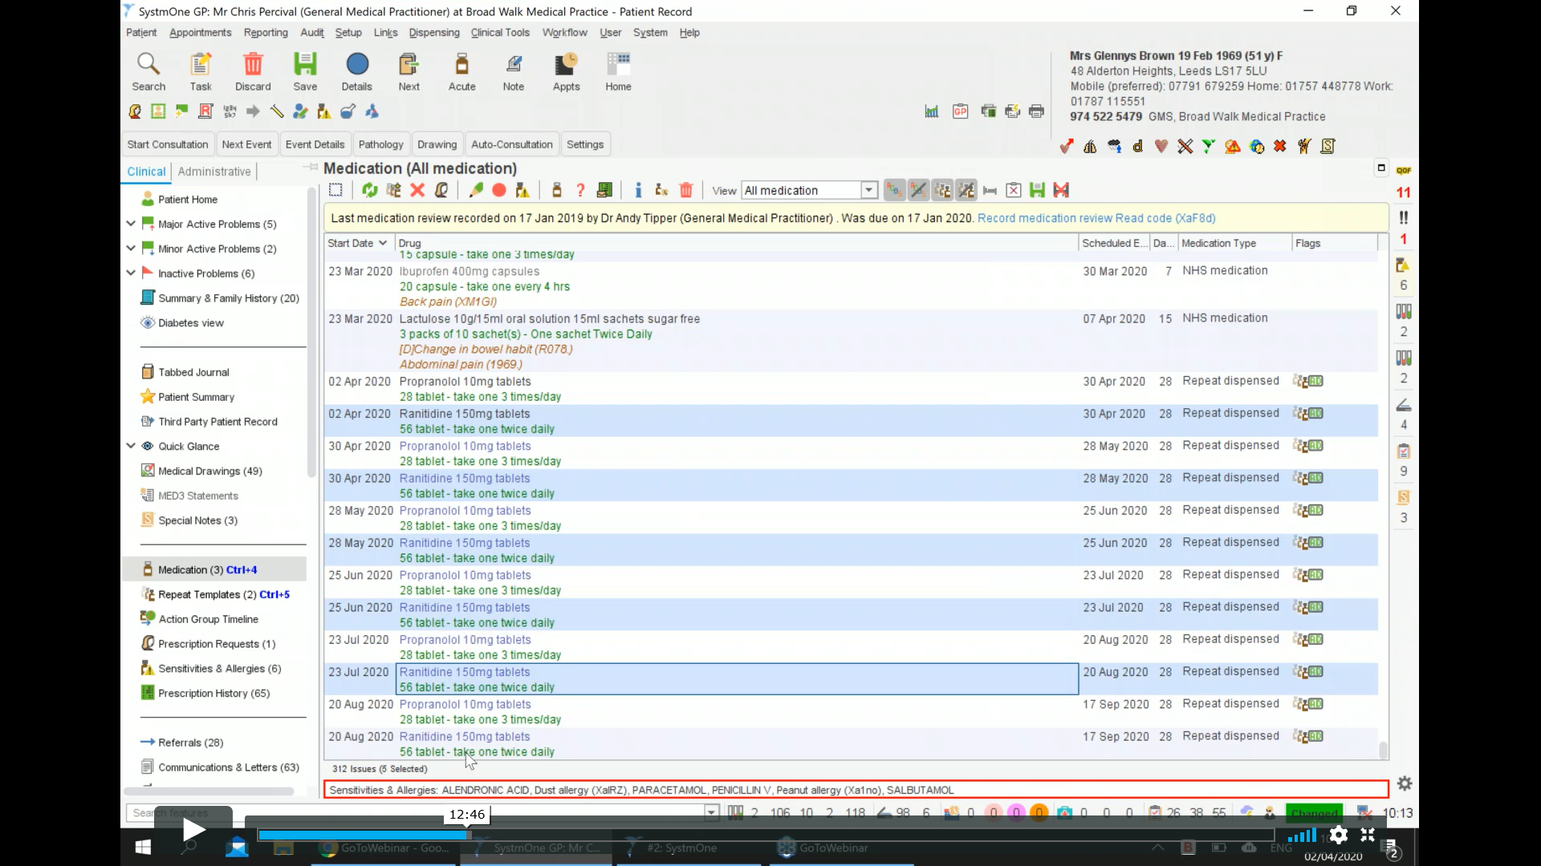
In medication screen . Highlight all of the items that you want to cancel (fig 14)
Fig 15.
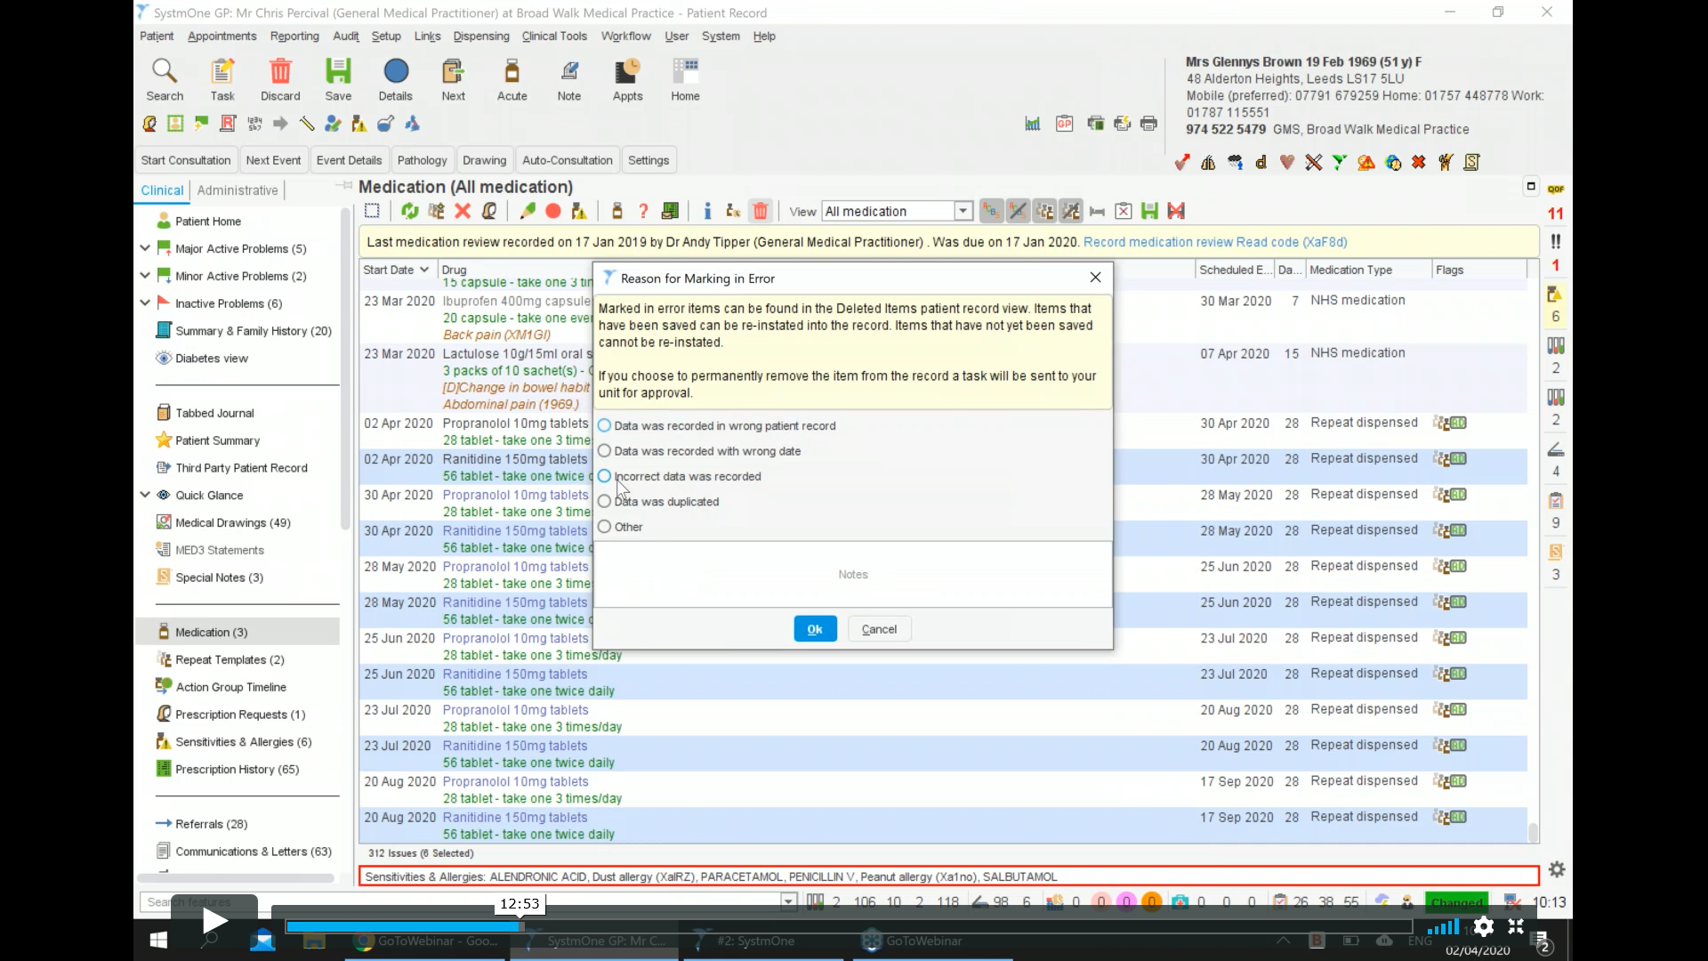
Click on the bin icon at the top of the page and mark in error . Add reason for cancelling medication (fig 15)

Fig 16.
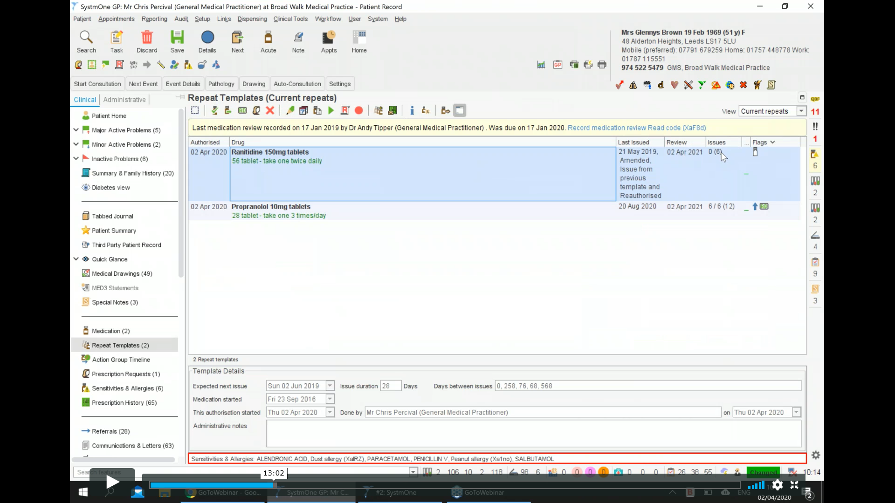
That will the roll back all of the issued items (as you can see the number of issues is now 0 see Fig 16)
FOR ETP :
Fig 17.
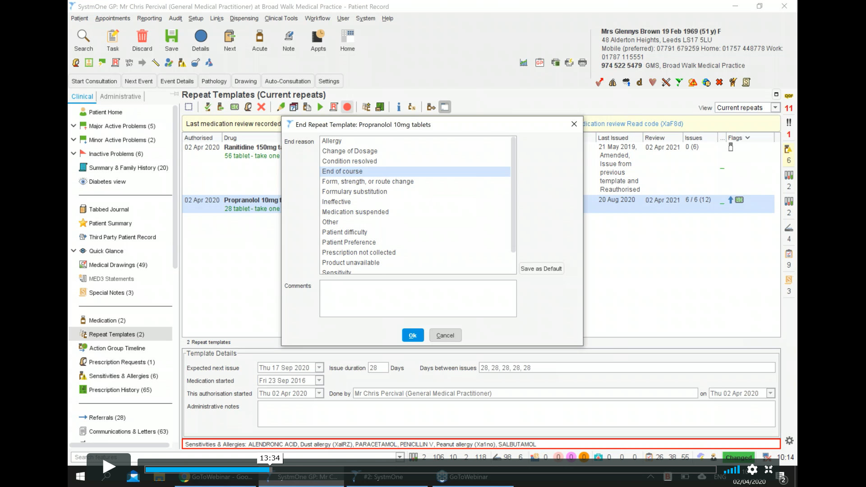
Stop item
State reason for cancelling scripts
Select item and stop it. This then sends a request up to the spine to stop the existing tokens.
Once you click okay a notification will pop up to state the number of issues that are being cancelled
This will then create a task – Electronic prescription cancellation task
It will then let you know if it has been successful or if it has been rejected by the spine as in Fig 18 .
Fig 18 .
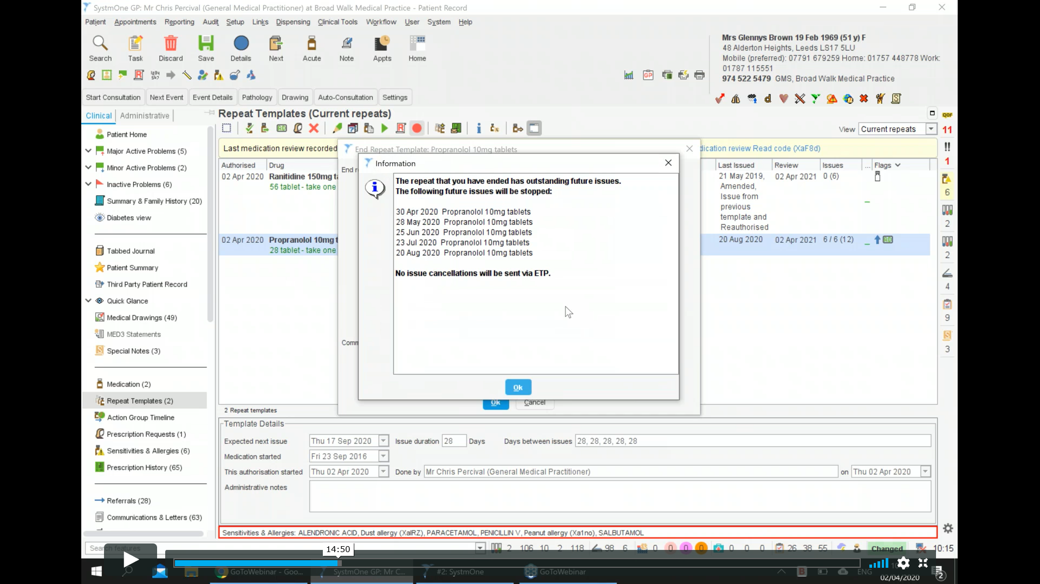
Fig 19.
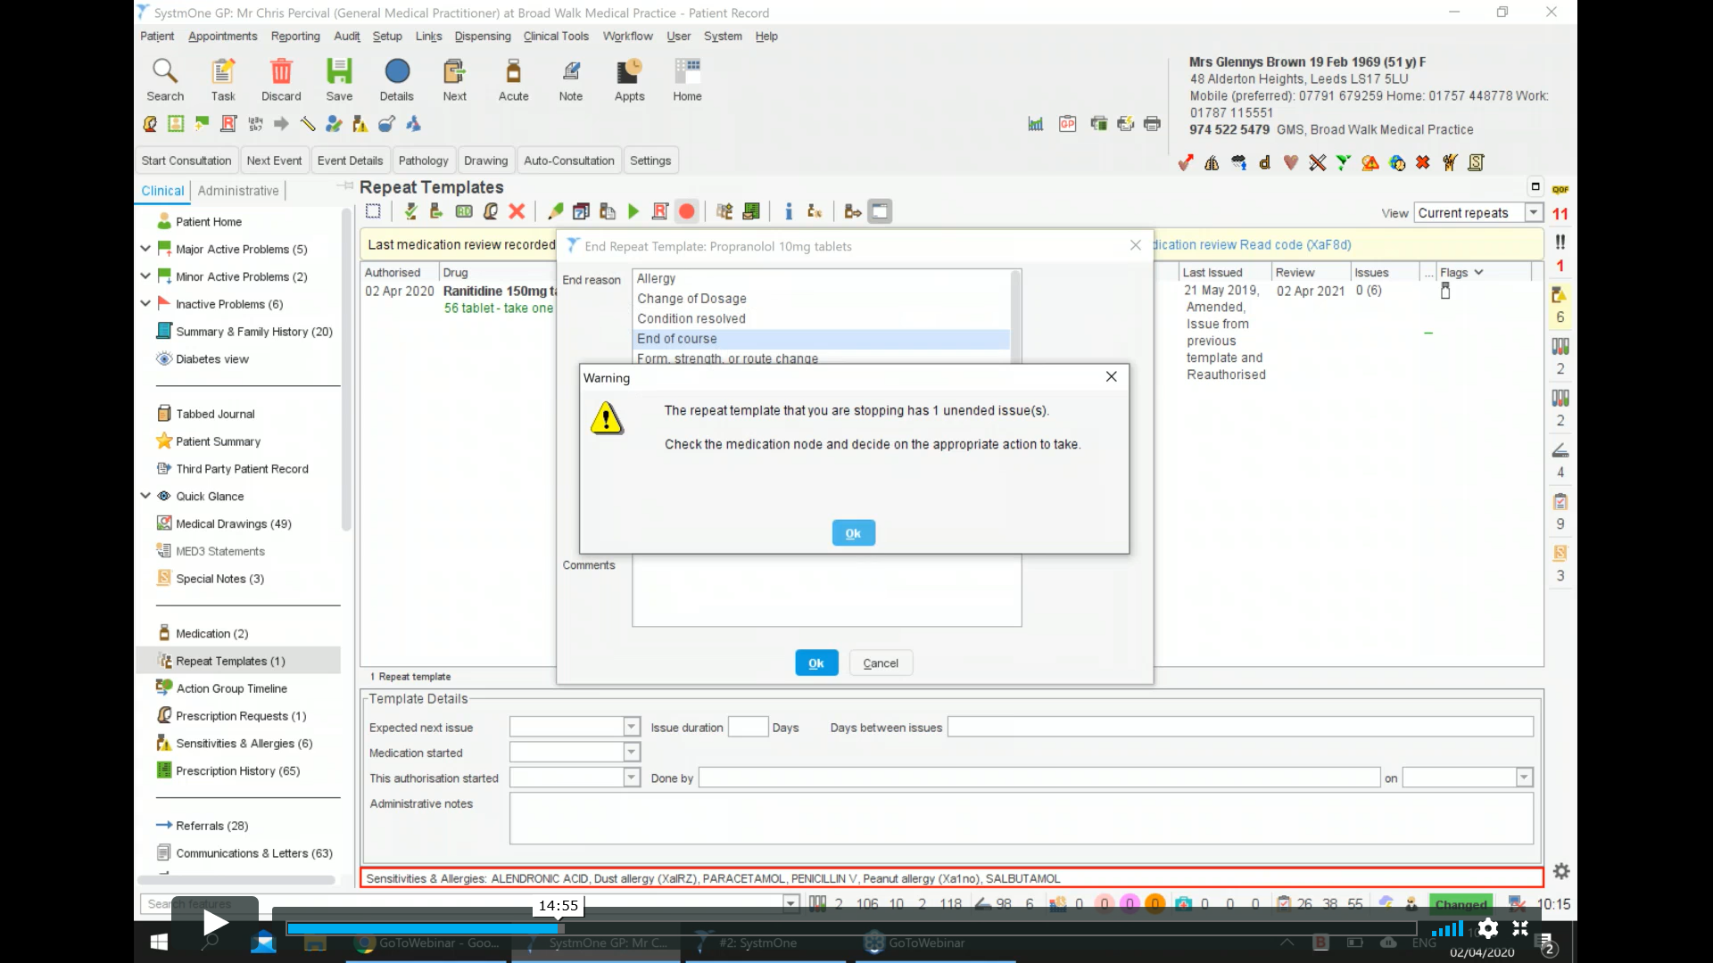

Fig 20.
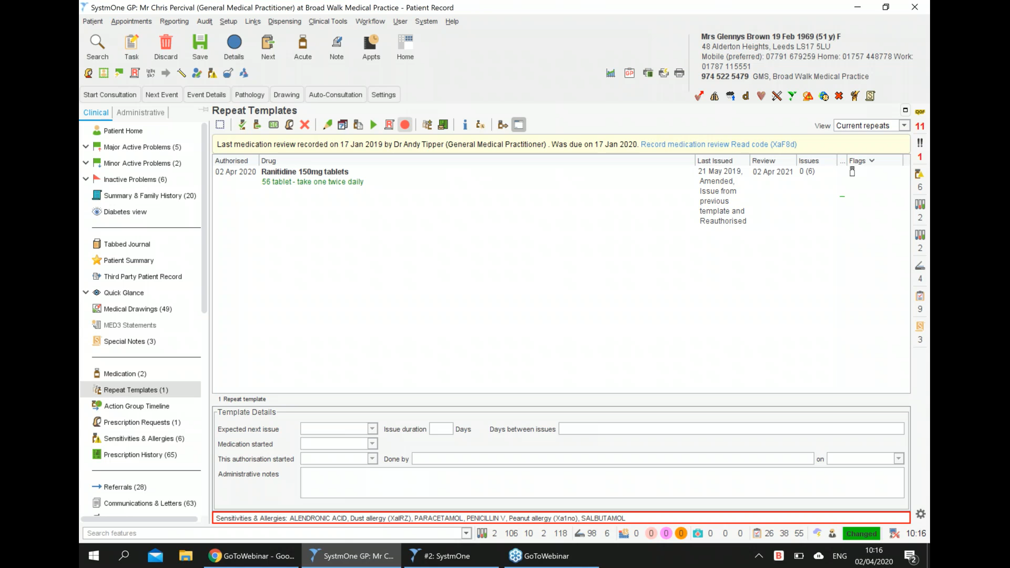
The item is now stopped.
FAQ’s
- Can you print a paper token for the patient ?
as below there is an option when issuing the script – print tokens . If you tick this it will print a paper token for the patient .
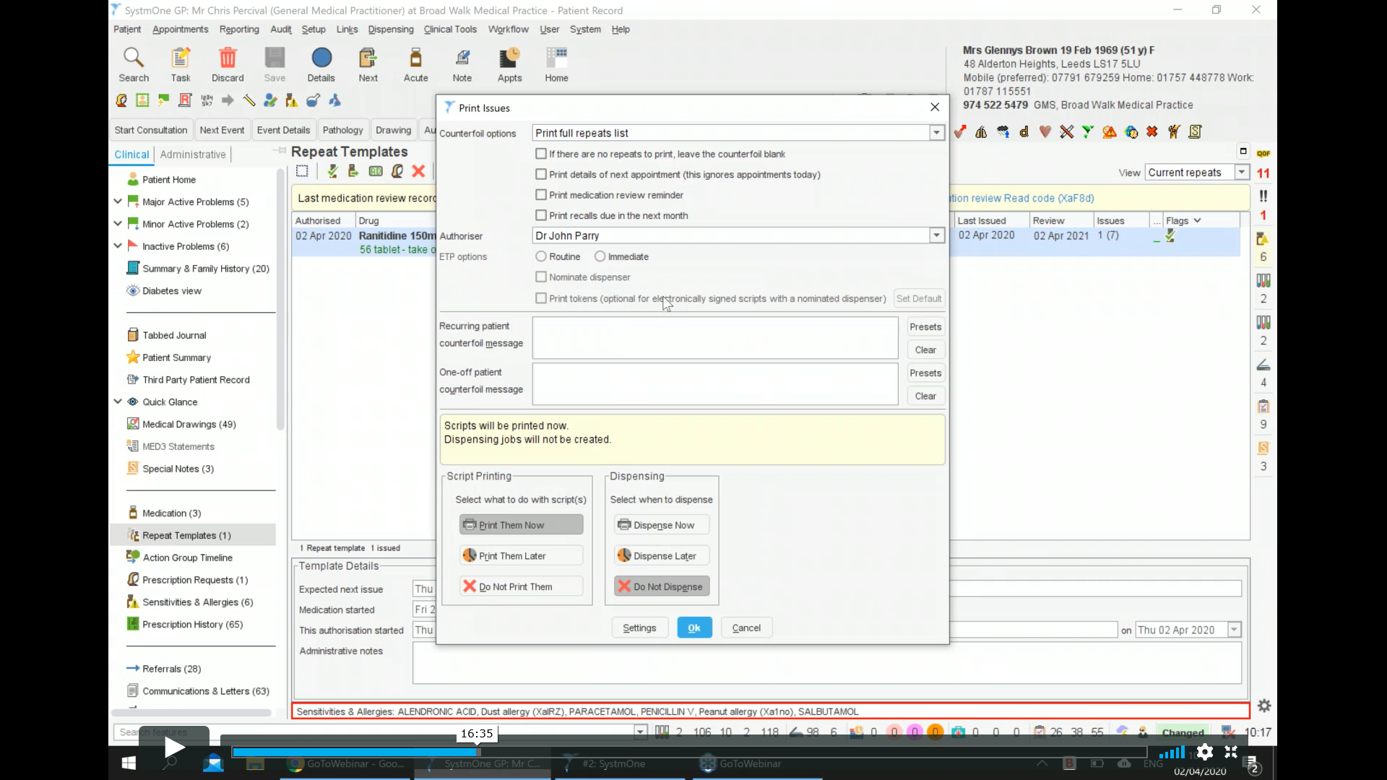
Print Tokens
- Can you future date the initial prescription ?
Yes
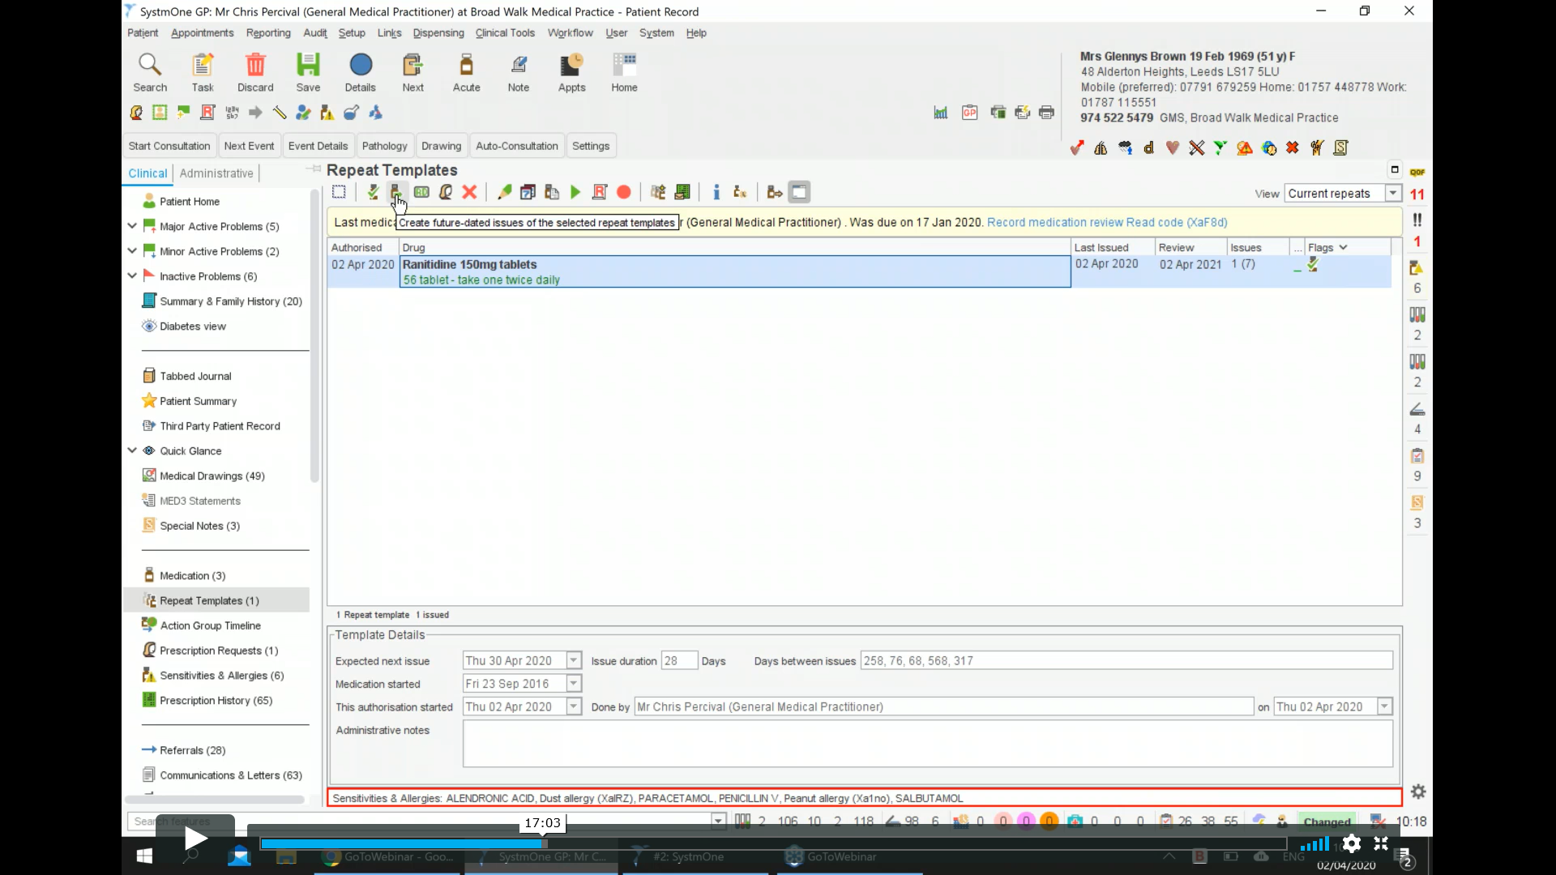
Create future dated repeats
On the top tab – create future dated issues. Click on that and then the calendar comes up for you to select the future dates you want the item to be issued .
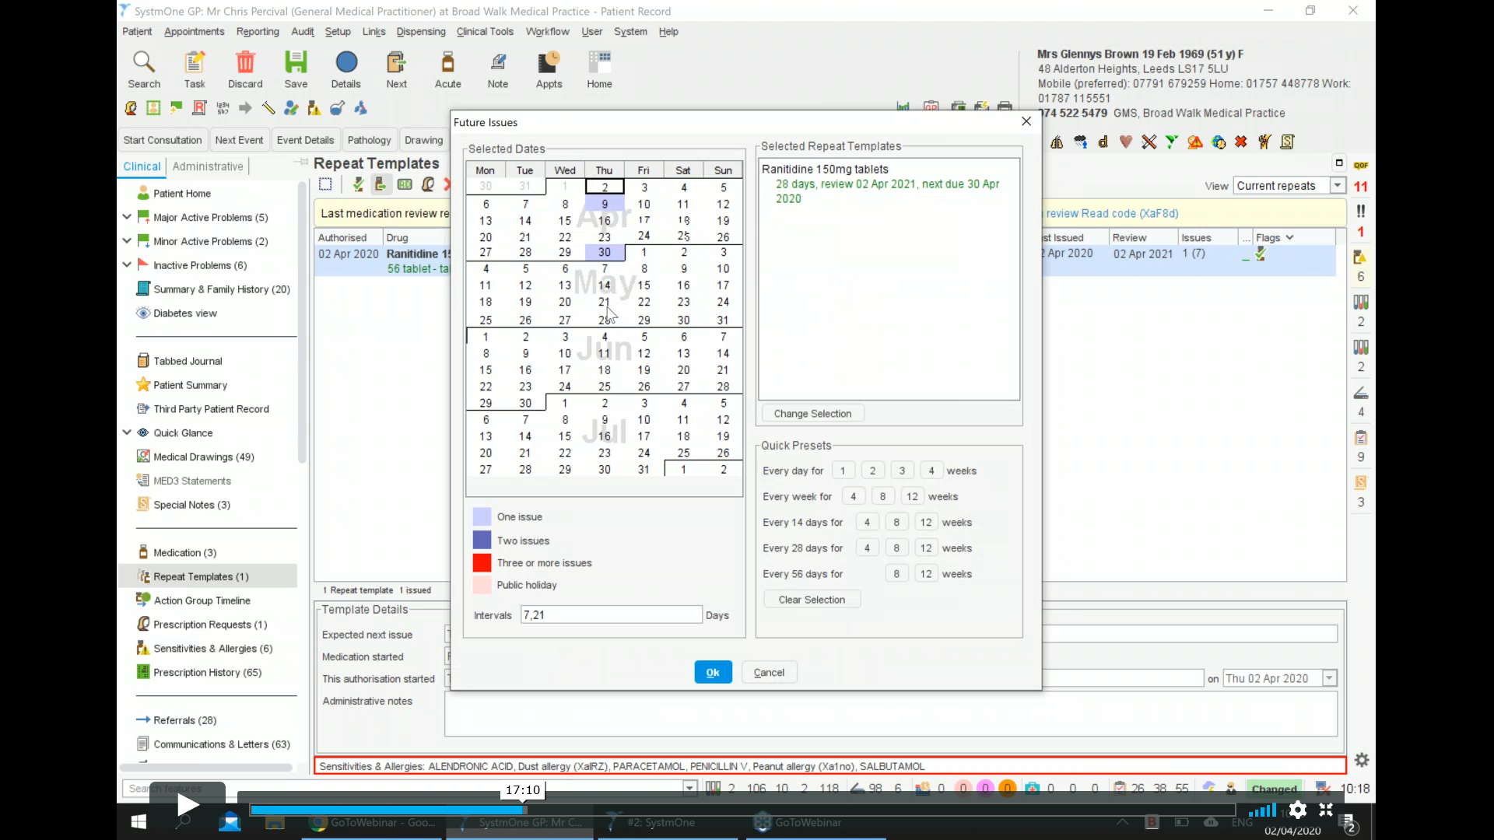
- When would you be unable to cancel a medication from the spine ?
This would normally only happen if it was within the 7 day window and the pharmacy had pulled it down to be dispensed.
- If a medication is changed by the GP ?
The old eRD would need to be cancelled and a new repeat template would need to be set -up ensuring the new repeat template is set up with the same review date as the existing repeat templates. Synchronize review dates / max number of issues.
- Can you set up eRD with a 56 day cycle rather than a 28 day cycle ?
Yes as long as the quantity and duration of the medication is correct. When setting up the eTP it will work out the issues up to the set review date / maximum issues .
- If a repeat template is being added to eRD by a non-prescriber (MOT / Rx clerk etc )
When issuing select – Print later on printing dialogue window. This will then be sent to an eTP signing screen for the GP to sign . (If a repeat template is being added to eRD by a non-prescriber (Medicines Optimisation team member / Prescription clerk etc )” – there is option to add a message so that when GP signs a pop-up appears to state this is MOT in case the GP wants to double check.)
Print later
- Setting up a report to highlight potential eRD patients:
Reporting – Event Counts – Select >? (4) – Repeat Templates – Repeat exists – You can select dates etc to run report.
- Indicating patients have given consent for eRD:
**There is a read code on system one to indicate this (not sure what it is as I am unable to access system one at present)
- Items that will not set up as eRD
Ensure the item is a dmd item . If this is not the case, then amend the repeat template to a dmd alternative of the medication and set up as usual

