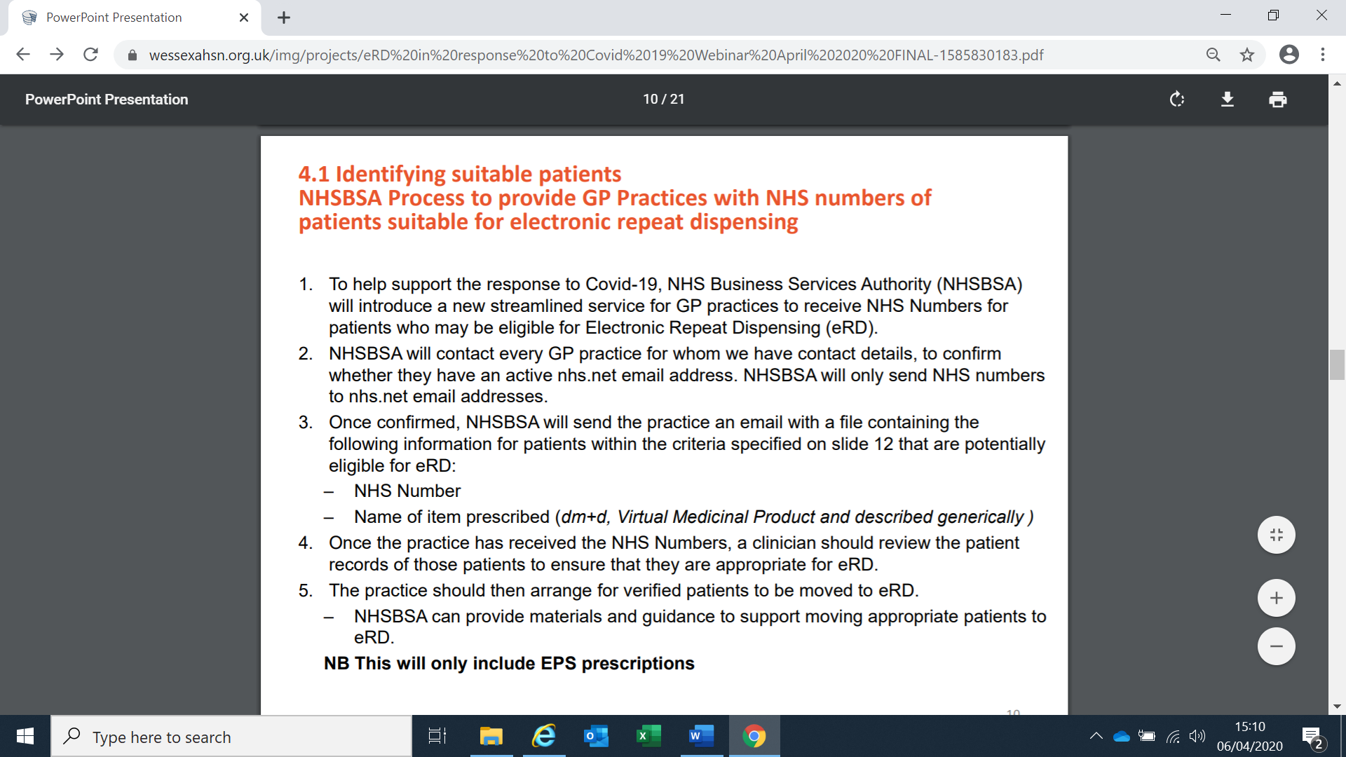

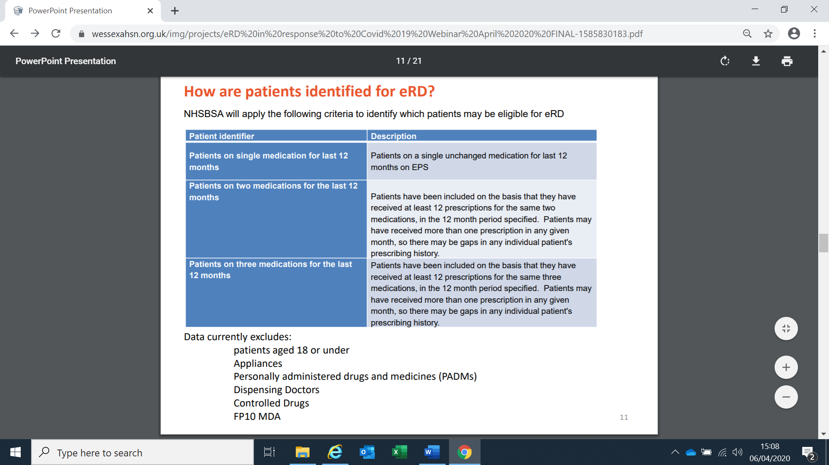

**Patient resources : eRD leaflet**

[https://www.nhsbsa.nhs.uk/sites/default/files/2019-11/eRD%20leaflet%20A5%20%28V3%29%20%28Local%29%2012.2018.pdf](https://www.nhsbsa.nhs.uk/sites/default/files/2019-%2011/eRD%20leaflet%20A5%20%28V3%29%20%28Local%29%2012.2018.pdf)

**Call Crib sheet – call script for staff .**

<https://wessexahsn.org.uk/img/publications/eRD%20Conversation%20Crib%20Sheet%20(NEHF%20CCG)_2020_02_04_02_45_14.pdf>