Aspiring Educator Training

Workbook

East of England

Primary Care School

Aspiring Educators Handbook

Table of Contents

Introduction |  | 7
Tiered Training |  | 8
Aspiring Educator Training Overview |  | 8
Step 1 - NHSE (All Tiers) |  | 10
Steps 2 & 3 - Educational Theory (All Tiers excluding those with
PGCertMedEd) |  | 22
1. | Educational Theory | 22
2. | Assessment | 24
3. | Reflection | 28
4. | Learner needs and learner safety. | 30
5. | Learning Styles | 33
6. | Peer to peer learning | 39
7. | Effective Feedback & Having Difficult Conversations | 41
Step 4 & 5 – School Specific Content (Primary Care School Educator
Specific Content) |  | 46
Preparation for Face-to-Face Learning |  | 47
Differential Attainment (All Tiers) |  | 47
Consultation Observation Tool (COT) (All Tiers) |  | 55
Audio-COTs (All Tiers) |  | 58
Clinical Examination and Procedural Skills (CEPS) (All Tiers) |  | 61
Urgent and Unscheduled Care (UUC) (All Tiers) |  | 63
Induction (All Tiers) |  | 65
Wider Workforce (Tiers 2B and 3) |  | 66
Case Based Discussion (CBD)/Care Assessment Tool (CAT) (Tier 2B
and 3) |  | 66
Copyright © 2023 NHS England |  | 2

Aspiring Educators Handbook

Reflective Log Entries (Tier 2B and 3) | 75
Clinical Supervisors Report (CSR) (Tier 2B and 3) | 79
Applied Knowledge Test (AKT) (Tier 2B and 3) | 80
Simulated Consultation Assessment (SCA) (Tier 3) | 81
Prescribing Assessment (Tier 3) | 82
Educator Notes (Tier 3) | 82
Educational Supervisors Review (ESR) (Tier 3) | 83
Understanding the Annual Review of Competency Progression (ARCP)
Process (Tier 3) | 84

Plenary Session including Suggested Personal Development Plan (PDP)

(All tiers) |  | 87
Face-to-Face Resources and Reflection |  | 89
1. | COTs, Audio-COTs and CEPS (All Tiers) | 89
2. | Urgent and Unscheduled Care (All Tiers) | 89
3. | Case Based Discussion / Care Assessment Tool (Tiers 2B/3) | 90
4. | Consulting and Feedback Exercise (Tiers 2B/3) | 90
5. | Reflective Learning Log (Tiers 2B/3) | 91
6. | Clinical Supervisors Report (Tiers 2B/3) | 92
7. | Applied Knowledge Test and Recorded Consultation Assessment
Plenary (Tiers 2B/3) |  | 92
8. | Educational Supervisors Review (Tier 3) | 93
9. | Annual Review of Competency Progression (ARCP) Panels (Tier 3) 93
10. Agreed PDP (All Tiers) |  | 99
CONGRATULATIONS |  | 100
Appendix 1 – List of Abbreviations |  | 101
Appendix 2 – Ongoing Quality Monitoring |  | 104
Appendix 3 – List of Training Hub Contacts |  | 105
Appendix 4 – Patient Encounter Scenarios |  | 106
Copyright © 2023 NHS England |  | 3

Aspiring Educators Handbook

Case 1 106

Case 2 107

Case 3 108

Case 4 109

Appendix 5 – CSR Cases 112

Case 1 112

Professionalism 112

Communication 112

Working with colleagues and in teams 112

Clinical Assessment 113

Management of Patients 113

Clinical record keeping 113

Context of Care 113

Case 2 114

Professionalism 114

Communication 114

Working with colleagues and in teams 115

Clinical Assessment 115

Management of Patients 115

Clinical record keeping 115

Context of Care 116

Case 3 116

Professionalism 116

Communication 116

Working with colleagues and in teams 117

Clinical Assessment 117

Management of Patients 117

Clinical record keeping 118

Context of Care 118

Case 4 118

Professionalism 119

Copyright © 2023 NHS England 4

Aspiring Educators Handbook

Communication 119

Working with colleagues and in teams 119

Clinical Assessment 120

Management of Patients 120

Clinical record keeping 120

Context of Care 121

Appendix 6 – Charlotte and Blank CSR 122

Professionalism 123

Communication 123

Working with colleagues and in teams 123

Clinical Assessment 123

Management of Patients 124

Clinical record keeping 124

Context of Care 124

Appendix 7 – ESR Preparation 125

Communication and consultation skills 125

Indicators of Potential Underperformance 126

COT – Dizziness NFD - ME for all PCs 127

CCR – Type 2 Diabetes 127

COT – Anxiety 128

COT – Congested Child 128

CCR – Genital Herpes 129

COT – Child with Persistent Cough 129

COT – Young Lady with Breathlessness 129

Learning Event Analysis – 2WW Referral not Sent 130

Audio-COT – Medication Review and USS Result 130

Practising holistically, promoting health and safeguarding 130

Indicators of Potential Underperformance 132

COT – Dizziness NFD - ME for all PCs 132

CCR – Palliative MDT 133

Copyright © 2023 NHS England 5

Aspiring Educators Handbook

CCR – Type 2 Diabetes 133

COT – Anxiety 133

COT – Congested Child 133

CAT – To Admit or not to Admit 134

COT – Child with Persistent Cough 134

COT – Young Lady with Breathlessness 134

COT – HRT 135

Audio-COT – Medication Review and USS Result 135

CCR – Safeguarding – Suspected Opioid Dependence 135

Copyright © 2023 NHS England | 6

Aspiring Educators Handbook

Introduction

Welcome to the start of your journey towards becoming an educator within the East of England. We are glad to have you onboard and look forward to working with you over the coming years.

This workbook has been designed with three purposes in mind. Firstly, it provides information on the aspiring educator training, which modules you need to complete and preparatory work for some of the sessions. Secondly, it acts as a repository for your learning; a resource that you may refer to in future. Thirdly, it provides us with assurances that you have completed the required training necessary to become an educator within the East of England.

Please note that this workbook will not be formally assessed but will be utilised in the sessions that you attend, and you may be required to discuss some of the content within. Once you have completed the training you will be recognised as an educator within the East of England. There will be no requirements for you to complete an application form or have an interview at the end of the training. However, if the facilitators have concerns that you have not engaged fully with the training package then you may be referred to the local training hub quality lead who will arrange an interview with a senior educator to discuss your suitability for the role.

It is important that you maintain your capabilities as an educator following this initial training and can provide evidence of this should this be required.

Where you see this icon throughout the workbook, you will be encouraged to think about your own experience – please come to the face-to face sessions with examples that you can share in the group discussions. You will also find ‘free-text’ boxes where you can record your thoughts or questions in preparation for the face-to-face sessions and group work.

Copyright © 2023 NHS England | 7

Aspiring Educators Handbook

Tiered Training

Being a primary care educator is both rewarding and stimulating. The Tiered system ensures that you can be recognised for different levels of educator responsibilities and educated and supported to the gain and maintain the right skills and competences for the role you choose.

The following link https://heeoe.hee.nhs.uk/general_practice/applying-approval-gp-educator provides greater detail about the Tiered approach and the process involved in seeking recognition as a:

- Tier 2a Educator: An out-of-hours (OOH) supervisor, also known as a Clinical Supervisor (CS)

- Tier 2b Educator: An associate trainer (AT), also known as a named Clinical Supervisor (CS)
- Tier 3 Educator: A trainer, also known as an Educational Supervisor (ES).

Aspiring Educator Training Overview

It is intended that the aspiring educator training be completed in a single block and within 12 months of commencement. The training utilises a blended approach of:

- self-directed learning via the completion of this handbook

- virtual learning

- face-to-face learning

it is important that you complete all sections relevant to the tier you aspire to be i.e. Tier 2a, Tier 2b or Tier 3 in order to be recognised as a Tiered Educator.

It is anticipated that this handbook will be completed in advance of any face-to-face sessions you are due to attend.

The training is divided into the 5 steps outlined on the next page.

Copyright © 2023 NHS England | 8

Aspiring Educators Handbook

Copyright © 2023 NHS England | 9

Aspiring Educators Handbook

Step 1 – NHSE Hub Videos (All Tiers)

This stage of your learning process is to build on your knowledge foundation and to explore the theory of education.

This workbook will provide you will pre-reading and links to additional educational materials that will prepare you for the face-to-face taught sessions where you will be able to practice putting your knowledge into practice.

You will need to complete the NHSE Hub content which are virtual sessions available via this link

https://heeoe.cloud.panopto.eu/Panopto/Pages/Sessions/List.aspx#folderID=%2286d4218d-820f-48df-a362-abbf012093d3%22

Please complete these prior to attending the face-to-face sessions.

In total there are eight videos to watch that cover the following areas:

- Induction and Educational Contract

- Study Leave Refresher Training

- Professional Support and Well-being Service

- Learners in Difficulty

- Supported Return to Training

- Educational Supervisor Reports (3 videos)

Induction and Educational Contract

Please follow the link below to access the online video for this content.

https://heeoe.cloud.panopto.eu/Panopto/Pages/Viewer.aspx?id=b19a9037-0888-41e3-9e14-abec00d44ad6

During this video there are opportunities for you to pause and think about your approach to specific situations. Please use the boxes below to record your thoughts when asked to pause the video.

Scenario 1

Copyright © 2023 NHS England | 10

Aspiring Educators Handbook

A foundation year 1 doctor with a history of mental health problems that have been shared with yourself as the educational supervisor. The doctor has performed well throughout their previous assessments.

Free-Text Box

Scenario 2

A foundation year 2 doctor who is making excellent progress and wishes to pursue a career in orthopaedics wishes for you as their educational supervisor to sign off study leave requests for ATLS, BASIC surgical skills course and to present a poster at an overseas orthopaedic meeting in Prague.

Free-Text Box

Copyright © 2023 NHS England | 11

Aspiring Educators Handbook

Scenario3

An anaesthetic learner returns to specialist training following a 2-year gap after their core training.

Free-Text Box

Scenario 4

You are the educational supervisor for a core trainee in medicine entering an IMT post in August. They have requested annual leave of 3 weeks to get married over the Christmas period, when they would be undertaking their ITU post, and dedicated clinic time has been arranged for IMTs.

Free-Text Box

Copyright © 2023 NHS England | 12

Aspiring Educators Handbook

Study Leave Refresher Training

Please follow the link below to access the online video for this content.

https://heeoe.cloud.panopto.eu/Panopto/Pages/Viewer.aspx?id=e96f3442-bbe1-4db2-8eb6-abf000e96b97

During the latter part of this presentation there is a quiz regarding the approval of study leave. Please use the boxes below to record whether you would approve the request or not and your reasoning. You should aim to do this without waiting for the answers to be revealed.

- A respiratory trainee submits a study leave claim for £20.55 travel expenses after attending an ARCP panel, which was 2 months earlier.

Free-Text Box

- A learner submits a study leave application for an MSc.

Free-Text Box

3. A learner submits an application for PACES for £1495.

Copyright © 2023 NHS England | 13

Aspiring Educators Handbook

Free-Text Box

- A learner submits a claim for a conference that they attended in Madrid and was approved by their training programme director.

Free-Text Box

5. A learner submits a claim for travel expenses for an exam they attended.

Free-Text Box

Copyright © 2023 NHS England | 14

Aspiring Educators Handbook

- An Out of Programme Experience (OOPE) learner submits a claim for Advanced Life Support.

Free-Text Box

Professional Support and Well-being Service

Please follow the link below to access the online video for this content.

https://heeoe.cloud.panopto.eu/Panopto/Pages/Viewer.aspx?id=9ae3d200-0402-4cb6-b0e1-abd70083b2f6

Having watched this content are you able to think of any situations when you may have encountered learners who would have benefited from a referral to PSW? Have you been involved with learners who have been referred? What was the outcome? Are there any scenarios that you had not considered previously that PSW could help with?

Free-Text Box

Copyright © 2023 NHS England | 15

Aspiring Educators Handbook

Learners in Difficulty

Please follow the link to access the online video below.

https://heeoe.cloud.panopto.eu/Panopto/Pages/Viewer.aspx?id=ba91524f-4fe4-40db-a171-abd700839f21

Before watching this video, please use the box below to think of any examples that you have encountered of either colleagues or learners who were in difficulty. What were the signs indicating this? Were behaviours addressed or allowed to go on unchallenged? How did you feel about the situation, for example, did you feel powerless to address the situation, or did it create additional stress? How did this affect your relationship with that person? What were your initial impressions of the situation, for example, was the situation thought to be related to individual or external factors?

Free-Text Box

During the video there are three cases for you to think about. Please record your thoughts in the boxes below before the case is discussed.

Copyright © 2023 NHS England | 16

Aspiring Educators Handbook

Case 1

You are the clinical supervisor of a learner who has not attended their shift three times since starting two months ago. He always texts to say that he is feeling unwell. What would you do next?

Free-Text Box

Case 2

A first year learner is quiet and keeps themself to themselves. They are not engaging with the educational process and their e-portfolio is completely empty despite being in placement for 6 months and having been previously reminded of the importance of engagement.

Free-Text Box

Case 3

A second-year learner is progressing well, but senior colleagues have requested that she not be assigned to their clinical areas.

Free-Text Box

Copyright © 2023 NHS England | 17

Aspiring Educators Handbook

Supported Return to Training

Please follow the link below to view the online video.

https://heeoe.cloud.panopto.eu/Panopto/Pages/Viewer.aspx?id=ac28ae7b-e682-4596-b8f5-abe900f402b8

Having watched this video how do you see your role in supported returning to training? What would supported returning to training look like within your organisation?

Free-Text Box

Educational Supervisors Report (Part 1)

Please follow the link below to access the online video.

https://heeoe.cloud.panopto.eu/Panopto/Pages/Viewer.aspx?id=1160b230-026a-4f8c-bef6-abe90104a3a9

During this module there will be opportunities for you to pause and think about your own experiences. Please use the boxes below to record your reflections.

What was your personal experience of having an educational supervisor?

Copyright © 2023 NHS England | 18

Aspiring Educators Handbook

- What helped you?

- What would you like to achieve as an ES?

Free-Text Box

And/or if you are already an ES for a learner, what are your experiences of supervision?

What works? What have the challenges been?

Free-Text Box

What qualities do you think make an excellent educational supervisor’s report?

Free-Text Box

Copyright © 2023 NHS England | 19

Aspiring Educators Handbook

Can you be both a clinical and an educational supervisor? What are the pros and cons of this? What can you do to deal with any challenges?

Free-Text Box

Please provide 3 learning points from this section

Free-Text Box

Educator Supervisors Report (Part 2)

Please follow the link below to view the related video

https://heeoe.cloud.panopto.eu/Panopto/Pages/Viewer.aspx?id=39635045-8d44-4e38-bf01-abe90104a322

Where indicated in the video please use the box below to record all of the assessments that you undertake for your learners within your organisation/placement and indicate whether you think these are formative or summative.

Copyright © 2023 NHS England | 20

Aspiring Educators Handbook

Free-Text Box

Entrustable Professional Activities – Use the box below to think about what aspects of your role, and at what stage of professional development, constitute entrustable professional activities.

Free-Text Box

Thinking back to the examples of assessments and entrustable professional activities previously, record these in the table below and then think about which aspect of Miller’s Pyramid and the professional competences (Knowledge, skills or attitude) these apply to.

Copyright © 2023 NHS England | 21

Aspiring Educators Handbook

Steps 2 & 3 - Educational Theory (All Tiers excluding those with PGCert MedEd and Prior Tier 2 recognition)

Prior to your Educational Theory Session, you should complete all elements of this section which includes:

- Educational Theory
- Assessment
- Reflection
- Learner needs and safety.
- Learning Styles
- Peer to peer learning
- Effective feedback and having difficult conversations.

1. Educational Theory

Learning needs will vary for learners and, knowing your audience is key in terms of applying theory into practice. The following section provides a brief overview of educational theory and the pioneering protagonists. In addition to this brief overview, you may wish to explore educational theory in greater detail by following the reference material and links provided at the end of this section.

Pedagogy is the method and practice of teaching, especially as an academic subject or theoretical concept. (Generally accepted as teaching children)

Andragogy is the method and practice of teaching adult learners i.e., adult education.

Heutagogy is the study of self-determined learning … It is also an attempt to challenge some ideas about teaching and learning that still prevail in teacher centred learning and the need for ‘knowledge sharing’ rather than ‘knowledge hoarding’. In this respect heutagogy looks to the future in which knowing how to learn will be a fundamental skill given the pace of innovation and the changing structure of communities and workplaces.”

Copyright © 2023 NHS England | 22

Aspiring Educators Handbook
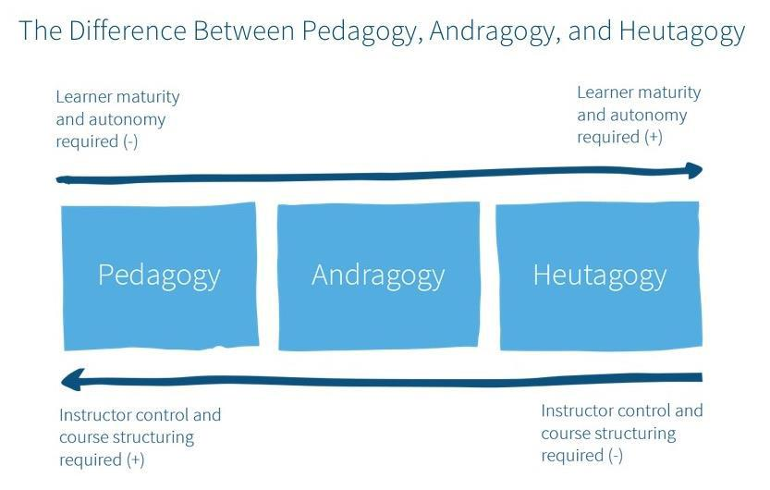

Knowles¹ tells us that adult learners are:

- Independent and self-directing.

- Prior experience is a potent resource for future learning.

- They value learning which has relevance to their current experience.

- Immediate problem-solving approaches are of more interest than subject-based ones and motivation to learn is primarily internal vs. external.

Think of examples from your personal or teaching experience where you have seen one or more of these principles applied.

Click or tap here to enter text.

- Malcolm Shepherd Knowles American adult educator, famous for the adoption of the theory of andragogy

Copyright © 2023 NHS England | 23

Aspiring Educators Handbook

Numerous scholars and educational theorists² believe that learners do not
acquire knowledge and understanding by passively perceiving it within a direct process of knowledge transmission. Instead, they construct new understandings and knowledge through experience and social discourse, integrating new information with what they already know (prior knowledge). This educational theory is called constructivism.

A relatively new educational theory is known as connectivism. It is a theoretical framework for understanding learning in a digital age. It emphasizes how internet technologies such as web browsers, search engines, wikis, online discussion forums, and social networks contributed to new avenues of learning. Technologies have enabled people to learn and share information across the World Wide Web and among themselves in ways that were not possible before the digital age. Learning does not simply happen within an individual, but within and across the networks.

What sets connectivism apart from theories such as constructivism is the view that "learning (defined as actionable knowledge) can reside outside of ourselves (within an organisation or a database), is focused on connecting specialised information sets, and the connections that enable us to learn more are more important than our current state of knowing".

References and links:

https://www.niu.edu/citl/resources/guides/instructional-guide/gagnes-nine-events-of-instruction.shtml

https://leadershipmanagement.com.au/understanding-4-stages-learning/ https://learning-theories.com/andragogy-adult-learning-theory-knowles.html

Kolb, D.A. (1984). Experiential Learning: Experience as a Source of Learning and

Development. Upper Saddle River, NJ: Prentice-Hall, Inc https://learning-theories.com/connectivism-siemens-downes.html https://www.youtube.com/watch?v=AICJRQq-soU

2. Assessment

Formative assessment and summative assessment are two overlapping, complementary ways of assessing learners. While the common goal is to establish the development, strengths and weaknesses of each student, each assessment type provides different insights and actions for educators.

 | FORMATIVE |  | SUMMATIVE
• | Intended to assess progress or | • | Testing against an explicit
 | help develop the learner. |  | benchmark
• | Cannot pass or fail (but can still | • | Pass/fail
 | be mandatory!)

- Jean Piaget, Lev Vygotsky, Lave & Wenger amongst others.

Copyright © 2023 NHS England | 24

Aspiring Educators Handbook

• | Examples | • Determines progression to next
• | Clinical Evaluation Exercise |  | stage.
• | Case based discussion. | • | Examples
• | Consultation observation tool | • | MCQ
• | Tutor report | • | OSCE

If formative assessment measures how a student is learning during a course of study, summative assessment is designed to measure “how much” a student has learned after a unit or course has reached its completion.

Linked to clinical competence is also professional competence such as skills, knowledge and attitudes which are specifically valued by regulatory and professional bodies, employers and fellow colleagues, and patients/clients and their families.

Millers’ Pyramid

In 1990, psychologist George Miller proposed a framework for assessing clinical competence. At the lowest level of the pyramid is knowledge (knows), followed by competence (knows how), performance (shows how), and action (does).
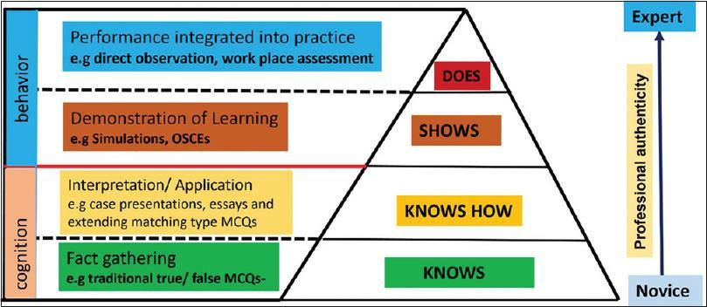

Copyright © 2023 NHS England | 25

Aspiring Educators Handbook

The nursing theorist Dr Patricia Benner³ developed a model for the stages of clinical competence in her book “From Novice to Expert: Excellence and Power in Clinical Nursing Practice”. Her model is one of the most used frameworks for assessing nurses’ needs at different stages of professional growth and can be used for any professional learner.

This nursing theory proposes that expert nurses develop skills and understanding of patient care over time through a proper educational background as well as a multitude of experiences. Dr Benner’s theory is not focused on how to be a nurse, rather on how nurses acquire nursing knowledge – one could gain knowledge and skills (“knowing how”) without ever learning the theory (“knowing that”).

Four stages of competence model

The Stages of Competence model was introduced by Noel Burch in the 1970s as a means of understanding the progression from incompetence to competence in a skill.

The four stages of learning, as depicted within the following grid, suggest that individuals are initially unaware of how little they know or are unconscious of their incompetence. As learners recognise their incompetence, they consciously acquire a skill, then consciously use it. Eventually, the skill can be utilised without it being consciously thought through i.e., the individual is said to have then acquired unconscious competence.
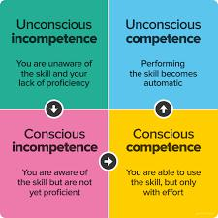

- https://nursing-theory.org/theories-and-models/from-novice-to-expert.php

Copyright © 2023 NHS England | 26

Aspiring Educators Handbook

Think about formative and summative assessments: Jot down how you would approach both assessment techniques. Which areas of assessment are you confident? Where are you not so confident? What else would you like to know?

Free-Text Box

Two concepts to consider when undertaking assessments:

- Validity - “the degree to which a method assesses what it claims or intends to assess”.

- Reliability - “the extent to which an assessment method or instrument measures consistently the performance of the student”

In preparation for the face-to-face sessions – think about these concepts and how they can be applied in your assessment of learners.

Copyright © 2023 NHS England | 27

Aspiring Educators Handbook

Free-Text Box

3. Reflection

‘The process whereby an individual thinks analytically about anything relating to their professional practice with the intention of gaining insight and using the lessons learned to maintain good practice or make improvements where possible.’⁴

Reflection can take place at multiple points in time in relation to an event. For example:

Reflection before action: This can include asking oneself: What may happen? What might be the challenges? and What do I need to know or do in order to best prepare?

Reflection in action: This includes thinking about what to do next and acting straight away as well as evaluating events as they occur. Ask yourself: is it working out as expected? Am I dealing with the challenges well? Is there anything I could do, say, or think to make the experience successful? And, What am I learning from this?

- Co-produced guidance by AoMRC, COPMeD, GMC,MSC

Copyright © 2023 NHS England | 28

Aspiring Educators Handbook

Reflection on action: This can include evaluating one’s insights immediately after an event, while the feelings are still fresh, and/or later when one is able to distance ones-self emotionally from an event.

Experiential learning is the process of learning through experience and is more narrowly defined as "learning through reflection on doing".

The Five Step of Experiential Learning
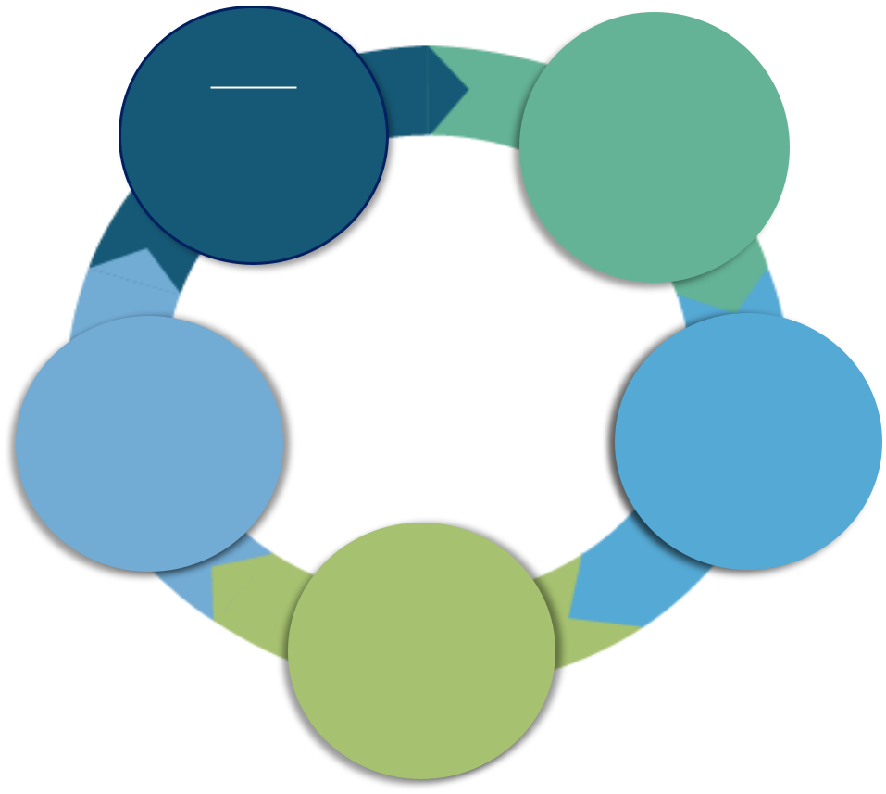

Step 1 |  | Step 2
Have an | Review and
experience | describe
 |  | the

 | Step 5 |  |  |  |  | Step 3
 |  |  |  |  | Analyze the
Plan the
next steps |  |  |  |  | experience
 |  |  |  | Step 4
 |  |  |  | Draw
 |  |  | conclusions
 |  |  | from the
 |  |  | experience

Reflection empowers practitioners to identify actions that will improve learning, enhance practice, and develop greater insight and self-awareness. It will increase awareness of opportunities to improve quality and patient safety in organisations.

There is a strong public interest in professionals being able to reflect in an open and honest way.

Copyright © 2023 NHS England | 29

Aspiring Educators Handbook

How confident are you in reflecting your own practice?

How would you use reflection in your supervision of learners?

Free-Text Box

4. Learner needs and learner safety.

A learners’ needs can depend on several factors including background, culture, previous education, expectations, and grade. Understanding our learners’ needs helps us to:

- Identify strengths and weaknesses.
- Achieve quality.

- Develop talents.

- Create interest.

- Plan teaching activities / organise teaching.

Individuals will learn best in an environment where they feel safe. Learner safety satisfies the basic human need to learn and grow. It allows us to feel safe as we engage in all aspects of the learning process—asking questions, giving and receiving feedback, experimenting, and even making mistakes, not if but when we make them.

Copyright © 2023 NHS England | 30

Aspiring Educators Handbook

When considering the needs and safety of learners, it is useful to consider Maslow's⁵ hierarchy of needs which is a theory of motivation which states that five categories of human needs dictate an individual's behaviour. An individual will attempt to fulfil bottom-level needs before moving up through the other levels.
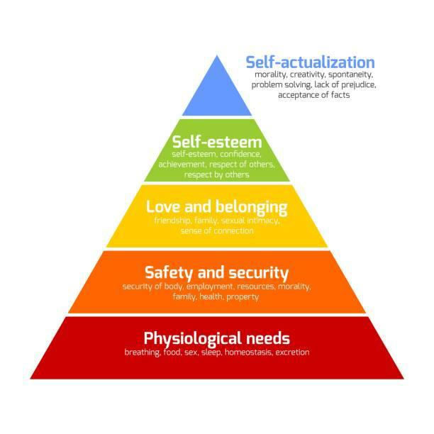

- Abraham Maslow – Humanistic theorist.

Copyright © 2023 NHS England | 31

Aspiring Educators Handbook

Think about how you might assess your learners’ needs – what techniques might you use?

Free-Text Box

Think about what actions you would take to ensure that your learner feels safe.

Copyright © 2023 NHS England | 32

Aspiring Educators Handbook

Free-Text Box

5. Learning Styles

Learning is: changing behavior/thinking feeling. Behavior can be an attitude, ideas, values, skills or interests. The effect of learning is to produce change. Learning is not just the accumulation of facts.

Teaching is: the facilitation of learning. It’s about the learner!

Copyright © 2023 NHS England | 33

Aspiring Educators Handbook
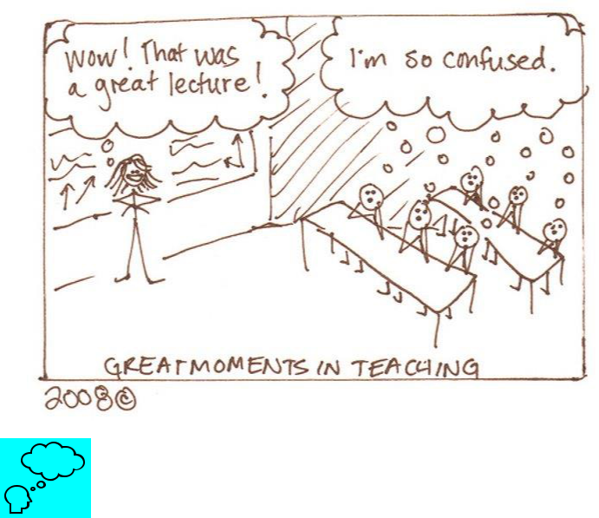

What factors might influence learning?

Free-Text Box

Copyright © 2023 NHS England | 34

Aspiring Educators Handbook
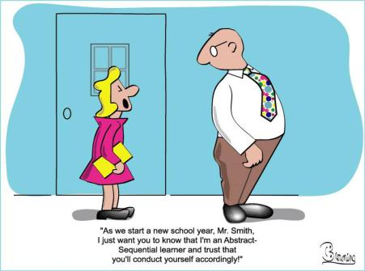

You may already be aware; from personal experience, that we respond best to different styles of learning. The 2 styles of this theory explored here are Honey & Mumford and VARK.

Honey & Mumford describes the attitudes and behaviours that determine our preferred way of learning.

Copyright © 2023 NHS England | 35

Aspiring Educators Handbook
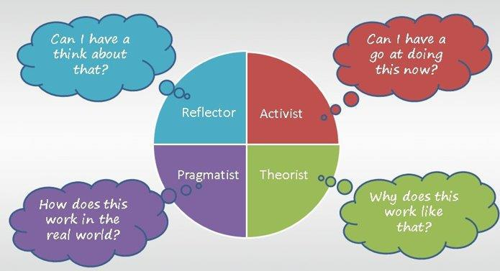

Take the H&M questionnaire by following the link below.

https://www.mint-hr.com/mumford.html

Copyright © 2023 NHS England | 36

Aspiring Educators Handbook

The VARK model suggests the learner has one of the following dominant learning styles:

- Visual
- Auditory

- Read / Write

- Kinesthetic
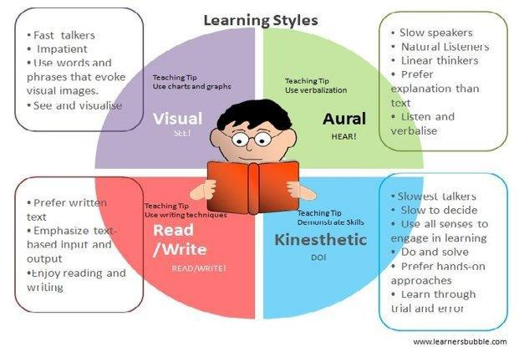

Take the VARK test by following the link below.

http://vark-learn.com/the-vark-questionnaire/

Copyright © 2023 NHS England | 37

Aspiring Educators Handbook

What is your preferred learning style?

Free-Text Box

How will you identify and meet the different learning styles of your learners?

Free-Text Box

Copyright © 2023 NHS England | 38

Aspiring Educators Handbook

6. Peer to peer learning

Peer to peer learning is essentially learners teaching learners. It can be formal and informal and both approaches should be maximised.
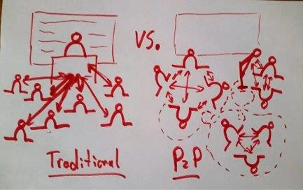

Basis in educational theory⁶ (some of which you will have explored in pervious sections of this workbook):

- http://thepeakperformancecenter.com/educational-learning/learning/theories/

Copyright © 2023 NHS England | 39

Aspiring Educators Handbook
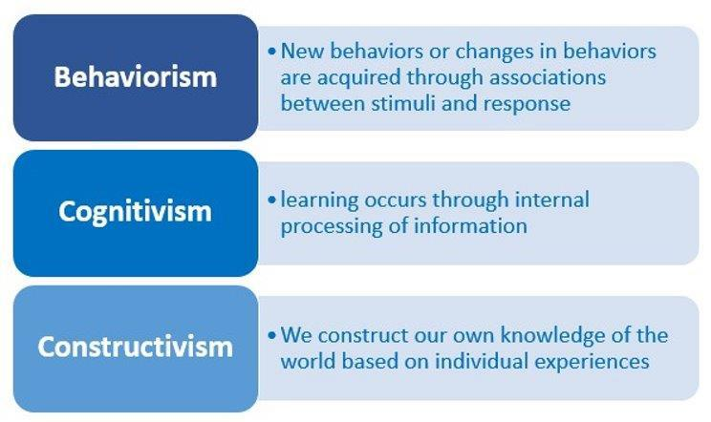

Methods and types of peer-to-peer learning

- Learning lunches

- Mentoring

- Learner accessible learning management systems e.g., webpage/twitter group/wiki/chat groups/Facebook pages

- Trainee led tutorials.

- Flipped classrooms.

- Conversations

What are the benefits or potential risks of peer-to-peer learning? Jot down a couple of examples and how you might encourage peer-to-peer learning and mitigate and risks.

Copyright © 2023 NHS England | 40

Aspiring Educators Handbook

Free-Text Box

7. Effective Feedback & Having Difficult Conversations

How does feedback differ from evaluation?

Feedback: helpful information or criticism about prior action or behaviour from an individual, communicated to the individual (or a group), who can use that information to adjust and improve current and future actions and behaviours.

Feeback is formative – it is frequent and on-going, often free-form and intended to improve performance and provide suggestions for further development.

Evaluation: the making of a judgement about the amount, number, or value of something.

Evaluation if summative – it is intended to compare actual performance to requirements or standards. It is usually standardised and well documented.

Avoid confusion of conflation!

Copyright © 2023 NHS England | 41

Aspiring Educators Handbook
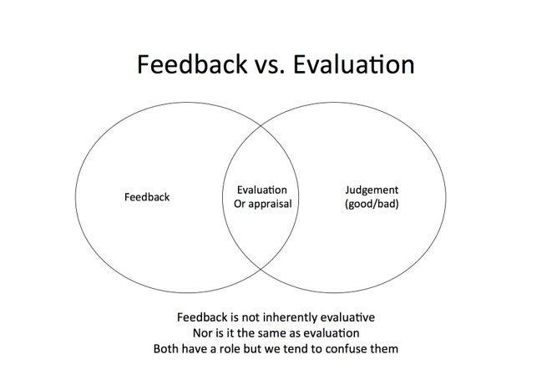

The challenge is how to draw trainees' attention to their less satisfactory aspects while maintaining or even increasing their desire to learn, improve, and seek further evaluation.

Effective Feedback is:

- Meaningful – discriptive of the behaviour not the personality
- Accurate – specific examples are given

- Timely – given as close to the event as possible

- Usable – relatable to acheivable goals

- Reflective – directed towards behaviour that can be changed.

Can you think of a situation where you have recevied or given feedback and the conversation did not go so well? What factors influenced this situation and how might you avoid it in the future?

Copyright © 2023 NHS England | 42

Aspiring Educators Handbook

Free-Text Box

Difficult conversations

Have you ever had a disagreement with someone, experienced all the emotions and frustrations of that person not coming round to your point of view, only to later have another colleague shed light on that person’s perspective?

Suddenly, it all makes sense, you can see what was holding them back and you realise how you could’ve handled the situation differently.

‘Perceptual positioning’ is an effective technique that can help in these situations because it means stepping outside of yourself to look at a situation from different points of view. There are three different perceptual positions that you can take:

- First position (self) = your position

- Second position (other) = the position of the other person that you’re communicating with e.g. a colleague

Copyright © 2023 NHS England | 43

Aspiring Educators Handbook

- Third position (observer) = the position of the observer, who is witnessing the conversation that’s taking place

Think about the way in which you ‘break bad news’. How do you manage these situations?

What skills do you do use?

Free-Text Box

Copyright © 2023 NHS England | 44

Aspiring Educators Handbook

Now think about giving feedback to your learners – how might you use perceptual positioning in these situations?

Free-Text Box

Copyright © 2023 NHS England | 45

Aspiring Educators Handbook

Step 4 & 5 – School Specific Content (Primary Care School Educator Specific Content)

The Primary Care School educator specific content has been especially designed to provide you with a solid base to the start of your journey as an educator. We have developed a blended approach which will utilise some online content in addition to face-to-face sessions. It is important that you read the following information carefully as you will be required to do some of the virtual learning and completion of this section of the workbook prior to attending the face-to-face sessions. These sessions are designed to run as a plenary for the pre-learning that you will be undertaking.

It is important to note that facilitators will be looking for evidence that the pre-learning has happened. Should there be any concerns that this has not happened you may be asked to return once you have completed the online material. Similarly, you are expected to participate within the face-to-face sessions. Facilitators are experienced at identifying those who may just be paying lip service and treating the sessions as a tick box exercise. Should they have concerns they may talk to you about these during the face-to-face sessions and you may not be able to progress.

Copyright © 2023 NHS England | 46

Aspiring Educators Handbook

Preparation for Face-to-Face Learning

Please work through the following content prior to attending the Primary Care School Educator Face-to-Face Training.

- Differential Attainment (All Tiers)

- Consultation Observation Tool (COT) (All Tiers)

- Audio-COTs (All Tiers)

- Clinical Examination and Procedural Skills (CEPS) (All Tiers)

- Urgent and Unscheduled Care (UUC) (All Tiers)

- Induction (All Tiers)

- Wider Workforce (Tiers 2B and 3)

- Case Based Discussion (CBD)/Care Assessment Tool (CAT) (Tier 2B and 3)

- Reflective Log Entries (Tier 2B and 3)

- Clinical Supervisors Report (CSR) (Tier 2B and 3)

- Applied Knowledge Test (AKT) (Tier 2B and 3)

- Simulated Consultation Assessment (SCA) (Tier 3)

- Prescribing Assessment (Tier 3)

- Educator Notes (Tier 3)

- Educational Supervisors Review (ESR) (Tier 3)

- Understanding the Annual Review of Competency Progression (ARCP) Process (Tier 3)

- Plenary Session including Suggested Personal Development Plan (PDP) (All Tiers)

1. Differential Attainment (All Tiers)

What is Differential Attainment?

The General Medical Council defines this as “Systematic differences in outcomes when grouping cohorts by protected characteristics and socio-economic background”.

Why is this Important?

Copyright © 2023 NHS England | 47

Aspiring Educators Handbook

The GMC data for pass rates in postgraduate medical exams across all specialties in the UK demonstrates a significant difference between different ethnic groups and by primary country of qualification.

- 75% UK White graduates

- 63% UK trained Black and Ethnic Minority (BAME)

- 46% White International Medical Graduates (IMG)

- 42% BAME IMG

Furthermore, BAME UK graduates are FIVE times more likely to fail their clinical assessment on their first attempt. IMGs are TEN times more likely to fail that assessment on their first try. However, it is not just clinical assessments that show a significant difference in pass rates. Even computer marked examinations reveal a similar pattern.

This is not a new issue and has been around for over 20 years. There has been some fear of raising the issue for fear of highlighting the gaps between groups and being branded a racist. It is also not an issue exclusive to doctors and affects all healthcare professionals. Similar effects have been documented within other degrees and even in school-age children.

In 2013 there was an independent review of the MRCGP examination which showed that the examination itself was not racist but there were some important recommendations which included

- Clear recognition that training programmes need to take account that doctors are entering training at different starting points and that some learners may need to have tailored support. This needs to include education for trainees and educators.

- The GMC should commission further research into understanding the differences in attainment.

Many additional health professionals are now entering the UK to work and need extra support.

What are the Causes of Differential Attainment?

Take a moment to think why differential attainment exists and record your thoughts in the box below.

Copyright © 2023 NHS England | 48

Aspiring Educators Handbook

Whilst it has been postulated that there may be many underlying causes, such as language skills, prior academic performance, socioeconomic status, motivation, and examiner bias, there is NO proof that any of these account for the differences. Cases are often complex and poorly understood. It should never be implied that the learner is at fault.

It is important to remember that we are dealing with “differences” and not “deficiencies” and one should be careful that as an educator you do not conflate the two.

Differential Attainment: What do we Know?
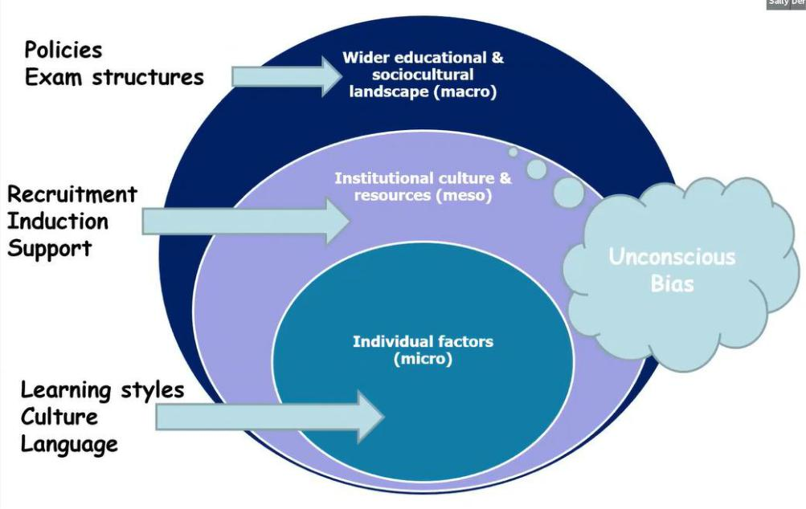

Meso factors operate at the group level and incorporates how well people integrate within groups and develop support networks. Have you ever been part of a group where people were not included due to perceived differences, or have you ever felt excluded from a group as you felt you did not belong? What effect do you think that had on that person? What effect did that have on yourself? What would you do differently in future? Please use the box below to reflect on this.

Copyright © 2023 NHS England | 49

Aspiring Educators Handbook

At the macro level those qualifying abroad may be used to different ways of examining and educational methods, as opposed to those who are from the UK, and they may therefore be disadvantaged by the UK educational system.

Katherine Woolf et al 2017

This study was designed to identify the risks of failure to progress for all learners on a training programme. It involved 96 learners and 41 educators taking part in 16 focus groups and 49 interviews. For most learners, the following risks were identified.

- Dysfunctional and highly pressurised environments

- Bullying

- Lack of autonomy

- Lack of work-life balance

- Lack of confidence

The same study then went on to look at the additional risks for learners that UK BAME and IMGs faced in addition.

Copyright © 2023 NHS England | 50

Aspiring Educators Handbook
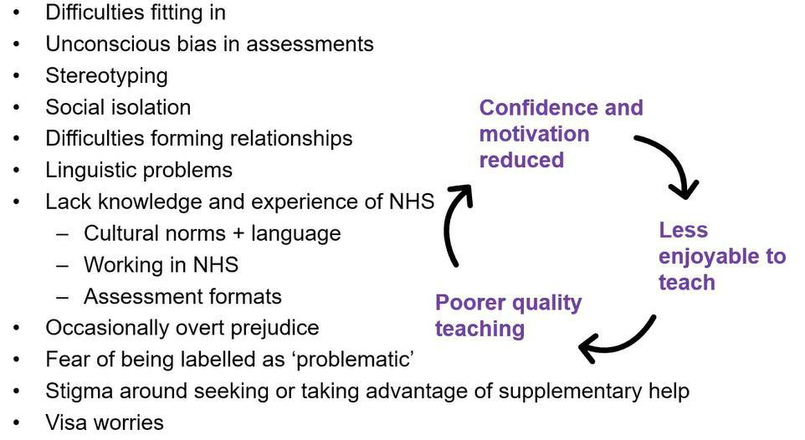

Simple things such as not being able to go to the pub meant that there were reduced opportunities for building social support networks. Some had difficulties approaching supervisors to get assessments done due to previously coming from hierarchical societies. For GP learners there were difficulties communicating with other members of staff which affected the patients being booked.

A lot of learners described having to work twice as hard to achieve the same as their UK white counterparts. Many found working in the NHS different as there was a lot of working in multidisciplinary teams rather than the hierarchies, they were more accustomed to. Commonly, white learners had fewer financial difficulties. Even working less than full time is difficult due to minimum salary required for visa rules.

A lot of learners struggle with asking for help, challenging seniors, asking questions and this makes progress harder.

Woolfe et al identified several protective factors.

The Role of the Educator

- Supportive, pastoral role, advice

- Taking time to get to know and build trust with the learner.

- Providing clinical learning opportunities

- Role modelling

- Showing faith in the learner

- Helping reframe past bad experiences.

- Having an open relationship

- Sharing their own experiences

- Providing effective feedback

Copyright © 2023 NHS England | 51

Aspiring Educators Handbook

- Helping to overcome exam anxiety Other Protective Factors

- Work-life balance and support of family and friends

- Learners developing friendships, both within and without their own cultural groups

- Organisations facilitating friendships.

- Educational bodies, supervisors and mentors who could help deal with problems such as bullying, racism, health, and other personal problems

- Re-framing challenges as learning opportunities, for example, exam failures

Thinking about your working/educational environment, what changes could you institute to provide additional support?

Victoria Roe et al 2019 – “What Supported Your Success in Training?”

This study explored factors associated with specialities of programmes which did not show differential attainment over a 3-year period. It looked at how amenable to change those factors were and thus what interventions could be employed to improve fairness in clinical education. The key findings were like those of Wolff et al. There was no single success factor but a combination of several factors including environmental characteristics, people, and strategies that supported learning. Learners attributed most of their success to uncontrollable external factors.

Copyright © 2023 NHS England | 52

Aspiring Educators Handbook
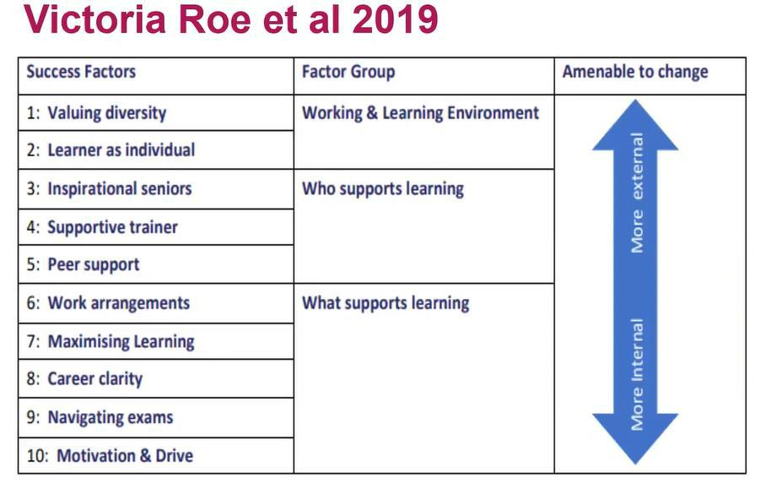

Biases

In both studies UK graduates and IMGs perceived that there were biases in their workplace assessments and in recruitment. Biases are deeply held beliefs and assumptions that are formed over time from previous experiences or from other influences, for example, social networking and the media. These biases do influence how people react to others and make decisions. Some of them may be overt and conscious, but there are others that you may not be aware of and are unconscious. Everyone has them, however, the question remains as to whether there is anything that can be done specifically about those that are unconscious.

What is HEEoE Doing About It?

The Transition Project helps to support IMGs into GP training and into the GP workforce within the normal training time. Work is going on across the rest of the deanery for other specialties and professions as this is recognised as a widespread issue.

Learners now receive an enhanced induction at the beginning of their course, and it is important that they are encouraged to accept this offer. They also receive dyslexia screening and a personalised learning plan. The personalised learning plan is agreed with the area Training Programme Director (TPD) for differential attainment and monitored by the educational supervisor. Interventions are put in early as identified by the personalised learning plan. All learners have iTAP (in Training Assessment Profile) at the end of their first year. This is a tool which looks at several data sets generated from recruitment scores and information in the e-portfolio to identify learners who need additional support. There is also early exam help and careers advice available.

Copyright © 2023 NHS England | 53

Aspiring Educators Handbook

Large numbers of learners failing the Applied Knowledge Test two or more times are thought to have dyslexia. This can sometimes be difficult for IMGs to acknowledge or accept but there are some positive aspects for those with dyslexia which include.

- Being highly intuitive and insightful

- Curious

- Highly aware of the environment and others

- Ability to “think outside the box.”

- Excellent problem-solving skills

Richard Branson, a very successful entrepreneur has dyslexia!

Communication skills support is also available through Professional Support and Wellbeing (PSW). This includes.

- Linguistic Competence – Grammar, vocabulary, pronunciation, fluency

- Sociolinguistic Competence – Pace, volume, intonation, body language, interactive style, mannerisms

- Applied Language Competence – Question forms, signposting, summarising, explaining, negotiating

What Is Important for Learners within a Local Learning Environment?

All the evidence indicates that the following are key.

- Educator support and relationship is key to success and often transformative.

- Learning environment is also important.

- Effective feedback is vital.

Feedback may be perceived differently by those from different backgrounds due to cultural influences and some languages do not have a word that equates to “feedback”. Potential barriers make the process more complex, for example, learners may not be used to personal reflection, and learners may have had adverse experiences in the past, particularly within secondary care. It is important to unpick that and have an open discussion with your learners on how and when they would like to receive feedback. The traditional approach of sandwiching negative feedback between positive feedback is often less effective.

Cultural Competence

This is the ability to interact with people from different cultures and respond to their needs. It is about creating a culture that recognises, respects and values differences and avoids the use of stereotypes. However, to develop this competence it is vital that you can identify your own culture and biases. In this sense it is several steps further on than normal equality and diversity training which focuses more on equal opportunity and differences than harmony and equity.

Copyright © 2023 NHS England | 54

Aspiring Educators Handbook

2. Consultation Observation Tool (COT) (All Tiers)

This session should take approximately 36 minutes to complete. All tiers must complete this session. Ideally, this session should be completed a couple of days before the face-to-face sessions so that it is fresher in your mind. Please watch the online Panopto Video on COTs and audio- COTs which can be found here https://heeoe.cloud.panopto.eu/Panopto/Pages/Viewer.aspx?id=90b4a9a9-c253-41db-9b06-ad2d00f8faa9

During this video, you will need to keep a record of your grading of the case to be discussed at the face-to-face day. Please use the table below to keep a record of this.

First consider how complicated you think the clinical case is to manage.

Level of Complexity

Low

Medium

High

Now choose a maximum of 2 clinical experience groups as applied to the case.

Clinical Experience Group

Infants, Children and Young People (Under 19)

Gender, reproductive and sexual health (including women’s, men’s, LGBQT, gynaecology and breast)

People with long-term conditions including cancer, multi-morbidity, and disability

Older adults including frailty and/or those at the end of life

Mental health (including addiction, alcohol and substance misuse)

Urgent and Unscheduled Care

People with health disadvantage and vulnerabilities (including veterans, mental capacity difficulties, safeguarding and those with communication difficulties/disability)

Population Health and health promotion (including people with non-acute and/or non-chronic health problems)

Copyright © 2023 NHS England | 55

Aspiring Educators Handbook

Clinical problems not linked to a specific clinical experience group

For each of the following performance criteria you will need to assess at what level this learner is performing. The learner in the video is a GP Specialist Trainee in their final year of training. Each performance criteria should be marked according to whether there is an opportunity for the learner to demonstrate the performance criteria, whether they are needing further development (NFD) and below expectations, NFD but meeting expectations, competent for licensing or excellent.

Competent means that the learner is demonstrating the criteria at the level of a qualified GP and excellent is above this. The difference between NFD below expectations and that of meeting expectations is that the former misses important aspects, whereas the latter is demonstrating some of them but not all.

Performance Criteria | Not | NFD – | NFD – | Competent | Excellent
 | Applicable | Below | Meets | for
 |  | Expectations | Expectations | Licensing
Encourages the
Patient’s Contribution
Responds to Cues
Places Complaint in
Appropriate
Psychosocial Contexts
Explores Patient’s
Health Understanding
and Beliefs, including
Ideas, Concerns and
Expectations
Takes Appropriate
Information in a
Focused Way to Allow
a Safe Assessment
(Includes/Excludes
Likely Relevant
Significant Condition)

Copyright © 2023 NHS England | 56

Aspiring Educators Handbook

Performs Appropriate

Physical or Mental

State Examination

Makes an Appropriate

Working Diagnosis

Explains the Problem

in Appropriate

Language

The Management

Plan is Appropriate for

the Working Diagnosis

Patient is Given the

Opportunity to be

Involved in Significant

Management

Decisions

The clinician checks

that there is shared

understanding of the

diagnosis,

management plan,

treatment, safety

netting and follow up

arrangements

Makes effective use of

available resources

The clinician specifies

the conditions and

interval for follow up or

review

Now that you have graded the individual performance criteria, please rate the OVERALL performance of this learner. Remember this is a learner in their final year of training.

Below the level expected prior to starting on a GP Training programme

Copyright © 2023 NHS England | 57

Aspiring Educators Handbook

Below the level expected of a GP trainee working in the current clinical post

At the level expected of a GP trainee working in the current clinical post

Above the level expected of a GP trainee working in the current clinical post

Finally, please think about the written feedback that you would provide to this learner. It is important to focus on observed, tangible behaviours and not subjective opinion. Try to think of some specific agreed actions that are Specific, Measurable, Achievable, Relevant and Timebound (SMART).

OBSERVATION AND FEEDBACK ON PERFORMANCE

AGREED ACTION FOR FURTHER DEVELOPMENT

3. Audio-COTs (All Tiers)

An audio-COT differs from a COT in that it is conducted purely by telephone. For this reason, the marking schedule is different to that of a COT as it is considered a higher-risk clinical encounter and it is important that learners can demonstrate their capability. At least one audio-COT must be undertaken during a learner’s final year.

Take a few minutes to reflect in the box below on what you think the differences are between assessing a COT and an audio-COT. How would the organisation of this be different? Are there are practical considerations? What are the advantages and disadvantages of each of these assessment methods?

Copyright © 2023 NHS England | 58

Aspiring Educators Handbook

The audio-COT marking schedule is shown below for your information.
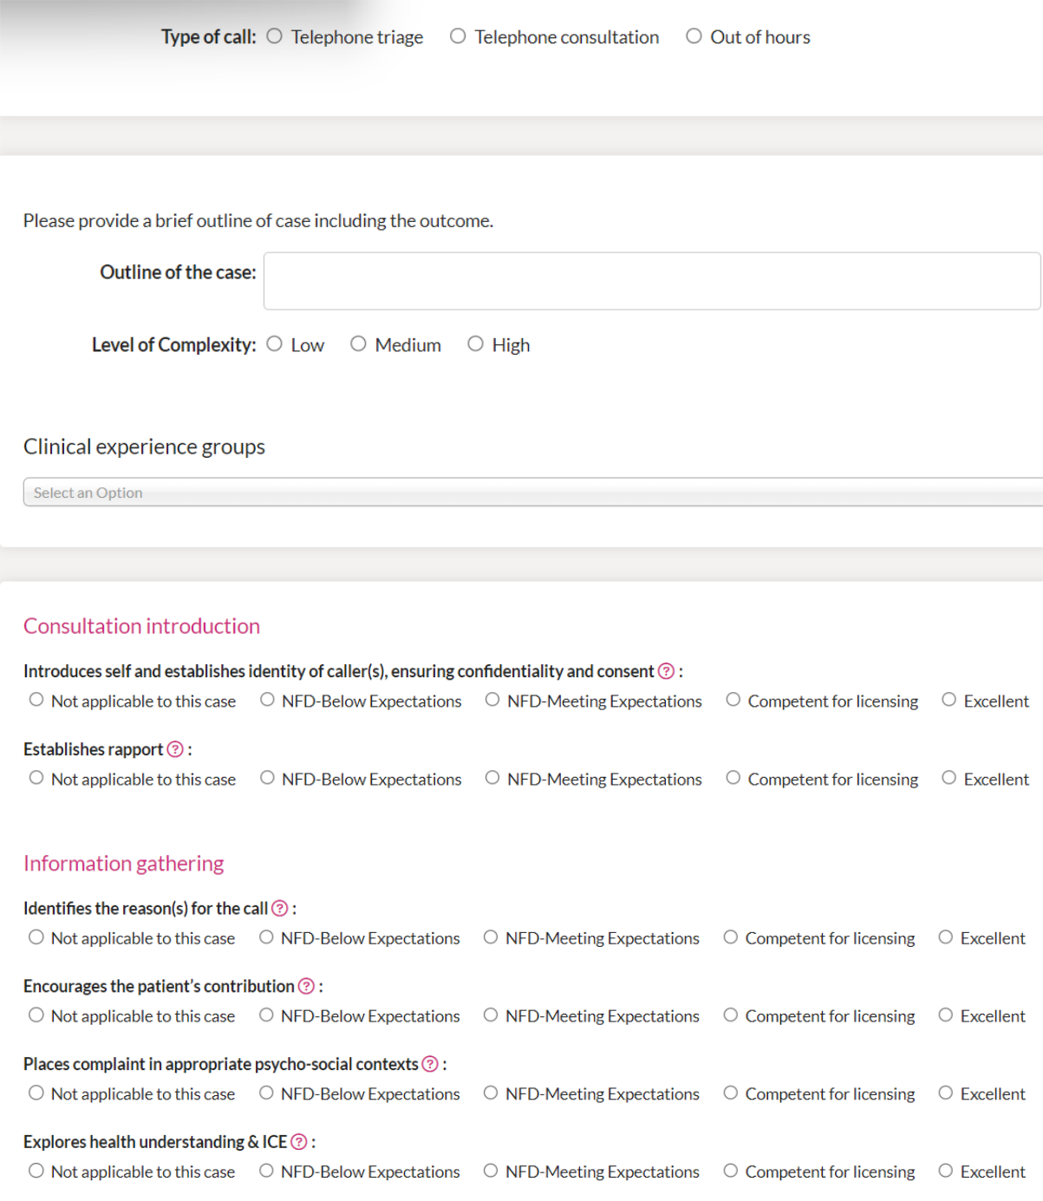

Copyright © 2023 NHS England | 59

Aspiring Educators Handbook
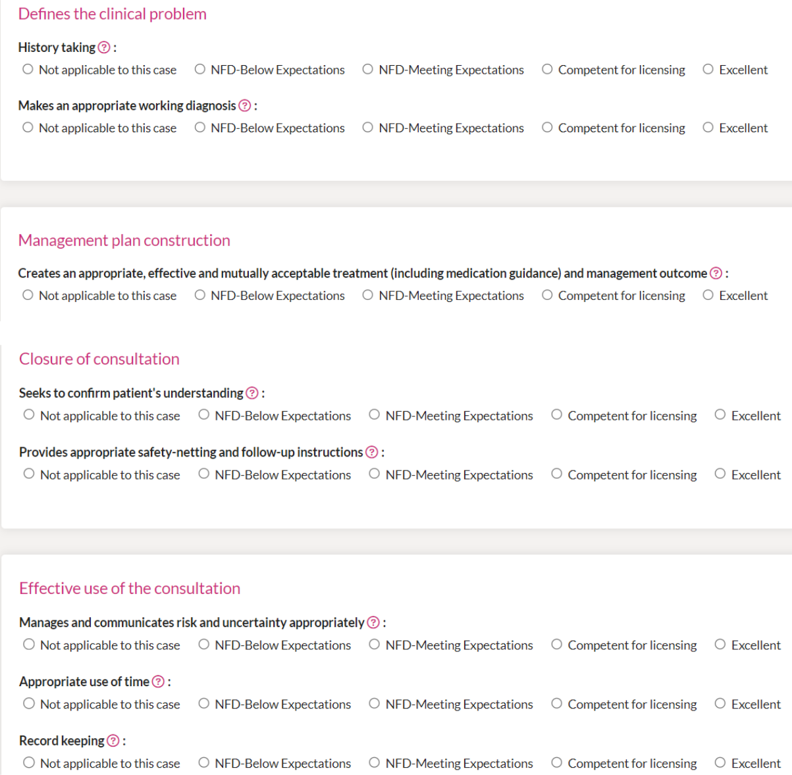

Copyright © 2023 NHS England | 60

Aspiring Educators Handbook
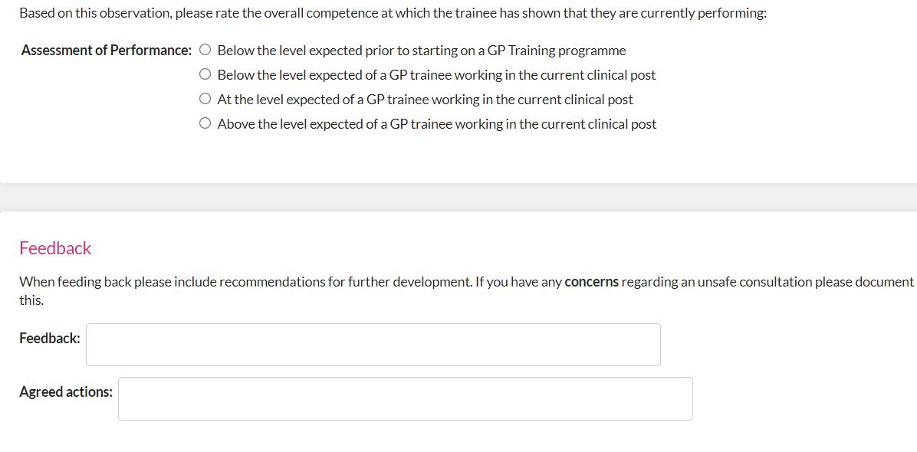

4. Clinical Examination and Procedural Skills (CEPS) (All Tiers)

This section is to be completed ideally no longer than a few days prior to the face-to-face session. It is to be completed by all tiers and should take approximately 20 minutes.

CEPS are an assessment of a learner’s capability to undertake various examinations or procedures. Any examination or clinical procedure may be assessed using CEPS and this may be especially useful where there are concerns regarding a learner’s ability.

For GP trainees there are five mandatory CEPS and 7 additional CEPS that need to be graded as “Competent to Perform Procedure Unsupervised” by the end of their programme.

The 5 mandatory examinations are not a ‘minimum requirement’ and cannot by themselves demonstrate overall competence in CEPS. A range of observed assessed CEPS which are relevant to general practice are also required. 7 “system” observed CEPS categories are included in the CEPS section of the Portfolio to help meet this requirement

Where a healthcare professional has appropriate experience, it is acceptable for them to undertake a CEPS assessment. For example, a clinical nurse specialist may be perfectly placed to assess a female genital examination CEPS.

It is essential you learn how to examine patients within the general practice setting.

To be awarded your CCT, evidence for the following must be included:

- The five mandatory intimate examinations. A suitably trained professional will need to observe and document your performance on a CEPS evidence form.
  - Breast,
  - Prostate,
  - Male Genital,

Copyright © 2023 NHS England | 61

Aspiring Educators Handbook

  - Female Bimanual
  - Speculum and Rectal.

- A range of additional Examinations and Procedural Skills relevant to General Practice which demonstrate competence. 7 “system” observed CEPS categories are included in the Clinical Examination and Procedural Skills section of the Portfolio. Your supervisor must also be satisfied through observed evidence or documented evidence from others that you are competent in general and systemic examinations for the clinical curriculum areas. These may well have been completed in your previous training but can be easily covered in joint surgeries for example.

These are:

- Respiratory system
- Ear Nose and Throat
- Abdominal system
- Cardiovascular system
- Musculoskeletal system
- Neurological examination
- Child 1- 5 years

Please watch the online Panopto Video on CEPS which can be found here

https://heeoe.cloud.panopto.eu/Panopto/Pages/Viewer.aspx?id=94e99474-caff-4061-86b4-ad2d00ef44a2

During this video, you will need to keep a record of your grading of the case to be discussed at the face-to-face day. Please use the table below to keep a record of this.

Clinical Examination and/or Procedure Observed – Examination of the Ears

Observation and feedback on performance

To consider:

- Communication with the patient

- Awareness of Cultural and ethical factors

- Ability to perform clinical examination or procedural skill.

- Consideration of patient and professionalism demonstrated.

Copyright © 2023 NHS England | 62

Aspiring Educators Handbook

Agreed actions for further development:

Assessment of Performance
Based on this observation, please rate the learner’s overall performance:
Unable to perform the procedure appropriately |  | ▢
Able to perform the procedure but needs direct supervision and /or assistance |  |  | ▢
Able to perform the procedure with minimal supervision or assistance |  |  | ▢
Competent to perform the procedure unsupervised |  |  | ▢

Further information on all of the Royal College of GP Workplace-Based Assessments may be found here https://www.rcgp.org.uk/gp-training-and-exams/training/workplace-based-assessment-wpba/assessments.

5. Urgent and Unscheduled Care (UUC) (All Tiers)

Copyright © 2023 NHS England | 63

Aspiring Educators Handbook

This session should take 20 minutes to complete and should be completed by all tiers. It is important to complete this before the face-to-face session as there will be a quiz during this to check your learning. The UUC Panopto video covering the basics of UUC is available here https://heeoe.cloud.panopto.eu/Panopto/Pages/Viewer.aspx?id=7f03a606-9d9b-47c1-9c3d-acab00964333.

Please use the box below to record any important points you wish to keep for future reference.

Now that you have completed the online video it is worthwhile prior to the face-to-face session starting to think about your role in facilitating and assessing UUC capability. This will vary depending upon which tier you are planning to become and your specific role. In the box below you can record some of your thoughts on the practical aspects of helping learners to undertake their traditional OOH, whether there are any foreseeable barriers or opportunities and how you will help learners to demonstrate their capability. This will be covered in more detail during the face-to-face session.

Copyright © 2023 NHS England | 64

Aspiring Educators Handbook

More information on UUC may be found here https://heeoe.hee.nhs.uk/general_practice/urgent-and-unscheduled-care

6. Induction (All Tiers)

Please complete these sections in advance of the face-to-face training as you will need to discuss this in the sessions themselves.

Thinking about any of your previous inductions to roles what was your experience? Were there any things that were done well and may be useful to emulate? What could have been done better? Please record your reflections in the box below.

Free text box

Imagine a new learner starting in your organisation. They are new to the NHS having qualified from abroad. Plan an induction for them. How long should this be? What sort of information should they be given and how should this information be given? What are they going to be doing during this induction period? What do you consider the difference between personal and organisational induction? Please record your thoughts in the box below so that they can be discussed at the face-to-face session.

Copyright © 2023 NHS England | 65

Aspiring Educators Handbook

Free text box

7. Wider Workforce (Tiers 2B and 3)

This video should be watched by those applying for tiers 2B and 3. It should be done prior to the first face-to-face teaching session. The video lasts 16 minutes and is available here https://heeoe.cloud.panopto.eu/Panopto/Pages/Viewer.aspx?id=556f30c5-4d64-4c4a-a659-ad2d00f19af3 Please use the box below to reflect on your learning from the module. How will the wider workforce roles support the educational role that you are planning to undertake?

- Case Based Discussion (CBD)/Care Assessment Tool (CAT) (Tier 2B and 3)

Copyright © 2023 NHS England | 66

Aspiring Educators Handbook

This module will need to be completed by those delegates hoping to become tier 2B or 3. It is not relevant to those applying for tier 2A. A few days before the first Primary Care School Educator Specific Training you should complete the CAT Panopto Video so that the case is relatively fresh in your mind. The video may be accessed here https://heeoe.cloud.panopto.eu/Panopto/Pages/Viewer.aspx?id=8dae0723-89ac-435c-869b-ae2300a9a992.

During this video, you will need to complete an assessment of the learner’s performance. Please do so using the table below. In contrast to a COT, CBDs and CATs normally focus on just 2 – 3 of the professional capabilities. For the purposes of this exercise and for the subsequent plenary session we have selected the relevant capabilities for you below.

First consider how complicated you think the clinical case is to manage.

Level of Complexity

Low

Medium

High

Now choose a maximum of 2 clinical experience groups as applied to the case.

Clinical Experience Group

Infants, Children and Young People (Under 19)

Gender, reproductive and sexual health (including women’s, men’s, LGBQT, gynaecology and breast)

People with long-term conditions including cancer, multi-morbidity, and disability

Older adults including frailty and/or those at the end of life

Mental health (including addiction, alcohol and substance misuse)

Urgent and Unscheduled Care

People with health disadvantage and vulnerabilities (including veterans, mental capacity difficulties, safeguarding and those with communication difficulties/disability)

Population Health and health promotion (including people with non-acute and/or non-chronic health problems)

Copyright © 2023 NHS England | 67

Aspiring Educators Handbook

Clinical problems not linked to a specific clinical experience group

The learner has suggested three professional capabilities that they feel this case applies to.

Please fill out the relevant sections below.

Maintaining an Ethical Approach

This is about practising ethically with integrity and a respect for equality and diversity.

Indicators of | Needs further
Potential |  | Competent | Excellent
 | development
Underperformance

• | Does not | • | Awareness
 | consider |  | of the
 | ethical |  | professional
 | principles, |  | codes of
 | such as good |  | practice as
 | vs harm, and |  | described in
 | use this to |  | the GMC
 | make |  | document
 | balanced |  | “Good
 | decisions. |  | Medical
• | Fails to show |  | Practice”.
 | willingness to | • | Understands
 | reflect on |  | the need to
 | own attitudes |  | treat
 |  |  | everyone
 |  |  | with respect
 |  |  | for their
 |  |  | beliefs,
 |  |  | preferences,
 |  |  | dignity and
 |  |  | rights.
 |  | • | Recognises
 |  |  | that people
 |  |  | are different
 |  |  | and does

• | Demonstrates | • | Anticipates
 | the |  | the potential
 | application of |  | for conflicts
 | “Good |  | of interest
 | Medical |  | and takes
 | Practice” in |  | appropriate
 | their own |  | action to
 | clinical |  | avoid these.
 | practice. | • | Anticipates
• | Reflects on |  | situations
 | how their |  | where
 | values, |  | indirect
 | attitudes and |  | discrimination
 | ethics might |  | might occur.
 | influence | • | Awareness of
 | professional
 |  |  | current
 | behaviour.
 |  |  | legislation as
• | Demonstrates |  | it applies to
 | equality, |  | clinical work
 | fairness and |  | and practice
 | respect in |  | management.
 | their day-to- | • | Actively
 | day practice.
 |  |  | supports
 |  |  | diversity and

Copyright © 2023 NHS England | 68

Aspiring Educators Handbook

not | • | Values and | harnesses
discriminate |  | appreciates | differences
against |  | different | between
them |  | cultures and | people for the
because of |  | personal | benefit of the
those |  | attributes, | organisation
differences. |  | both in | and patients
• Understands |  | patients and | alike.
 |  | colleagues.
that “Good |  |  | • Able to
Medical | • | Reflects on | analyse
Practice” |  | and | ethical issues
requires |  | discusses | with
reference to |  | moral | reference to
ethical |  | dilemmas | specific
principles. |  | encountered | ethical
 |  | in the course | theory.
 |  | of their work.

Not Applicable | NFD – Below | NFD – Meets | Competent for | Excellent
 | Expectations | Expectations | Licensing

Feedback on performance and

justification for grade based on the

capability descriptors

Recommendations for further

development based on the capability

descriptors

Community Orientation

This is about the management of the health and social care of the practice population and local community.

Copyright © 2023 NHS England | 69

Aspiring Educators Handbook

Indicators of
Potential Needs further _{Competent Excellent} Underperformanc development

e

• Fails to take | • | Demonstrate | • | Demonstrate
responsibilit |  | s |  | s
y for using |  | understandin |  | understandin
resources in |  | g of |  | g of how the
line with |  | important |  | characteristic
local and |  | characteristic |  | s of the local
national |  | s of the local |  | population
guidance. |  | population, |  | shapes the
 |  | e.g., patient |  | provision of
 |  | demography, |  | care in the
 |  | ethnic |  | setting in
 |  | minorities, |  | which the
 |  | socio- |  | doctor is
 |  | economic |  | working.
 |  | differences | • | Shows how
 |  | and disease
 |  |  |  | this
 |  | prevalence,
 |  |  |  | understandin
 |  | etc.
 |  |  |  | g has
 | • | Demonstrate |  | informed
 |  | s |  | referral
 |  | understandin |  | practices
 |  | g of the |  | they have
 |  | range of |  | utilised for
 |  | available |  | their patients.
 |  | services in |  | This could
 |  | their |  | include
 |  | particular |  | formal
 |  | locality. |  | referral to a
 | • | Understands |  | service or
 |  |  |  | directing
 |  | limited
 |  |  |  | patients to
 |  | resources
 |  |  |  | other local
 |  | within the
 |  |  |  | resources.
 |  | local
 |  | community, | • | Demonstrate
 |  | e.g. the |  | s how they

- Takes an active part in helping to develop services in their workplace or locality that are relevant to the local population.

- Understands the local processes that are used to shape service delivery and how they can influence them, e.g. through Health Boards and CCGs.

- Reflects on the requirement to balance the needs of individual patients, the health needs of the local community and the

Copyright © 2023 NHS England | 70

Aspiring Educators Handbook

availability of

certain

drugs,

counselling,

physiotherap

y or child

support

services.

- Takes steps to understand local resources in the community – e.g. school nurses, pharmacists, funeral directors, district nurses, local hospices, care homes, social services including child protection, patient participation groups, etc.

have

adapted their

own clinical

practice to

take into

account the

local

resources,

for example

in referrals,

cost-effective

prescribing

and following

local

protocols.

- Demonstrate s how local resources have been used to enhance patient care.

available resources. Considers local and national protocols, e.g., SIGN or NICE

guidelines.

- Develops and improves local services including collaborating with private and voluntary sectors, e.g. taking part in patient participation groups, improving the communicatio n between practices and care homes, etc.

Not Applicable | NFD – Below | NFD – Meets | Competent for | Excellent
 | Expectations | Expectations | Licensing
Copyright © 2023 NHS England |  |  | 71

Aspiring Educators Handbook

Feedback on performance and

justification for grade based on the

capability descriptors

Recommendations for further

development based on the capability

descriptors

Practising holistically, promoting health and safeguarding

This is about the ability of the clinician to operate in physical, psychological, socio-economic, and cultural dimensions. The clinician can take account of the patient’s feelings and opinions. The clinician encourages health improvement, self-management, preventative medicine and shared care planning with patients and their carers. The clinician has the skills and knowledge to consider and take appropriate safeguarding actions.

Indicators of
Potential Needs further _{Competent Excellent} Underperformanc development

e

• | Treats the | • | Enquires | • Demonstrates | • Accesses
 | disease, not |  | into physical, | understanding | information
 | the patient. |  | psychologica | of the patient | about the
• | Does not |  | l, and social | in relation to | patient’s
 |  |  | aspects of | their socio- | psycho-social
 | recognise
 |  |  | the patient’s | economic and | history in a
 | possible
 |  |  | problem. | cultural | fluent and
 | signs of
 |  |  |  | background. | non-
 | adult and | • | Recognises
 |  |  |  | The doctor | judgemental
 | child abuse, |  | the impact of
 |  |  |  | uses this | manner that
 | harm and |  | the problem
 |  |  |  | understanding | puts the
 | neglect or |  | on the
 |  |  |  | to inform | patient at
 | engage with |  | patient.
 |  |  |  | discussion | ease.
 | safeguardin
 |  |  |  | and to
Copyright © 2023 NHS England |  |  |  |  | 72

Aspiring Educators Handbook

g • Offers

processes. treatment

and support

for the

physical,

psychologica

l and social

aspects of

the patient’s

problem.

• Recognises

the role of

the GP in

health

promotion.

• Understands

and

demonstrate

s principles

of adult and

child

safeguarding

, recognising

potential

indicators of

abuse, harm

and neglect,

taking some

appropriate

action.

generate

practical

suggestions

for the

management

of the patient.

- Recognises the impact of the problem on the patient, their family and/or carers.

- Utilises appropriate support agencies (including primary health care team members) targeted to the needs of the patient and/or their family and carers.

- Demonstrates the skills and assertiveness to challenge unhelpful health beliefs or behaviours, whilst maintaining a continuing and productive relationship.

- Demonstrates appropriate

- Recognises and shows understandin g of the limits of the doctor’s ability to intervene in the holistic care of the patient.

- Facilitates appropriate long term support for patients, their families and carers that is realistic and avoids doctor dependence.

- Makes effective use of tools in health promotion, such as decision aids, to improve health understandin g.

- Demonstrates skills and knowledge to contribute effectively to safeguarding processes

Copyright © 2023 NHS England | 73

Aspiring Educators Handbook

responses to | including
adult and child | identifying
safeguarding | risks and
concerns | contributing
including | to/formulating
ensuring | policy
information is | documents
shared/referral | and
s made | communicatin
appropriately. | g effective
Practises in a | safeguarding
manner that | plans for
seeks to | adults/childre
reduce the | n at risk of
risk of abuse, | abuse, harm
harm or | or neglect
neglect. | with wider
 | inter-
 | agencies.

Not Applicable | NFD – Below | NFD – Meets | Competent for | Excellent
 | Expectations | Expectations | Licensing

Feedback on performance and

justification for grade based on the

capability descriptors

Recommendations for further

development based on the capability

descriptors

Now please rate the overall level at which you think this learner is working.

Below the level expected prior to starting on a GP Training programme

Copyright © 2023 NHS England | 74

Aspiring Educators Handbook

Below the level expected of a GP trainee working in the current clinical post

At the level expected of a GP trainee working in the current clinical post

Above the level expected of a GP trainee working in the current clinical post

Agreed Actions:

9. Reflective Log Entries (Tier 2B and 3)

You will need to complete this section of the workbook prior to the first face-to-face session. In the previous modules of reflection, you will have learnt about some of the theory. This part of the course is to provide some practical experience for you to use to help your learners.

Objectives

- Appreciate the difference between reflection and description.

- Consider how to inculcate reflection amongst learners.

- Be able to guide safe reflection.

Think about your own experience of reflective practice. Take a moment to jot some thoughts down about what you think the point is. Is there any value in this?

It is likely that many of you will consider reflection as a tick-box exercise that has to be done as part of appraisal processes but there is good evidence to suggest that when reflection is formalised and written down it is a vital part of professional development. There is an implicit assumption that when you are introduced to a colleague with years of experience their

Copyright © 2023 NHS England | 75

Aspiring Educators Handbook

wisdom and guidance is validated. If that colleague with “years of experience” had been a passive agent and never used that experience to challenge or reframe their own construct of reality would this undermine that wisdom and guidance?

Take a moment to think of how over time your approach to any given clinical scenario has changed.

Now use the box below to think about a recent clinical encounter that was interesting and provide a written reflection.

In practice learners should be able to provide the following when writing down reflections.

A brief description of what happened – This should be a short, anonymised overview of the scenario. Too much detail may allow a particular service user to be identified and does not demonstrate any learning.

Critical Analysis – Why did I do what I did? Why did this happen? What other factors are at play? This may also segway into self-awareness.

Self-Awareness – What have I learnt about myself as a professional? What underlying thoughts, beliefs, attitudes, and values may have influenced the situation.

Evidence of Learning – How is what you do in future going to change because of this?

One of the difficulties within an educational setting can be that when learners are asked to provide evidence of capability using examples of practice that demonstrate a developmental need learners can struggle with this as a concept and early on tend to provide written reflections that lack depth of reflection as they wish to show themselves in a favourable light. Conversations with learners about the importance of demonstrating professional development through their reflections can help to encourage deeper thought. Reflection may also be deeply personal, and some learners may not wish to lay bare their innermost thoughts and feelings to arbitrary assessors. Consider the reflection you have written above.

Copyright © 2023 NHS England | 76

Aspiring Educators Handbook

Would you be happy to share this with a large group of people? Have you held back in anyway because you are concerned about how this may be used?

Consider the following examples that show the difference between reporting and reflection. How does this compare to what you have written above?

Reporting (What) | Reflection (So what)
We keep running out of milk at home | I’d better buy more milk each week!
I’ve been late for work twice this week | I’d better get up earlier!
Learners like it when I bring cake | I’d better keep bringing cake along!

You will sometimes hear educators talk about the shape of reflection. This can be a quick way of identifying the depth of reflection that a learner is providing, particularly when looking at numerous reflections. You may have heard of people talking previously about “Christmas trees” and “Apple trees”. The former is what you want to see where the bulk of writing considers the learning, whereas the former is often much more journalistic as shown below.
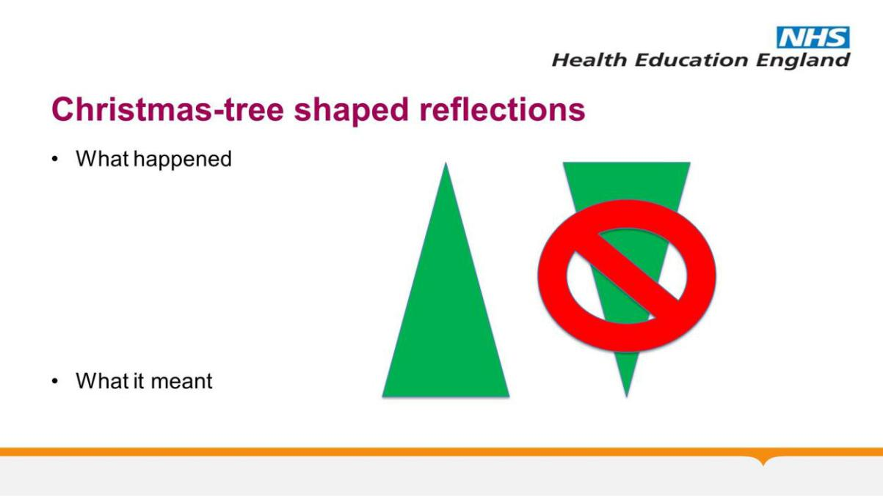

Look again at your entry above. Which shape best represents what you have written?

As an educator there are things that you can do to support learners to provide regular written reflection and to improve their depth of reflection.

Role Modelling – Not essential, but if you can demonstrate that you do this on a regular basis and even share some of your reflections with learners this may be helpful.

Copyright © 2023 NHS England | 77

Aspiring Educators Handbook

Feedback – Provide regular written and verbal feedback on the reflections that learners are producing. If they are regularly providing journalistic entries write in the comments section within the e-portfolio or talk to them about how they can be more reflective. Comments on reflections about further learning opportunities or how to clinically manage a problem may be useful for learners, but it is also important to provide feedback where depth of reflection needs development.

Look for Opportunities – When you are discussing interesting clinical scenarios with learners encourage them to write reflections on those scenarios/discussions. Promote deeper thought with learners when undertaking those discussions and when teaching to provide guidance on how they should approach reflection. The sharing of a deep reflective entry with you about a teaching session or mentorship provides you as an educator with invaluable feedback that what you are doing is of high quality.

Share Your Thought Processes – If a learner is observing your practice or you are discussing clinical scenarios make your thought processes explicit. As professionals, people will often use shortcuts to decision making that they have developed over the years. Highlighting how you have arrived at those shortcuts enables learners to see the endpoint of reflective practice. Sharing uncertainty within practice empowers learners to embrace that uncertainty for themselves and understand that senior colleagues are not infallible.

Promote Safe Reflection – Several high-profile incidents have left learners often confused about what they should write within a reflection. The following may help when trying to reassure them:

- Christmas Trees – Stick to the learning and not what happened.

- Vagueness Improves Anonymity – Consider a 47-year-old man vs a middle-aged patient.

- Reviewing Entries – Before signing off any contentious reflections ensure that you have had a discussion with learners giving them the opportunity to rectify them

Be Aware of Curricular Requirements – For certain groups of learners there is a requirement for a set number of reflective log entries to be completed. For example, for GP learners they need to complete at least 3 clinical case reviews per month whole-time equivalent.

The following link contains some useful advice for learners https://heeoe.hee.nhs.uk/general_practice/e-portfolio-resources.

Now that you have finished this module examine your reflection again. Please look at what you have written above. Is the entry reporting or reflecting? Looking at it again how could you improve the depth of reflection and meaningful learning. If this were a learner you were supervising, what feedback would you provide?

Copyright © 2023 NHS England | 78

Aspiring Educators Handbook

- Clinical Supervisors Report (CSR) (Tier 2B and 3)

This video needs to be watched by those applying for tier 2B and 3. It will need to be

completed prior to the second day of the face-to-face teaching. The video lasts 45 minutes

and can be found here

https://heeoe.cloud.panopto.eu/Panopto/Pages/Viewer.aspx?id=867b6e0b-be39-47f9-b17d-

ad2d00f0b313

Please use the box below to record any important learning points or to make note of any questions that you would like to ask during the face-to-face teaching.

Copyright © 2023 NHS England | 79

Aspiring Educators Handbook

Appendix 5 contains some examples of Clinical Supervisor Reports. Prior to the face-to-face session on day two and now that you have watched the video, please complete the boxes in the appendix. This will feed into the discussion during the face-to-face teaching.

More information about the CSR may be found here https://rcgp.org.uk/getmedia/c4776f1f-1291-4412-9e0f-5b79bee2a3ac/Clinical-Supervisors-Report-for-website.pdf

Once you have completed your review of the cases in appendix 5 you will also need to prepare a CSR for Charlotte (appendix 6). Please complete the blank CSR form below Charlotte’s information as you will need to bring this for the discussion during the face-to-face teaching.

- Applied Knowledge Test (AKT) (Tier 2B and 3)

This video is to be watched by those applying for tier 2B and 3. It needs to be completed before the second day of the face-to-face teaching. Prior to watching this video think back to the last time that you sat a written exam and record in the box below what strategies worked well for you as a learner.

The video lasts 59 minutes and is available here https://heeoe.cloud.panopto.eu/Panopto/Pages/Viewer.aspx?id=bc494b31-8e61-4675-bda3-ad2d00f1e07f

Now that you have watched the video record below what other strategies have you learned to support learners with their written examinations.

Copyright © 2023 NHS England | 80

Aspiring Educators Handbook

More information may be found about the AKT here https://www.rcgp.org.uk/gp-training-and-exams/mrcgp-exam/mrcgp-applied-knowledge-test-akt

- Simulated Consultation Assessment (SCA) (Tier 3)

This video is to be watched by all those applying to become tier 3 educators. It provides some information and helpful tips on the SCA, including the support available within the East of England. Before watching the video thinking about your future educational role, what do you think your role will be in supporting learners to pass the SCA? Think about the specifics of what you may need to be doing with learners.

Now please watch the video which will take 45 minutes to complete. Please do this prior to the second face-to-face day. The video is available here https://heeoe.cloud.panopto.eu/Panopto/Pages/Viewer.aspx?id=1e3b68ac-1036-43c9-87eb-ae3500d18b11

Now that you have watched the video, please use the box below to record your learning and what you think your future educational role in respect of the SCA will involve.

Copyright © 2023 NHS England | 81

Aspiring Educators Handbook

Further information on the SCA may be found here https://www.rcgp.org.uk/mrcgp-exams/simulated-consultation-assessment

Information on exam support for learners within the East of England may be found here https://heeoe.hee.nhs.uk/general_practice/gp-training/gp-trainee/exam-support

- Prescribing Assessment (Tier 3)

This module should be completed prior to the face-to-face teaching by all of those applying to be tier 3 educators. The video lasts 50 minutes and is available here https://heeoe.cloud.panopto.eu/Panopto/Pages/Viewer.aspx?id=9d2ccd3d-9f20-439e-9c9a-ad2d00f67b87

Please use the box below to record any important learning points.

- Educator Notes (Tier 3)

This module is for all delegates applying for tier 3 and should be completed prior to the face-to-face sessions. The video lasts 14 minutes and is available here https://heeoe.cloud.panopto.eu/Panopto/Pages/Viewer.aspx?id=aa2aba92-6ca6-43a5-a1d9-ad2d00f5dd9a

Copyright © 2023 NHS England | 82

Aspiring Educators Handbook

Now that you have watched the video, please use the box below to record your learning. When should educator notes be made? Which educators can make these? How should an educator note be structured? Should you share the educator note with the learner before recording it?

- Educational Supervisors Review (ESR) (Tier 3)

All delegates applying to become tier 3 should watch this video in advance of the face-to-face teaching which should take 36 minutes and is available here https://heeoe.cloud.panopto.eu/Panopto/Pages/Viewer.aspx?id=a4d442ee-c904-4136-8188-ad2d00f4fbe4

This video provides an overview of the practicalities of undertaking an ESR. Please use the box below to record any important learning points. When does a full ESR need to be done instead of an interim one? How frequently do these need to happen? What is the maximal gap between undertaking an ESR and having an ARCP? Whose responsibility is it to organise an ESR?

Copyright © 2023 NHS England | 83

Aspiring Educators Handbook

Further information with some worked examples is available here https://www.rcgp.org.uk/training-exams/training/workplace-based-assessment-wpba/esr-for-workplace-based-assessment

- Understanding the Annual Review of Competency Progression (ARCP) Process (Tier 3)

This section is for those educators wishing to become tier 3. Please work your way through the following prior to the second face-to-face day where you will be discussing various scenarios.

Please watch the following You Tube video which was designed for learners to introduce them to the ARCP process. The video is available here

https://www.youtube.com/watch?v=UyY6HdkzJ0U

What is an ARCP?

ARCP stands for Annual Review of Competence Progression; this is a vital part of the training programme. The ARCP fulfils the requirement of a formal review process to provide a coherent record of the learner’s progress. The following are key functions fulfilled by the ARCP:

- An effective way to review and record evidence related to the learner’s performance within programme.

- Provide a means for the evidence of the formal assessments (WPBAs) and other learning and assessment strategies, including exams, to be collated into a record of progress

- A system of reviewing the out of programme experiences

- Providing opportunity to assess the fitness to practice, via both their own self-declaration and the testament of others (Revalidation)
- Provide a final statement of competence at the programme’s end.

- The essence of this process is assessing the learner’s capability and suitability to progress onto the next year of training or CCT, based on their years’ work and the competences that have been achieved.

What is Revalidation?

Revalidation is the process that all licensed doctors are required to undertake. Every licensed doctor must demonstrate on a regular basis that they are fit to practise and up to date with their chosen speciality, this includes demonstrating their ability to provide a good level of care.

Health Education England is the organisation responsible for doctors in training and therefore has the responsibility to monitor and facilitate appropriate revalidation. This is linked with the ARCP process and the Form R, which is a self-declaration of fitness to practise. Non-engagement in this process could result in a referral to the GMC. Learners are revalidated every 5 years and at CCT.

Copyright © 2023 NHS England | 84

Aspiring Educators Handbook

The Panel

A total of 3 panel members needs to be present to be compliant with the Gold Guide. The panel should consist of the following:

- Panel Chair – Dean, Deputy Dean, Associate Dean or TPD
- 2 panels members – this can be an ES or any of the above
- Lay representative –10% of all outcomes – central panel only
- External advisor – for 10% of central panels only – central panel only

It can be beneficial to have an administrator present to give advice on process and ensure that everything runs smoothly, although this is not essential.

During covid-19 the requirement minimum of panel members has been reduced to 2.

Panels are taking place via video conferencing during covid-19, as meeting face to face is not possible.

It is also possible to do a virtual ARCP. This is carried out using an email template.

Who needs to have an ARCP?

In short, everyone in training and some of those out of programme (OOP) need an annual review on a calendar basis. This includes all those in less than full time training (LTFT) and all those out of programme on experience or research (OOPE/R). Those on Maternity leave, compassionate leave, sick leave and any other out of programme career break reasons do not need an ARCP until they are back in programme, they do need to submit a Form R part B. Learners will need an ARCP before they go on maternity leave or any other planned break where there has been more than 4 months of education since their previous ARCP. It helps to assess this time before their planned absence starts. They also require an ARCP before they Inter Deanery Transfer (IDT) out of the region.

ARCP Outcomes

Outcome 1 – satisfactory progress

Satisfactory progress – Achieving progress and the development of competences at the expected rate.

The trainee has provided all the necessary evidence and is deemed to be progressing at the appropriate rate for that point in the training programme.

Outcome 2 – Development of specific competences

Development of specific competences required – Additional training time not required Progress has been acceptable overall but there are some competences that have not been fully achieved and need to be further developed. It is not expected that the learner will need additional time to address these competencies. Learners must be present at their ARCP when this outcome is being given and have the right of appeal.

Outcome 3 – Inadequate progress (additional training time)
Inadequate progress – Additional training time required.

The panel has identified that a formal additional period of training is required that will extend the duration of the learner’s programme. Where such an outcome is anticipated, the learner

Copyright © 2023 NHS England | 85

Aspiring Educators Handbook

must attend the panel meeting. Extensions can be awarded at any point throughout the year. The learner, educational supervisor and employer will need to receive clear recommendations from the panel about what additional learning is required as well as the circumstances under which it should be delivered (e.g., concerning the level of supervision).

The learner has the right to appeal this decision if they are not happy with this. The outcome 3 although given based on a lack of or slow progress is not a punitive outcome and will be meant as a supportive measure to allow the learner more time to complete their programme.

Outcome 4 – Released from training programme.

Outcome 4 Released from training programme – With or without specified competences. The panel will recommend that the learner is released from their programme where there is still insufficient and sustained lack of progress despite having had additional time to address concerns over progress. The learner must be present at their ARCP and may appeal the decision.

Outcome 5 – incomplete evidence presented.
Outcome 5 - Incomplete evidence presented – Additional training time may be required.

The panel can make no statement about progress or otherwise since the learner has supplied either no information or incomplete information to the panel. Usually, learners are advised to provide missing information within the next two weeks. Depending upon whether the information supplied is acceptable or not the ARCP panel may then choose to give a satisfactory outcome (1) or arrange a face-to-face ARCP panel to discuss issuing a non-standard outcome (usually 2, 3 or 4).

Outcome 6 – Gained all the required competences.

Gained all required competences – Will be recommended as having completed the training programme (core or specialty) and if in a run-through training programme or higher training programme, will be recommended for award of a CCT/CESR(CP)/CEGPR(CP)

An outcome 6 is the recommendation to the RCGP that the learner is fit to practise as a GP and has completed all competences.

During Covid there were additional outcomes that an ARCP panel could issue which implied that a learner had failed to progress not due to their own fault but that of the conditions of the pandemic.

The Evidence

All learners having a standard ARCP will need the following evidence:
- Educational Supervisors Report (within 8 weeks of the ARCP panel)
- Form R Part B (For revalidation purposes)

- Evidence of satisfactory WPBA (Please see the link below for requirements) https://www.rcgp.org.uk/mrcgp-exams/wpba/asssessments

- Wider Scope of Practice form (To be used when a learner has a second medical role outside of their programme, for example, some learners may run a cosmetic clinic)

Copyright © 2023 NHS England | 86

Aspiring Educators Handbook

Local ARCP Panels

Most learners will have a local panel either in June or December (depending upon when they started their programme). Local ARCP panels are held without the learner. These panels are only suitable for those learners who are progressing as expected. Local ARCP panels may issue outcomes 1, 6 and 5.

Central ARCP Panels

Where there are concerns re learner progression a central ARCP panel will need to happen. This will be the case where there has been non-engagement and a non-standard outcome is anticipated. Those learners resigning will also require a central ARCP. Central ARCP panels may issue any of the outcomes.

It is important to note that central ARCP panels will not automatically happen where the ESR is non-standard, and it is therefore important that should you grade an ESR as “Panel Opinion Requested” or “Unsatisfactory” that you inform the local administrative team as they will need to arrange this.

As an educator you should be aware of the following points such that your learners are prepared should they be required to attend a central ARCP panel

- Ensure that they have completed and uploaded their form R

- You may wish to make an educator’s note as to why they need to be referred to central panel

- Discuss with the learner the likely outcome that the panel will give them
- Signpost them to support such as PSW and the TPDs
- The outcome will be decided before the panel meets the learner and is no negotiable
- They will be asked about possible mitigating circumstances.
- They will be sent information on the outcome given and how to appeal this if relevant.

Following ALL panels, you should sit to meet with your learner to discuss the outcome of the ARCP panel and how you are going to address any recommended actions. Learners must accept the outcome of the ARCP panel in their e-portfolio.

During the face-to-face session there will be the opportunity to discuss some ARCP scenarios. These are within the section “Face to Face Resources and Reflection”. You

should consider the scenarios and start to write down some of your thoughts prior to the session.

- Plenary Session including Suggested Personal Development Plan (PDP) (All tiers)

At the end of the face-to-face teaching for the Primary Care School Educator Specific Content there is an opportunity for you to share your learning and ask any further questions

Copyright © 2023 NHS England | 87

Aspiring Educators Handbook

you may have. Please use the box below to note any particularly important learning points or points of clarification that you may have.

As a recognised educator you will need to maintain a PDP that reflects this role. Please list 2

– 3 suggested PDP objectives. These should be Specific, Measurable, Achievable, Relevant and Timebound, and represent your educational rather than clinical role. These will be agreed during the face-to-face sessions.

Objective

Complete By

(Month/Year)

Copyright © 2023 NHS England | 88

Aspiring Educators Handbook

Face-to-Face Resources and Reflection

1. COTs, Audio-COTs and CEPS (All Tiers)

Now that you have completed the face-to-face session, please take a moment to record some of your reflection on your learning below. How was your assessment of the COT and CEPS as compared to your peers? Are you a “Hawk” or a “Dove”? Do you fall foul of the “Halo Effect”? How and when will you undertake these assessments? Are there any practical considerations for you personally in this regard? Is there any further learning or reading that you think you need to do at this point?

2. Urgent and Unscheduled Care (All Tiers)

Please use the box below to record any final reflections on your role in facilitating and assessing urgent and unscheduled care. Are there other people within your organisation who need to be aware of the learning, for example, if you are within a new learning organisation does the practice manager need to be aware? How does your role change if you are a clinical supervisor in an organisation where no educational supervisor is present? Is there any further information that you need to find out? What is the role of wider workforce?

Copyright © 2023 NHS England | 89

Aspiring Educators Handbook

3. Case Based Discussion / Care Assessment Tool (Tiers 2B/3)

Once you have completed the face-to-face session take some time to reflect on some of your key learning points. Are you confident in when you should undertake a CAT and when this should be a CBD? What different types of CAT are there? How do CBDs and CATs differ in terms of preparation? Were your gradings like that of other people? How can you make the agreed actions more tangible?

4. Consulting and Feedback Exercise (Tiers 2B/3)

During this exercise within small groups, you will practice giving feedback. The clinical cases are contained in appendix 4. Once you have completed the exercise, please record some reflection of your learning below. What have you learnt about yourself when providing feedback? Are you focused or not? How do you think you would approach a learner who lacks insight into their performance?

Copyright © 2023 NHS England | 90

Aspiring Educators Handbook

5. Reflective Learning Log (Tiers 2B/3)

When asked to do so by the facilitator please provide a reflection on a recent clinical encounter in the boxes below. It is important that you do not provide any patient specific details within this. Please do not copy the entry provided from the preparatory session on reflective learning logs.

What Happened?

What, if anything happened

subsequently?

What did you learn?

What will you do differently in future?

What further learning needs did you

identify?

How and when will you address

these?

Once you have completed the reflection above now start to think about which of the professional capabilities you think you could link this reflection to. You may link this to up to 3 different capabilities. The description of these is available here https://www.rcgp.org.uk/gp-training-and-exams/training/workplace-based-assessment-wpba/capability-framework Please do not complete the justification side of the table at this stage. This will be for the tier 3 delegates only when instructed to do so.

Suggested Capability

Justification for this (How does the entry

provide evidence of this capability?)

Copyright © 2023 NHS England | 91

Aspiring Educators Handbook

Once you have completed the session on reflection during day 2, please record in the box below what you have learnt. How will you encourage learners to reflect on a regular basis? What strategies have you learnt for increasing the depth of their reflection?

6. Clinical Supervisors Report (Tiers 2B/3)

Once you have completed the face-to-face teaching, please use the box below to reflect on any useful learning. What have you learnt about your style of feedback? What is important to include in a CSR? What should be avoided when undertaking a CSR?

- Applied Knowledge Test and Recorded Consultation Assessment Plenary (Tiers 2B/3)

Copyright © 2023 NHS England | 92

Aspiring Educators Handbook

Once you have completed the face-to-face session, please use the box below to record any further important learning points that will help you to support learners with their exams.

8. Educational Supervisors Review (Tier 3)

Once you have completed the session on ESR please use the box below to record any further useful learning that will help you to improve the quality of your ESRs.

9. Annual Review of Competency Progression (ARCP) Panels (Tier 3)

The following scenarios will be discussed during the face-to-face session. You may wish to note some initial thoughts prior to the session but this is not essential.

Scenario 1

ST1 working full-time.

ST1 Local ARCP panel taking place in June.

Copyright © 2023 NHS England | 93

Aspiring Educators Handbook

4 CBDs and 3 COTs/mini-CEXs (HINT – How many assessments are required?) Everything else in place

What is the possible outcome?

Scenario 2

ST1 working at 60% less than full-time.

Local panel held in June at anniversary of start date.

- CBDs and 3 mini-CEXs Is this an issue?

Scenario 3

ST1 struggling to engage with e-portfolio during their A+E placement

Clinical experience group coverage limited and not enough evidence to fully demonstrate capabilities at the time of their first interim ESR

What options does the educational supervisor have?

Would this involve an ARCP panel?

Copyright © 2023 NHS England | 94

Aspiring Educators Handbook

Scenario 4

At the time of the next ESR things have not really improved and engagement remains poor

Missing mandatory assessments and clinical experience group coverage is poor.

What ESR outcome will you give?

What outcome will the ARCP panel give?

Scenario 5

ST3 who has passed both exams and has completed all their WPBA BLS/AED is out of date as is their safeguarding level 3 What would the ARCP panel do?

Would this be any different if the BLS/AED were in date at the time of the panel but due to expire before the qualification date?

Scenario 6

An ST3 on an extension has failed their SCA for the second time.

You are a panel member and note that the ES has given satisfactory progress as part of their interim ESR

Is this an issue?

What will the ARCP panel do?

Copyright © 2023 NHS England | 95

Aspiring Educators Handbook

Scenario 7

An ST3 is being considered at their final ARCP. Everything appears to be satisfactory apart from their PDP. The panel note that they have 16 uncompleted objectives dating back over the last 2 years, only one of which was not generated from an ESR. The objectives don’t appear to be particularly SMART either.

What outcome do you give?

Scenario 8

An ST2 has been involved in a serious untoward incident that is ongoing at present

They have declared this on their form R.

They are due to have a local ARCP panel as everything else is satisfactory.

Can this still happen locally?

What is the likely outcome?

What if the learner had not declared this on their form R?

Scenario 9

Copyright © 2023 NHS England | 96

Aspiring Educators Handbook

An ST3 due to qualify declares a serious untoward incident on their form R that has been resolved and they have reflected on this.

Is this, OK?

What if the incident was not resolved at the time that the learner was due to qualify?

Scenario 10

An ST3 due to qualify has declared time off for sickness of 16 days since their last ARCP. The evidence on their e-portfolio is exemplary and there are no concerns about their capability.

Does this matter? What should you do?

What if they had declared 30 days of sickness?

What if this was an ST2 with unsatisfactory progress?

Scenario 11

You complete a final ESR for an ST3 and sign them off as satisfactory.

Two weeks later you are advised that you have marked one of the capabilities as “Meeting Expectations”

What happens now?

Copyright © 2023 NHS England | 97

Aspiring Educators Handbook

Scenario 12

Your current learner is due to start maternity leave in a month.

Their last ARCP was 10 months ago.

What should happen in this scenario?

What if their last ARCP was 2 months ago but they are planning to be off for a year?

Copyright © 2023 NHS England | 98

Aspiring Educators Handbook

- Agreed PDP (All Tiers)

Following the plenary session please use the box below to document your agreed PDP objectives as an educator. It is important that you note these as you will need to demonstrate you have achieved them by your next self-assessment.

Agreed PDP Objective

Complete By

(Month/Year)

Copyright © 2023 NHS England | 99

Aspiring Educators Handbook

CONGRATULATIONS!

Well done on making it this far. Your facilitator will have advised you if you have successfully completed the course and if you are recommended for recognition as an educator within the East of England. We look forward to working with you over the years to come. Your details will be passed to the Primary Care School Quality Oversight Panel and once the decision is ratified the training hub will write to you to confirm that you have been recognised and at which tier.

Please take a moment to review the ongoing quality monitoring requirements for your tier within appendix 2. If you are recognised as a tier 2A you should contact your local OOH provider where you are planning to work and the local GP Training Programme Directors. If you are recognised as either tier 2B or 3 please also introduce yourself to the GP Training Programme Directors and your local training hub.

Copyright © 2023 NHS England | 100

Aspiring Educators Handbook

Appendix 1 – List of Abbreviations

Within clinical and medical education there are many acronyms. Please find below a list of some of the more commonly used ones for your information.

AD – Associate Dean. Strategic responsibility for managing issues across or within schools.

Advanced Care Practitioner – Any practitioner operating at Masters Level. Adheres to the four pillars of advance practice.

AKT – Applied Knowledge Test. A computer-marked summative examination of GP learner’s clinical knowledge.

AP – Advanced Practice.

ARCP – Annual Review of Competency Progression. This is an annual assessment used to determine whether a learner should progress to the next stage of training.

Audio-COT – Audio Consultation Observation Tool. An assessment of a telephone consultation within primary care.

CAT – Care Assessment Tool. A discussion about an individual case, planned or developed during debriefing, a post-prescribing assessment review or a professional conversation that allows a learner to demonstrate their capability.

CBD – Case Based Discussion. A clinical case that a learner prepares in advance of being assessed on and then uses that case to demonstrate their capability within different domains.

CCT – Certificate of Completion of Training.

CEPS – Clinical Examination and Procedural Skills. An assessment of a practical procedure.

This could be an examination or a therapeutic procedure, for example, a joint injection.

COT – Consultation Observation Tool. An assessment tool used to assess learner encounters with patients in primary care.

CS – Clinical Supervisor. Responsible for the overall clinical experience (named clinical supervisor) or responsible for ensuring patient safety and daily clinical supervision.

CSR – Clinical Supervisors Report. A report that evaluates the clinical performance of an individual learner and is usually completed by a named clinical supervisor.

DA – Differential Attainment. The attainment gap between learners from different ethnic origins.

Copyright © 2023 NHS England | 101

Aspiring Educators Handbook

ES – Educational Supervisor. Responsible for educational supervision of learners.

ESR – Educational Supervisors Report. A report produced by a named educational supervisor indicating the progress that a learner is making educationally.

DOPS – Direct Observation of Procedural Skills. Structured assessment of a procedure.

FCP – First Contact Practitioner. Someone who is a first point of contact for assessing patients.

HDR – Half Day Release. Weekly teaching for learners.

HEI – Higher Educational Institute. i.e., a university.

HOS – Head of School. Responsible for the running of specific schools within Health Education England.

IMG – International Medical Graduate. Someone whose primary medical qualification was awarded outside of the UK.

LTFT – Less than full-time. This applies to learners who are working less than full-time.

Mini-CEX – Mini-Clinical Evaluation Exercise. This is an assessment of an individual learner’s interaction with a patient.

MSF – Multi-source Feedback. An assessment collating feedback from various colleagues.

OOP – Out of Programme. This occurs when a learner decides to have a break from their course and may be for several reasons (maternity, ill health, elective experience, academic opportunities etc.)

OSCE – Objective Structured Clinical Examination. This usually involves a specific task that a learner must undertake and is then assessed against an objective checklist.

PA – Physican’s Associate. Degree level professional who can see and treat patients under supervision.

PDP – Personal Development Plan. Objectives that will help to drive learning and development. Please see SMART below as to how these should be agreed.

PSQ – Patient Satisfaction Questionnaire. Structured feedback collated from a specified number of patients.

SCA – Simulated Consultation Assessment. One of the GP summative assessments in which videos of consultations are submitted.

SMART – Specific, Measurable, Achievable, Relevant, Time bound. Usually used for PDP/learning objectives.

Copyright © 2023 NHS England | 102

Aspiring Educators Handbook

SOX – Support on Extension. There is SCA-SOX and AKT-SOX which are additional support for GP learners needing to pass their summative assessments.

ST – Specialist Trainee.

SuppoRRT – Supported Returning to Training. This is a programme whereby learners who have been out of programme for 3 months or greater may have a period of shadowing for two weeks prior to starting work fully.

TAB – Team Assessment of Behaviour. This is an assessment of a learner’s overall professional behaviours.

TPD – Training Programme Director. Responsible for the running of a specific training programme.

WPBA – Workplace Based Assessment. This is an overall term for the various assessments listed above.

Copyright © 2023 NHS England | 103

Aspiring Educators Handbook

Appendix 2 – Ongoing Quality

Monitoring

Once recognised as a GP educator within the East of England you are required to maintain your capability. The requirements for GP educators within the Primary Care School are as below. These will be assessed by way of a self-declaration which you will need to submit to your local training hub initially at 2 years and then 4-yearly. Further information on the requirements and self-declaration is available here https://heeoe.hee.nhs.uk/general_practice/ongoing-quality-monitoring
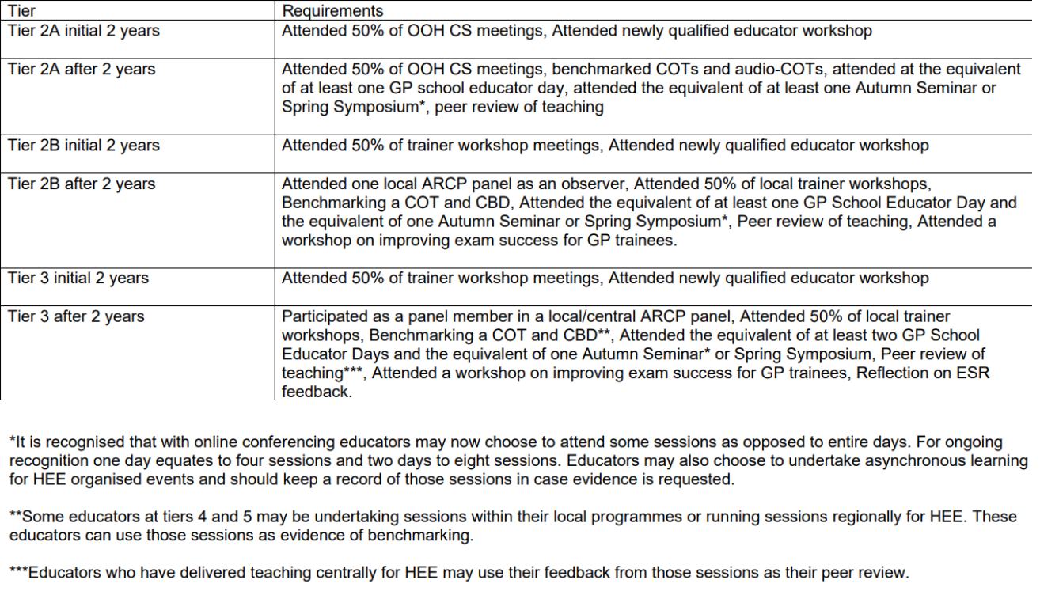

Copyright © 2023 NHS England | 104

Aspiring Educators Handbook

Appendix 3 – List of Training Hub Contacts

Training Hub | Email Address
Bedfordshire, Luton, and | ccs.blmk.traininghubqualityteam@nhs.net
Milton Keynes
Cambridgeshire & | cpth.qualityteam@nhs.net
Peterborough
Hertfordshire & West Essex | hwetraininghub@nhs.net
Mid and South Essex | primarycare.workforce@nhs.net
Norfolk & Waveney | norfolkwaveneytraininghub@nhs.net
Suffolk & North East Essex | snee.traininghub@nhs.net

Copyright © 2023 NHS England | 105

Aspiring Educators Handbook

Appendix 4 – Patient Encounter

Scenarios

All cases belong to Bury St Edmunds GP Speciality Training Scheme (© 2020) and are reproduced here solely to assist delegates become tier 3 educators. Delegates attending the Primary Care School Specific Aspiring Educator Training are not to copy or distribute these cases without permission from Bury St Edmunds GPSTP.

Because everyone taking part in this exercise is a health professional, it isn’t a major problem if the roleplaying practitioner has seen the briefing notes. The purpose of the exercise is for the Observer to practice giving feedback and discussing what further learning might take place with the practitioner after the roleplay is complete.

If there are fewer than 4 delegates in a Zoom Breakout room, you don’t need to do every case, and you can choose to repeat a case if you wish. But it is compulsory for everyone to practice being the Observer at least once.

- Case 1

Notes for Practitioner

Mrs Grace Thompson, Aged 29

4months postnatal with child, a baby girl called Anna.

Has become increasingly low and withdrawn since birth of baby.

Poor sleep pattern and overly anxious about baby’s health.

Feels ashamed and guilty that she is feeling this way as she has a beautiful daughter and a very supportive and loving husband.

Notes for Patient:

Opening statement from role player: “I didn’t want to come, but my husband feels I should talk to you about how I’m feeling.”

Role player’s manner- clearly unhappy, poor eye contact. Tearful on talking.

You are 4 months postnatal with your first child, a girl called Anna.

You and your husband were so excited about this planned pregnancy, but you have become increasingly anxious, tearful and depressed.

You feel so guilty for feeling like this as you have everything you ever wanted. Now you feel you are ruining it all.

Copyright © 2023 NHS England | 106

Aspiring Educators Handbook

You are sleeping very poorly and continually anxious about Anna’s health. She has been seen by a GP and OOH 4 times in the last month worried she has a chest infection. Paramedics were called on one occasion. Nothing is ever found.

You suffered from depression 3 years ago due to work related stress. You had counselling and citalopram.

You feel as if you are the worst mother and wife. You have never thought of harming yourself or the baby.

You have become increasingly isolated from your friends. Your mum lives an hour’s drive away and helps as often as she can, but your dad has Parkinson’s.

You are normally fit and well. Non-smoker.

- Case 2

Notes for Practitioner

Sarah/Sam Lewis is 48 years old and has no PMH of note.

Sarah/Sam attended a Health Check clinic that she/he received an online discount voucher for. They did a lot of blood tests that were normal (renal function/glucose/FBC/random cholesterol), found her/his blood pressure was 124/75 and advised her/him to lose weight (she has a BMI of 31).

The nurse who checked her/him told her she/he had a rapid, irregular pulse and advised that she/he should check that.

A colleague spoke to her on the phone and these notes appear:

Dr I.M. Holidaying-Nextweek, 24th June 2020, 9.58am

Paid for health check. Was told pulse irregular and the nurse didn’t do anything except tell the patient to see us instead. No symptoms of note. ECG and follow up with GP next week. (I will be away so needs to follow up with colleague.)

Notes for Patient

You’re a bit scared. You only went to have a health check because you got an email discount voucher for it, and it’d be a good New Year Resolution. Now the nurse tells you

Copyright © 2023 NHS England | 107

Aspiring Educators Handbook

you’ve got Tachycardia, or Atrial Fibrillation, or both. Either way, it sounds scary. There’s something wrong with your heart, and you might drop dead at any minute.

The FCP on the phone didn’t seem to worry that you might drop dead and didn’t make you an appointment until today. Hopefully, this practitioner will listen more.

You have no symptoms of note, but your father died of a heart attack when you were a teenager, and you’re a single mum/dad after your spouse died in a car accident. You’re scared that your 13 and 10-year-old sons might have no one to bring them up if anything happens to you.

You eat a little too much junk food- you know you’re overweight but it’s so hard to make the time to do anything about it, though you’re trying Weight Watchers now- but you drink very rarely (who has time for that with two children?) and you’ve never smoked. Apart from your dad, who died of a sudden heart attack when he was 58, you have no family history of note. You work as a local town planning administrator.

You might be scared when strokes and similar risks of AF are explained, or risks of GI bleeding, but will engage with and agree with anticoagulation if sensitively explained.

Your examination findings:

Pulse 90-110 irregularly irregular

BP 124/75

No clinical failure, CRT 2s, warm peripheries.

No oedema

No added chest sounds, heart sounds normal.

ECG:

Rate 90bpm, irregular, normal axis.

No P waves, normal QRS complexes and T waves.

No ST changes of note.

- Case 3

Notes for Practitioner

Dr Cecily/Charles Ward 68yo retired Professor of Psychology.

Retired 3 y ago from Oxford University.

Married to a retired accountant.

Copyright © 2023 NHS England | 108

Aspiring Educators Handbook

Two sons, both married and living abroad.

Normally fit and well.

Notes for Patient:

Opening Statement

“I’m very concerned that I may be losing my memory.”

Role player’s manner:

Clearly concerned, has always prided herself on her academic abilities, feels doomed.

Role player’s agenda and main problems:

For the last 6 months she and her spouse have noticed some loss of short-term memory, for example, forgetting the name of a friend she was on the phone to that day, or often forgetting what she had done the day before. Nothing extreme but happening more frequently.

She watched her mother ‘slowly fade away’ and die of dementia 8 y ago. She was aged 82. You remember this as if it were yesterday and have always worried that you will go the same way.

You have continually expanded your mind and lived in academic circles hoping to stave off any form of dementia. You say you would rather die now than slowly lose my mind to dementia.

Since retiring 3 y ago you feel as if you have lost so much, now you feel you are losing your mind. You describe dementia as a shadow that you can’t get rid of. You admit you have become quite tearful and a little withdrawn in case your colleagues’ comment on your memory.

You are normally fit and well, you go to the local gym, eat well and enjoy travel.

Your mother died following pneumonia and your father had a heart attack aged 70 and died a couple of days later.

- Case 4

Notes for Practitioner

Telephone call about Charlie Green, Aged 5

Lives with parents, dad is an accountant, mum stays at home.

One sibling aged three.

All immunisations up to date

PMH:

Copyright © 2023 NHS England | 109

Aspiring Educators Handbook

- 9 months ago, Immunisations for family holiday in Turkey.

- 8 months ago, URTI – reassured. Mum wanted antibiotics but agrees to wait and see.

- 8 months ago – 2 days later

Visit request – temperature. For last 8 hours. Advised calpol. Came down to the surgery, well child, aural temperature 37.3, sore throat, ears NAD, reassured.

- 7 months ago – pharyngitis – reassured, advised calpol.

- 5 months ago- Gastroenteritis when on holiday in Turkey last week. Bought OTC antibiotics, Charlie got a rash. On exam well, alert hydrated, abdo soft, reassured no further treatment needed. Mum not very happy, would like investigations, stool sample sent – NAD.

- 3 months ago – otitis media – ears a little red, deferred prescription offered for antibiotics mum keen to have them now. Amoxicillin 125/5 5ml tds 100mls.

- 2 months ago – tummy ache. Imp mesenteric adenitis, reassured.

- 1 month ago – dry skin on leg, small bruise on ankle. Reassured.

Medication: None

Notes for Role-player

Opening statement from role-player: “I’m phoning for someone to come now please.

Charlie has been sent home from school today because he was sick at lunchtime, and he’s just been sick again three times.”

Role-player’s manner – very worried – you are a very anxious frequent consulter who needs reassurance on every minor illness – but you don’t want to come out with Charlie in case he’s sick in the car.

Role players agenda and main problem:

Charlie is usually very well.

He was apparently sick in a lesson at school today, so you were asked to collect him. He was sick again in your car on the way home and you have put him to bed.

He was perfectly well this morning. Nobody else in the family is ill.

He’s not got a temperature nor a rash. He has no pain, headache, stiff neck nor light intolerance.

If you’re asked what he’s doing now, he is currently watching TV in his room. You’ve made him stay in bed.

You don’t want to bring him out as he’s been sick three more times since then and your spouse doesn’t want him being sick in the car.

You’ve been trying to give him fluids.

Copyright © 2023 NHS England | 110

Aspiring Educators Handbook

Each time he vomited you immediately gave him a large glass of water as your spouse felt that this would stop him getting dry. He was sick again each time – three more times in all.

There is no blood or bile. He is not disorientated, drowsy or ill.

Your spouse is upset as when people are sick it makes him sick too.

Your spouse says the doctor should come out right now and give Charlie something to stop him vomiting. Before he gets dehydrated. You don’t drive and your spouse won’t have Charlie in the car as he might be sick. Your spouse has a phobia about vomiting.

You are asking for a visit as you are an anxious parent wanting an immediate cure.

If the doctor can reassure you and explain that there isn’t really anything that can be given to stop the vomiting but that regular small sips may help the situation, then you will accept this advice.

Copyright © 2023 NHS England | 111

Aspiring Educators Handbook

Appendix 5 – CSR Cases

- Case 1

Professionalism

Includes being respectful, diligent and self-directed in their approach to patients and others and to their own learning needs, developing resilience, making appropriate ethical decisions

Capabilities: Maintaining Performance Learning and Teaching, Ethics, Fitness to practice

Areas of strength: Several colleagues have complained that lacks respect for more junior members of the team. Often leaves tasks unfinished and other team members have to pick them up. Poor punctuality. Appears to have basic knowledge and prefers to ask other staff members to fill the gaps rather than addressing them personally.

Areas to develop: Needs to become more self-reliant and demonstrate greater initiative. To work on relationship with colleagues and ensure that handover is appropriate.

Rating: Significantly below expectations

Communication

Includes communication with patients, establishing patient rapport, managing challenging consultations, third-party consulting, the use of interpreters.

Capability: Communication and consultation skills

Areas of strength: I have not received any patient complaints about them.

Areas to develop: Poor communication with colleagues and an air of superiority demonstrated with junior staff and non-medical colleagues. Needs to avoid use of jargon when talking to patients. Poor English. Written communication is brief and gives no indication of intended management plans.

Rating: Significantly below expectations

Working with colleagues and in teams

Includes working effectively with others, sharing information with colleagues, leadership, management and team-working skills.

Capabilities: Working with colleagues and in teams, Organisation, Management and Leadership

Areas of strength: MSF was ok.

Areas to develop: As above. Has offended several members of staff. Poor handover and leaving tasks for other members of staff to pick up. Availability at times is a problem. Does not always answer emergency bleeps in a timely manner.

Copyright © 2023 NHS England | 112

Aspiring Educators Handbook

Rating: Significantly below expectations

Clinical Assessment

Includes patient history, Clinical Examination and Procedural Skills (CEPS), choosing investigations, and making an appropriate diagnosis or decision. Please also comment on clinical skills that have been observed.

Capabilities: Data Gathering, CEPS, Making a diagnosis / decisions

Areas of strength: Has completed several CEPS during this post although most of them illustrate a rudimentary approach to examinations.

Areas to develop: Clinical information gathered is often stunted, presented in an illogical way and lacks clarity of further management. Often requests excessive investigation and interpretation of these results is at times erroneous. Lacks confidence in decision making.

Rating: Significantly below expectations

Management of Patients

Includes recognition and appropriate management of medical conditions encountered in the role, prescribing safely, and taking account of co-morbidity, polypharmacy. Managing uncertainty & risk

Capabilities: Clinical management, medical complexity

Areas of strength: No significant events or patient safety incidents yet. Asks for senior help constantly.

Areas to develop: Management plans lack clarity. Unable to handle complex situations where there is more than one problem. Prescribing is not always correct. Often prescribes the wrong dose or timings of medication. Not good at handling uncertainty.

Rating: Significantly below expectations

Clinical record keeping

Includes showing an appropriate use of administration systems, effective and appropriate record-keeping and use of IT for the benefit of patient care.

Capabilities: Organisation, Management and Leadership

Areas of strength: Uses the computer to record notes.

Areas to develop: Written communication in the record is poor and does not provide others with a sense of direction for the patient. Notes are excessive with lots of information that is irrelevant and this makes it difficult to find the important things.

Rating: Significantly below expectations.

Context of Care

Copyright © 2023 NHS England | 113

Aspiring Educators Handbook

Includes seeking to understand and support patients through an appreciation of the interplay between their disease and their lives and considering local pathways, formularies and resources.

Capabilities: Holistic care, Community orientation

Areas of strength: Shows some awareness of various protocols and pathways, but this is not at the level I would expect of someone in this post.

Areas to develop: Does not tend to follow formulary guidelines. Treats disease rather than illness and tends to prescribe for every condition. Fails to see what other members of the multidisciplinary team can offer patients. Rarely determines the social context of patients.

Rating: Significantly below expectations

Case 1

What is good about this

CSR?

How could the CSR be

improved?

- Case 2

Professionalism

Includes being respectful, diligent and self-directed in their approach to patients and others and to their own learning needs, developing resilience, making appropriate ethical decisions.

Capabilities: Maintaining Performance Learning and Teaching, Ethics, Fitness to practice

Areas of strength: Excellent at addressing their learning needs

Areas to develop: Continue current progress.

Rating: Above expectations

Communication

Includes communication with patients, establishing patient rapport, managing challenging consultations, third-party consulting, the use of interpreters.

Capability: Communication and consultation skills

Areas of strength: Clear communication with colleagues and patients

Copyright © 2023 NHS England | 114

Aspiring Educators Handbook

Areas to develop: Aim to present at the next clinical meeting.

Rating: Above expectations

Working with colleagues and in teams

Includes working effectively with others, sharing information with colleagues, leadership, management and team-working skills.

Capabilities: Working with colleagues and in teams, Organisation, Management and Leadership

Areas of strength: Excellent MSF.

Areas to develop: Continue to develop good relationships with staff.

Rating: Above expectations

Clinical Assessment

Includes patient history, Clinical Examination and Procedural Skills (CEPS), choosing investigations, and making an appropriate diagnosis or decision. Please also comment on clinical skills that have been observed.

Capabilities: Data Gathering, CEPS, Making a diagnosis / decisions

Areas of strength: Solid clinical assessment throughout this placement

Areas to develop: Practice neurological examination.

Rating: Above expectations

Management of Patients

Includes recognition and appropriate management of medical conditions encountered in the role, prescribing safely, and taking account of co-morbidity, poly-pharmacy. Managing uncertainty & risk

Capabilities: Clinical management, medical complexity

Areas of strength: Assessment of patients is excellent at all times.

Areas to develop: Gain more experience in managing patients with chronic disease.

Rating: Above expectations

Clinical record keeping

Includes showing an appropriate use of administration systems, effective and appropriate record-keeping and use of IT for the benefit of patient care.

Capabilities: Organisation, Management and Leadership

Areas of strength: Very IT literate

Copyright © 2023 NHS England | 115

Aspiring Educators Handbook

Areas to develop: Working on a project to improve the organisation’s website

Rating: Above expectations

Context of Care

Includes seeking to understand and support patients through an appreciation of the interplay between their disease and their lives and considering local pathways, formularies and resources.

Capabilities: Holistic care, Community orientation

Areas of strength: Understands the lived experience of patients.

Areas to develop: Read more about local pathways.

Rating: Above Expectations

Case 2

What is good about this

CSR?

How could the CSR be

improved?

- Case 3

Professionalism

Includes being respectful, diligent and self-directed in their approach to patients and others and to their own learning needs, developing resilience, making appropriate ethical decisions.

Capabilities: Maintaining Performance Learning and Teaching, Ethics, Fitness to practice

Areas of strength: Appears respectful towards patients and others. Very reliable. Good at addressing their learning needs.

Areas to develop: At times tends to take too much responsibility for patients and often late in asking seniors for help. Tending to stay after contracted hours to complete tasks on a regular basis.

Rating: Meets expectations

Communication

Copyright © 2023 NHS England | 116

Aspiring Educators Handbook

Includes communication with patients, establishing patient rapport, managing challenging consultations, third-party consulting, the use of interpreters.

Capability: Communication and consultation skills

Areas of strength: Communicates well with patients and colleagues. Adapts language appropriately when explaining to patients. Is aware of the use of interpreters and avoiding family members to interpret those unable to speak English. Has a pleasant manner.

Areas to develop: Struggles with difficult conversations with patients. Can talk too quickly when presenting in front of large groups.

Rating: Meets expectations

Working with colleagues and in teams

Includes working effectively with others, sharing information with colleagues, leadership, management and team-working skills.

Capabilities: Working with colleagues and in teams, Organisation, Management and Leadership

Areas of strength: good team player and helps out others whenever can. Appreciates the role of non-medical staff. Handover is appropriate.

Areas to develop: Takes a back seat in MDTs and does not contribute much. Happy to let others lead.

Rating: Meets expectations

Clinical Assessment

Includes patient history, Clinical Examination and Procedural Skills (CEPS), choosing investigations, and making an appropriate diagnosis or decision. Please also comment on clinical skills that have been observed.

Capabilities: Data Gathering, CEPS, Making a diagnosis / decisions

Areas of strength: Solid examination skills. Information gathering generally appropriate for the problem. Most diagnoses seem sensible.

Areas to develop: Lacks confidence when situations are complex but does seek senior help in those situations. Tends to request more investigations than are absolutely necessary.

Rating: Meets expectations

Management of Patients

Includes recognition and appropriate management of medical conditions encountered in the role, prescribing safely, and taking account of co-morbidity, polypharmacy. Managing uncertainty & risk

Capabilities: Clinical management, medical complexity

Copyright © 2023 NHS England | 117

Aspiring Educators Handbook

Areas of strength: Awareness of own limits and when to seek help. Demonstrated safe prescribing and use of local protocols for managing various conditions.

Areas to develop: Less confident in managing patients with multiple conditions. Has not had much opportunity to demonstrate skills in managing chronic disease.

Rating: Meets expectations

Clinical record keeping

Includes showing an appropriate use of administration systems, effective and appropriate record-keeping and use of IT for the benefit of patient care.

Capabilities: Organisation, Management and Leadership

Areas of strength: Records timely, accurate and clear. Uses the IT systems appropriately for the benefit of patient care.

Areas to develop: None that I can think of

Rating: Above expectations

Context of Care

Includes seeking to understand and support patients through an appreciation of the interplay between their disease and their lives and considering local pathways, formularies and resources.

Capabilities: Holistic care, Community orientation

Areas of strength: Tends to consider the psycho-social aspects of cases. Follows local guidelines and formularies appropriately.

Areas to develop: Can be overly rigid and stick to guidelines which causes difficulties when patients presenting with multiple issues or acute on chronic problems.

Rating: Meets expectations

Case 3

What is good about this

CSR?

How could the CSR be

improved?

- Case 4

Copyright © 2023 NHS England | 118

Aspiring Educators Handbook

Professionalism

Includes being respectful, diligent and self-directed in their approach to patients and others and to their own learning needs, developing resilience, making appropriate ethical decisions.

Capabilities: Maintaining Performance Learning and Teaching, Ethics, Fitness to practice

Areas of strength: Recognises learning needs and regularly updates PDP objectives to address those learning needs. Recognises when their own health may be putting others at risk – Documented reflection on how they managed their role as a carer for someone at home and how this was impacting sometimes on their availability. Several discussions with myself regarding the everyday ethics of practice.

Areas to develop: Struggles sometimes to accept constructive criticism. We have had several conversations about this, and these are documented within the educator notes.

Rating: Meeting expectations

Communication

Includes communication with patients, establishing patient rapport, managing challenging consultations, third-party consulting, the use of interpreters

Capability: Communication and consultation skills

Areas of strength: General observation by other staff members and myself, including recent mini-CEXs show that communication with patients is excellent. Uses appropriate explanations for patients. Very good feedback in recent MSF which highlights their ability to communicate with other team members.

Areas to develop: There is some evidence that struggles with managing difficult conversations. They have reflected on this in their entry of 25th December where they realise that they tend to collude with unreasonable demands and avoid conflict. It may be worthwhile considering some conflict resolution training.

Rating: Meeting expectations

Working with colleagues and in teams

Includes working effectively with others, sharing information with colleagues, leadership, management and team-working skills.

Capabilities: Working with colleagues and in teams, Organisation, Management and Leadership

Areas of strength: Very good MSF results – “A reliable colleague who is always willing to help out”, “Is able to see the value that all colleagues bring”. Has led a few of the multi-disciplinary meetings at short notice with good feedback from attendees. Shows a clear understanding of the roles of different team members and how their skills are best utilised.

Areas to develop: There have been few opportunities for teaching other colleagues during this post and this may be something that they wish to consider moving forwards.

Copyright © 2023 NHS England | 119

Aspiring Educators Handbook

Rating: Excellent

Clinical Assessment

Includes patient history, Clinical Examination and Procedural Skills (CEPS), choosing investigations, and making an appropriate diagnosis or decision. Please also comment on clinical skills that have been observed.

Capabilities: Data Gathering, CEPS, Making a diagnosis / decisions

Areas of strength: Several of the workplace-based assessments demonstrate that their ability to gather information and undertake a focused assessment of patients is good. They have completed 3 of their mandatory CEPS during this post which are all rated as “able to undertake procedure without assistance”. During observation I have noticed that they are able to make decisions quickly and when we have discussed CBDs they have been able to explain their rationale.

Areas to develop: There have been a few cases where over-investigation has led to further unnecessary investigations. We have discussed these and they have been reflected on. It may be worthwhile revising some of the required investigations for a few specific conditions.

Rating: Meeting expectations

Management of Patients

Includes recognition and appropriate management of medical conditions encountered in the role, prescribing safely, and taking account of co-morbidity, polypharmacy. Managing uncertainty & risk

Capabilities: Clinical management, medical complexity

Areas of strength: Management of conditions is generally sound. They follow appropriate local guidelines and know how to access these. When stuck they do seek senior opinion, and this seems to be at the right level for others who have worked within this post. The CBDs undertaken have allowed them to demonstrate their knowledge on common conditions and how they have tailored management plans to individual patients.

Areas to develop: We identified a couple of minor prescribing issues and have discussed these. They have been recorded as learning events within the portfolio. They are going to read further articles on polypharmacy and the inherent risks of this.

Rating: Meeting expectations

Clinical record keeping

Includes showing an appropriate use of administration systems, effective and appropriate record-keeping and use of IT for the benefit of patient care.

Capabilities: Organisation, Management and Leadership

Areas of strength: Information recorded contemporaneously and is accurate and focused. Feedback from the MSF states “It is easy to pick-up where they left off as the notes are clear and the next steps are highlighted”.

Copyright © 2023 NHS England | 120

Aspiring Educators Handbook

Areas to develop: To start thinking about how IT systems can be used for enhancing care, for example, utilising the ability of the system to keep patients informed of test results etc.

Rating: Excellent

Context of Care

Includes seeking to understand and support patients through an appreciation of the interplay between their disease and their lives and considering local pathways, formularies and resources.

Capabilities: Holistic care, Community orientation

Areas of strength: Anecdotal feedback from patients is that they have been happy with them with comments such as “I really felt that this person listened to me and my concerns and treated me as a person”.

Areas to develop: As above can sometimes struggle with challenging patient expectations which has led to prescribing off formulary. We have discussed strategies for dealing with this in one of the CBDs.

Rating: Meets Expectations

Case 4

What is good about this

CSR?

How could the CSR be

improved?

Copyright © 2023 NHS England | 121

Aspiring Educators Handbook

Appendix 6 – Charlotte and Blank CSR

Charlotte came to the UK from her native New Zealand, and this is her first job in the UK. She’s an experienced practitioner of 15 years’ standing, who worked in the hospital in more than one country for about 5 years beforehand. However, an Associate Trainer in your practice was concerned about her abilities in respect of basic examinations and procedures. She would often jump to odd conclusions very quickly, and you once had to intervene as she was about to send a 77-year-old male away with a new onset of bloody diarrhoea for over-the-counter pile treatment. After a couple of very strange clinical decisions, no one leaves the practice without another health professional reviewing them.

You have had discussions with her about writing entries for physical examinations that she didn’t perform. This hasn’t recurred. You have made an Educator’s Note about this.

The receptionists think she’s very nice but always double check with a doctor or nurse what she advises. She often arrives to local teaching sessions with elaborate cakes but not having prepared any of the work you’ve asked her to. The week before this CSR, she asked if she could join a colleague on her day off, and asked to do the 2 COTs and 2 CBDs on that day which she needed by the end of the attachment. Your colleague agreed to do one COT and declined the others.

You managed a complaint about palliative care where she asked a family of a patient with Alzheimer’s (who is still alive) if they had any preferences about her funeral plans. She cited the PEACE document as rationale for doing so but didn’t- and still doesn’t- appreciate that you need to build rapport before asking delicate questions of patients and families.

She attends lots of teaching sessions, but her reflections are just a copy of her notes and lack any depth. She doesn’t seem to be able to apply the lessons of them either- you told her about the importance of checking a BM in patients with diabetes when they are unwell, only to need to remind her a couple of weeks later during a discussion of a similar encounter. This is a recurring theme. One of your colleagues’ reports: “You can teach Charlotte, but it has to be at least three times before anything goes in.”

Feedback from many of the patients is that she is lovely and spends time with them listening to their concerns. Many patients have asked to see her again and she has received some flowers of appreciation on at least one occasion.

Please now complete the blank CSR form in advance of the face-to-face session.

Copyright © 2023 NHS England | 122

Aspiring Educators Handbook

Professionalism

Includes being respectful, diligent and self-directed in their approach to patients and others and to their own learning needs, developing resilience, making appropriate ethical decisions.

Capabilities: Maintaining Performance Learning and Teaching, Ethics, Fitness to practice

Areas of strength

Areas to develop.

Rating

Communication

Includes communication with patients, establishing patient rapport, managing challenging consultations, third-party consulting, the use of interpreters.

Capability: Communication and consultation skills

Areas of strength

Areas to develop.

Rating

Working with colleagues and in teams

Includes working effectively with others, sharing information with colleagues, leadership, management and team-working skills

Capabilities: Working with colleagues and in teams, Organisation, Management and Leadership

Areas of strength

Areas to develop.

Rating

Clinical Assessment

Includes patient history, Clinical Examination and Procedural Skills (CEPS), choosing investigations, and making an appropriate diagnosis or decision. Please also comment on clinical skills that have been observed.

Capabilities: Data Gathering, CEPS, Making a diagnosis / decisions

Areas of strength

Areas to develop.

Rating

Copyright © 2023 NHS England | 123

Aspiring Educators Handbook

Management of Patients

Includes recognition and appropriate management of medical conditions encountered in the role, prescribing safely, and taking account of co-morbidity, poly-pharmacy. Managing uncertainty & risk

Capabilities: Clinical management, medical complexity

Areas of strength

Areas to develop.

Rating

Clinical record keeping

Includes showing an appropriate use of administration systems, effective and appropriate record-keeping and use of IT for the benefit of patient care

Capabilities: Organisation, Management and Leadership

Areas of strength

Areas to develop.

Rating

Context of Care

Includes seeking to understand and support patients through an appreciation of the interplay between their disease and their lives and considering local pathways, formularies and resources

Capabilities: Holistic care, Community orientation

Areas of strength

Areas to develop.

Rating

Copyright © 2023 NHS England | 124

Aspiring Educators Handbook

Appendix 7 – ESR Preparation

When instructed to do so by the facilitator consider the evidence below. Pick up to three pieces of evidence, provide a suggested rating for each of the capabilities and a narrative to support your judgement. You will need to consider the evidence and narrative of the learner to see whether you agree or not with their assessment.

- Communication and consultation skills

This is about communication with patients, the use of recognised consultation techniques, establishing patient partnership, managing challenging consultations, third-party consultations and the use of interpreters.

Needs further | Competent | Excellent
development

- Develops a working relationship with the patient, but one in which the problem rather than the person is the focus.

- Uses a rigid or formulaic approach to achieve the main tasks of the consultation.

- Provides explanations that are relevant and understandable to the patient, using appropriate language.

- The use of language is technically correct but not well adapted to the needs and characteristics of the patient.

- Explores the patient’s agenda, health beliefs and preferences.

- Elicits psychological and social information to place the patient’s problem in context.

- Achieves the tasks of the consultation, responding to the preferences of the patient in an efficient manner.

- Explores the patient’s understanding of what has taken place.

- The use of language is fluent and takes into consideration the needs and characteristics of the patient, for instance when talking to

- Incorporates the patient’s perspective and context when negotiating the management plan.

- Appropriately uses advanced consultation skills, such as confrontation or catharsis, to achieve better patient outcomes.

- Employs a full range of fluent communication skills, both verbal and non-verbal, including active listening skills.

- Uses a variety of communication techniques and materials (e.g. written or electronic) to adapt explanations to the needs of the patient.

- Whenever possible, adopts plans that

Copyright © 2023 NHS England | 125

Aspiring Educators Handbook

- Provides explanations that are medically correct, but doctor centred.

- Communicates management plans but without negotiating with, or involving, the patient.

- Consults to an acceptable standard but lacks focus and requires longer consulting times.

- Aware of when there is a language barrier and can access interpreters either in person or by telephone.

children or patients with learning disabilities.

- Uses the patient’s understanding to help improve the explanation offered.

- Works in partnership with the patient, negotiating a mutually acceptable plan that respects the patient’s agenda and preference for involvement.

- Consults in an organised and structured way, achieving the main tasks of the consultation in a timely manner.

- Manages consultations effectively with patients who have different languages, cultures, beliefs and educational backgrounds.

respect the patient’s autonomy. When there is a difference of opinion the patient’s autonomy is respected and a positive relationship is maintained.

- Consults effectively in a focussed manner moving beyond the essential to take a holistic view of the patient’s needs within the timeframe of a normal consultation.

- Uses a variety of communication and consultation techniques that demonstrates respect for, and values, diversity.

Indicators of Potential Underperformance

- Does not establish rapport with the patient.

- Makes inappropriate assumptions about the patient’s agenda.

- Misses / ignores significant cues.

- Does not give space and time to the patient when this is needed.

- Has a blinkered approach and is unable to adapt the consultation despite cues or new information

- Is unable to consult within time scales that are appropriate to the stage of training

- Uses stock phrases / inappropriate medical jargon rather than tailoring the language to the patients’ needs and context

- The approach is inappropriately doctor centred.

Learner Overall Rating | Competent for Licensing
Attached Evidence | CCR Type 2 Diabetes, CCR Genital Herpes, COT Anxiety

Copyright © 2023 NHS England | 126

Aspiring Educators Handbook

Learner Justification | I am good at establishing a rapport with patients and giving
 | them time to talk to establish their ideas, concerns, and
 | expectations. In the CCR on diabetes I explored the patient’s
 | understanding of their condition so that we could work on a
 | management plan together. I was able to provide reassurance
 | to the patient with genital herpes on their fears surrounding
 | how they may have got this. My COT anxiety rated me as
 | competent for licensing for many of the criteria.
Suggested Actions | In future I will use a variety of communication techniques and
 | materials (e.g. written or electronic) to adapt explanations to
 | the needs of the patient.
Supervisor Overall Rating
Attached Evidence
Justification

COT – Dizziness NFD - ME for all PCs

Allowed the patient to talk and tell their story which was good. During the opening speech the patient explained their concerns and expectations of a blood test for B12 and other things. The examination was appropriate and focused. However, the heart was examined through clothing, and this should be avoided in future. The consultation was unstructured and moved from data gathering to explanation and management and then back to data gathering. Because of this some focus was lost and the consultation lasted longer than 20 minutes. Account was taken of the patient's expectations and further blood tests arranged, but these were arranged urgently when they should have been routine and therefore does not represent a good use of resources. The patient left happy with the plan. The safety-netting and follow-up was vague and could do with being more specific.

CCR – Type 2 Diabetes

Learner Justification - Communication plays an important part in motivating patients to make healthy lifestyle changes. Making it clear to patient that it is fully reversible if you change your diet. We discussed asking questions such as where do you think you’re going wrong? - this can quickly clarify where patient's lifestyle can be improved and the patients understanding of the influence of their diet and lifestyle on their diabetes.

To educate patients about their diet - having a low carb diet but also choosing their carbohydrates wisely.

To reduce obvious sugars and the complex carbohydrates.

Also when starting a patient on GLP-1, how you counsel them is important, to encourage them you can say works well, reduces weight, injection only once a week, and a small needle, whereas tablets you would have to do finger prick test, gain weight and there are specific driving regulations to follow.

ES Justification - This entry shows understanding of the importance of framing information in a positive way to improve concordance with the agreed plan.

Copyright © 2023 NHS England | 127

Aspiring Educators Handbook

COT – Anxiety

Encourages the patient's contribution Competent for licensing.

Responds to cues NFD-Meeting Expectations

Places complaint in appropriate psychosocial contexts Competent for licensing

Explores patient's health understanding/beliefs including identifying and addressing patients’ ideas and concerns and expectations Competent for licensing

Explains the problem in appropriate language Competent for licensing.

The doctor checks that there is shared understanding of the diagnosis, management plan, treatment, safety netting and follow up arrangements NFD-Meeting Expectations

Patient is given the opportunity to be involved in significant management decisions NFD-Meeting Expectations

Makes effective use of available resources NFD-Meeting Expectations

The patient was able to tell their story, and this allowed the ideas and expectations to be identified early. There was some repetition of data gathering. Management options were discussed. I would have taken it a step further and been explicit about the only two options that were possible. The reservations around medication were explored and the discussion could have been supported by having knowledge of duration of treatment for anxiety and common side effects of SSRIs. Follow-up was arranged appropriately. The screening for depression and suicidal ideation was done sensitively.

COT – Congested Child

Encourages the patient's contribution Competent for licensing.

Responds to cues NFD-Meeting Expectations

Places complaint in appropriate psychosocial contexts Competent for licensing

Explores patient's health understanding/beliefs including identifying and addressing patients ideas and concerns and expectations Competent for licensing

Explains the problem in appropriate language NFD-Meeting Expectations

The doctor checks that there is shared understanding of the diagnosis, management plan, treatment, safety netting and follow up arrangements NFD-Meeting Expectations

Patient is given the opportunity to be involved in significant management decisions NFD-Meeting Expectations

Makes effective use of available resources NFD-Meeting Expectations

There was some disruption as the Mum attended with two children who were hyperactive during the consultation. The mother was encouraged to express what she wanted to get out of the consultation which was some antibiotics. Assessment included asking about fever and other symptoms to see whether these were indicated or not. The interaction between Mum and the children raised some concerns to my mind and there was scope to ask how things were at home. Mum expressed some health beliefs that were

Copyright © 2023 NHS England | 128

Aspiring Educators Handbook

incongruent with the condition of the child, and this was also a potential cue. As she had fixed beliefs this was difficult to challenge. Senior help was sought regarding the potential management, but conservative measures had already been explored. Examination was appropriately focused, but otoscopy was a bit clunky and needs some refinement.

CCR – Genital Herpes

Learner Justification - Patient was very upset with her diagnosis. She did not understand where she got it from, as she has not been sexually active for many years and had no history of STI. I explained that you can catch the virus and not have symptoms initially but then develop symptoms later as virus can lay dormant in body. I reassured her that she had been started on antiviral treatment which had helped as no longer had genital sores. I also provided her with a leaflet to read more about the condition.

ES Justification - The patient's feelings on the diagnosis were explored and her shock and disbelief about how she may have acquired the infection. This allowed a constructive conversation with the patient about the infection lying dormant for many years and helped to support the course of action taken. This demonstrates a patient-centred approach to communication.

COT – Child with Persistent Cough

Encourages the patient's contribution NFD-Meeting Expectations

Responds to cues NFD-Meeting Expectations

Places complaint in appropriate psychosocial contexts Competent for licensing

Explores patient's health understanding/beliefs including identifying and addressing patients’ ideas and concerns and expectations NFD-Meeting Expectations

Explains the problem in appropriate language NFD-Meeting Expectations

The doctor checks that there is shared understanding of the diagnosis, management plan, treatment, safety netting and follow up arrangements NFD-Meeting Expectations

Patient is given the opportunity to be involved in significant management decisions NFD-Meeting Expectations

Makes effective use of available resources NFD-Meeting Expectations

The consultation was primarily medical in nature. There were attempts to understand the patient's perspective, but this was lost as the consultation lacked structure and was thus chaotic flitting from one dimension to another. There was good engagement with the child as well as the mother. The impact of the problem was not fully explored. The patient's mother had to ask for the chest to be examined which should always be done with any patient with a persistent cough. The assessment that this was likely due to rhinosinusitis was appropriate, but the explanation lacked some clarity. It was unclear whether the thoughts were that this was due to a virus or to an allergy. The concern of asthma was addressed but there could have had greater conviction in reassuring that this was not the case. Follow-up was specific and timebound.

COT – Young Lady with Breathlessness

All PCs NFD – ME apart from placing complaint in appropriate psychosocial context, which is Competent.

Copyright © 2023 NHS England | 129

Aspiring Educators Handbook

The patient was asked about their ideas, concerns and expectations and the social impact of the symptoms were explored. There was sufficient information gathered and a relevant focused examination was performed to exclude any potential significant causes for the symptoms. The assessment that the problem was rooted within anxiety was right but then further investigations were arranged that were extraneous and had the potential to create more anxiety, especially if these produced incidentalomas. The consultation needed greater explanation of how the patient was coping being a Mum and what support networks she had. This would have allowed a therapeutic relationship to be developed in which the doctor acts as the drug. The management conversation instead veered towards medication, which was not fully explored, and counselling. This meant there was no conclusive management for the symptoms at the end of the consultation whilst further investigations were awaited.

Learning Event Analysis – 2WW Referral not Sent

Learner Justification - I was transparent with the patient about what had happened, apologised and explained how the situation would be rectified.

ES Justification - Was able to have a conversation with the patient about the event and apologised for what had happened. Explanation was offered as to what would happen next.

Audio-COT – Medication Review and USS Result

Introduces self and establishes identity of caller(s), ensuring confidentiality and consent Competent for licensing.

Establishes rapport Competent for licensing.

Encourages the patient’s contribution Competent for licensing.

Places complaint in appropriate psycho-social contexts Competent for licensing Explores health understanding & ICE Competent for licensing.

Creates an appropriate, effective and mutually acceptable treatment (including medication guidance) and management outcome Competent for licensing.

Seeks to confirm patient's understanding NFD-Meeting Expectations

Provides appropriate safety-netting and follow-up instructions Competent for licensing. Manages and communicates risk and uncertainty appropriately NFD-Meeting Expectations

There was some complexity within this case in that the patient had underlying chronic disease and results of a scan to be discussed. All issues were dealt with, but the consultation lacked focus and structure which meant that it took longer than needed to complete. Breaking the consultation down into smaller chunks may have helped with keeping it on track. There was an interesting discussion with the patient about the quality of life they had and the use of preventative medication. The patient did agree to taking the preventative medication following discussion about the risks and benefits, however, these were not fully qualified in terms of QRISK. The social circumstances and need to get medication quickly as the patient were going away were elicited.

- Practising holistically, promoting health and safeguarding

Copyright © 2023 NHS England | 130

Aspiring Educators Handbook

This is about the ability of the doctor to operate in physical, psychological, socio-economic and cultural dimensions. The doctor is able to take into account patient’s feelings and opinions. The doctor encourages health improvement, self-management, preventative medicine and shared care planning with patients and their carers. The doctor has the skills and knowledge to consider and take appropriate safeguarding actions.

Needs further | Competent | Excellent
development

- Enquires into physical, psychological and social aspects of the patient’s problem.

- Recognises the impact of the problem on the patient.

- Offers treatment and support for the physical, psychological and social aspects of the patient’s problem.

- Recognises the role of the GP in health promotion.

- Understands and demonstrates principles of adult and child safeguarding, recognising potential indicators of abuse, harm and neglect, taking some appropriate action.

- Demonstrates understanding of the patient in relation to their socio-economic and cultural background. The doctor uses this understanding to inform discussion and to generate practical suggestions for the management of the patient.

- Recognises the impact of the problem on the patient, their family and/or carers.

- Utilises appropriate support agencies (including primary health care team members) targeted to the needs of the patient and/or their family and carers.

- Demonstrates the skills and assertiveness to challenge unhelpful health beliefs or behaviours, whilst maintaining a continuing and productive relationship.

- Demonstrates appropriate responses

- Accesses information about the patient’s psycho-social history in a fluent and non-judgemental manner that puts the patient at ease.

- Recognises and shows understanding of the limits of the doctor’s ability to intervene in the holistic care of the patient.

- Facilitates appropriate long term support for patients, their families and carers that is realistic and avoids doctor dependence.

- Makes effective use of tools in health promotion, such as decision aids, to improve health understanding.

- Demonstrates skills and knowledge to contribute effectively to safeguarding processes including identifying risks and contributing to/formulating policy documents and communicating effective safeguarding plans for adults/children at risk of abuse, harm or neglect

Copyright © 2023 NHS England | 131

Aspiring Educators Handbook

 | to adult and child |  | with wider inter-
 | safeguarding concerns |  | agencies.
 | including ensuring
 | information is
 | shared/referrals made
 | appropriately.
 | Practises in a manner
 | that seeks to reduce
 | the risk of abuse, harm
 | or neglect.

Indicators of Potential Underperformance

- Treats the disease, not the patient

- Does not recognise possible signs of adult and child abuse, harm and neglect or engage with safeguarding processes.

Learner Overall Rating | Competent for Licensing
Attached Evidence | CCR Safeguarding – Suspected Opioid Dependence, COT
 | HRT, CAT To Admit or not to Admit
Learner Justification | In the case of suspected opioid dependence, I realised there
 | was a safeguarding issue and that this simultaneously affected
 | both the adult and the child. I took steps to discuss this
 | amongst the wider team within one of our safeguarding
 | meetings. In COT HRT I took the time to discuss the patient’s
 | underlying health beliefs and used these to come up with a
 | shared management plan. In CAT To Admit or not to Admit I
 | considered the psycho-social aspects of the case. I always
 | establish ideas, concerns and expectations whenever
 | consulting.
Suggested Actions | To be excellent in this capability by the next review.
Supervisor Overall Rating
Attached Evidence
Justification

COT – Dizziness NFD - ME for all PCs

Allowed the patient to talk and tell their story which was good. During the opening speech the patient explained their concerns and expectations of a blood test for B12 and other things. The examination was appropriate and focused. However, the heart was examined through clothing, and this should be avoided in future. The consultation was unstructured and moved from data gathering to explanation and

Copyright © 2023 NHS England | 132

Aspiring Educators Handbook

management and then back to data gathering. Because of this some focus was lost and the consultation lasted longer than 20 minutes. Account was taken of the patient's expectations and further blood tests arranged, but these were arranged urgently when they should have been routine and therefore does not represent a good use of resources. The patient left happy with the plan. The safety-netting and follow-up was vague and could do with being more specific.

CCR – Palliative MDT

Learner Justification - These meetings give us an opportunity to manage patients holistically by efficient and effective use of different services to improve patient care and outcome. For example, social prescriber who has access to the 3rd sector, as well as financial support and advice, housing etc. The district nurse who can go out to these elderly patients who would struggle to go to the hospital frequently etc. bearing in mind that the practice is not that close to the Hospital.

ES Justification - There is recognition that different members of the MDT are able to bring their expertise to the holistic management of patients.

CCR – Type 2 Diabetes

Learner Justification - I learnt that those who have a borderline Hba1c can be referred to the diabetes prevention programme, and I have since referred a patient of mine to this who had a Hba1c 44.

ES Justification - This shows at a basic level there is recognition of the importance of prevention of disease. It would be good in future entries to reflect on any discussion around disease prevention relevant to the individual patient.

COT – Anxiety

Patient is given the opportunity to be involved in significant management decisions

NFD-Meeting Expectations

The patient was able to tell their story, and this allowed the ideas and expectations to be identified early. There was some repetition of data gathering. Management options were discussed. I would have taken it a step further and been explicit about the only two options that were possible. The reservations around medication were explored and the discussion could have been supported by having knowledge of duration of treatment for anxiety and common side effects of SSRIs. Follow-up was arranged appropriately. The screening for depression and suicidal ideation was done sensitively.

COT – Congested Child

Patient is given the opportunity to be involved in significant management decisions.

NFD-Meeting Expectations

There was some disruption as the Mum attended with two children who were hyperactive during the consultation. The mother was encouraged to express what she wanted to get out of the consultation which was some antibiotics. Assessment included asking about fever and other symptoms to see whether these were indicated or not. The interaction between Mum and the children raised some concerns to my mind and there was scope to ask how things were at home. Mum expressed some health beliefs that were incongruent with the condition of the child, and this was also a potential cue. As she had fixed beliefs this was difficult to challenge. Senior help was sought regarding the potential management, but conservative

Copyright © 2023 NHS England | 133

Aspiring Educators Handbook

measures had already been explored. Examination was appropriately focused, but otoscopy was a bit clunky and needs some refinement.

CAT – To Admit or not to Admit

Feedback on performance and justification for grade based on the capability descriptors.

In this case the potential risk for the patient given their co-morbidities, their preferences for place of care and their social responsibilities as a carer for their partner were considered.

Recommendations for further development based on the capability descriptors.

Continue to recognise the impact of ill health on immediate social networks, how this may influence the care offered/received and what can be done when there are competing psycho-social and biological demands.

Grading

Competent

COT – Child with Persistent Cough

Patient is given the opportunity to be involved in significant management decisions.

NFD-Meeting Expectations

The consultation was primarily medical in nature. There were attempts to understand the patient's perspective, but this was lost as the consultation lacked structure and was thus chaotic flitting from one dimension to another. There was good engagement with the child as well as the mother. The impact of the problem was not fully explored. The patient's mother had to ask for the chest to be examined which should always be done with any patient with a persistent cough. The assessment that this was likely due to rhinosinusitis was appropriate, but the explanation lacked some clarity. It was unclear whether the thoughts were that this was due to a virus or to an allergy. The concern of asthma was addressed but there could have had greater conviction in reassuring that this was not the case. Follow-up was specific and timebound.

COT – Young Lady with Breathlessness

Patient is given the opportunity to be involved in significant management decisions.

NFD-Meeting Expectations

The patient was asked about their ideas, concerns and expectations and the social impact of the symptoms were explored. There was sufficient information gathered and a relevant focused examination was performed to exclude any potential significant causes for the symptoms. The assessment that the problem was rooted within anxiety was right but then further investigations were arranged that were extraneous and had the potential to create more anxiety, especially if these produced incidentalomas. The consultation needed greater explanation of how the patient was coping being a Mum and what support networks she had. This would have allowed a therapeutic relationship to be developed in which the doctor acts as the drug. The management conversation instead veered towards medication, which was not fully

Copyright © 2023 NHS England | 134

Aspiring Educators Handbook

explored, and counselling. This meant there was no conclusive management for the symptoms at the end of the consultation whilst further investigations were awaited.

COT – HRT

Patient is given the opportunity to be involved in significant management decisions.

Competent for licensing

The reasons for the attendance and the health beliefs of the patient were established. This was important as it influenced the management plan. Guidelines were referred to appropriately during the consultation. Some of the health beliefs presented were interesting, for example, that a mammogram causes physical harm through the procedure itself. This was not explored in its entirety, but this appeared to have been the case to maintain rapport with the patient. It is important not to collude with abnormal health beliefs. The examination was appropriate. There was discussion about some of the underpinning reasoning for why the patient did not want to try other forms of HRT. Follow-up was clearly specified, and safety-netting was clear. There was confusion about evening primrose oil being an oral medication rather than topical.

Audio-COT – Medication Review and USS Result

Encourages the patient’s contribution.

Competent for licensing

Places complaint in appropriate psycho-social contexts

Competent for licensing

Explores health understanding & ICE.

Competent for licensing

There was some complexity within this case in that the patient had underlying chronic disease and results of a scan to be discussed. All issues were dealt with, but the consultation lacked focus and structure which meant that it took longer than needed to complete. Breaking the consultation down into smaller chunks may have helped with keeping it on track. There was an interesting discussion with the patient about the quality of life they had and the use of preventative medication. The patient did agree to taking the preventative medication following discussion about the risks and benefits, however, these were not fully qualified in terms of QRISK. The social circumstances and need to get medication quickly as the patient were going away were elicited.

CCR – Safeguarding – Suspected Opioid Dependence

Learner Justification - Patient was requiring acutely increasing doses of opioids and had a history of domestic violence and depression. She is the main carer for her toddler. HV had raised some concerns regarding child's behaviour and mother had declined a HV visit.

Her type of work meant that any safeguarding would have serious implications about this.

Patient was keen to only have oramorph as it was the only opioid that was helping her pain, not tramadol or buprenorphine patches of equivalent doses. I tried to address some of her health beliefs and explain it was the same medication, in a more longer acting form, which would give stable pain relief. This case was a good demonstration of how adult and child safeguarding can present together.

She reported that uncontrolled pain was having significant effect on her life, unable to look after child. She also recently moved into area and has no family or social support locally.

Copyright © 2023 NHS England | 135

Aspiring Educators Handbook

ES Justification - This was a very complex case that was multi-faceted. The problem of opioid misuse in the context of employment and ability to care for her child was established. The case was brought to a safeguarding meeting where the learner was involved in a discussion on how best to proceed with management. There was acknowledgement that a team approach to complex cases such as these is vital in having a joined-up approach. The learner had discussions about the psychosocial issues of the problem and attempted to demonstrate understanding of the patient's perspective.

Copyright © 2023 NHS England | 136

