East of England Teach & Treat project – DPP spoke FAQs
What is the Teach and Treat project?
NHS England have provided funding to the Integrated Care Systems (ICSs) in the East of England to pilot a ‘Teach & Treat’ project. The aim is to provide community pharmacists with the opportunity to train as Independent Prescribers (IPs), and ultimately provide a future pipeline of IP supervision.
Within the East of England we are currently piloting a Teach & Treat project, which involves a hub-and-spoke model, with one centralised (regional) Teach and Treat hub, and a small number of Designated Prescribing Practitioner (DPP) spokes across the region. The central hub provides coordination for the project, IP trainee & DPP support, and delivers additional learning opportunities for IP trainees to complement the university prescribing course. NHS England have now extended our funding for a second year, additional DPP spokes to be set up across the East of England
What will each DPP spoke need to do?
Each DPP spoke will be required to provide DPP supervision for two community pharmacists for the duration of their prescribing course (usually six months). In addition, DPPs will be asked to provide project data/ongoing reporting/participation in evaluation etc; this is to allow review of the project outcomes and inform future planning. This could be an opportunity to have one DPP supporting both of the learners, or for two DPPs to work together to provide the prescribing training, with each taking responsibility for assessing/signing off one of the learners.
Where possible, we are keen to encourage the development of new prescribing supervisors, particularly those who are new to being a DPP, and/or are non-medical prescribers.
Is funding available for the DPP spokes?
Yes, a funding contribution of £4,000 will be paid to each DPP spoke to support release of the DPP’s time to participate in the project (alongside other health care professionals working in the PCN/GP practice).
The funding contribution can be claimed by the DPP’s employer at the start of the IP trainee’s course. More information to follow.
When will the Teach and Treat project start?
We are aiming for the Teach & Treat pharmacists to start their IP training in March 2026. DPP spokes will be matched with their IP trainees in January 2026 (to permit time for IP course applications to be submitted).
Successful Teach & Treat IP trainees will be invited to a 1-hour webinar (provisional date Friday 9th January 2026) to support them to prepare their university IP application. Teach & Treat DPPs will also be invited to attend (& the session will be recorded/shared for those unable to make it).
Successful Teach & Treat IP trainees will need to submit their university IP application by 19th January 2026; to meet this deadline the trainees will require support from their DPP (to finalise their application) during the week commencing 12th January 2026.

What scopes will the DPP spokes need to supervise?
We propose that the community pharmacist will be able to select one of a limited number of scopes of practice:
- Primary hypertension
- Lower Respiratory Tract Infection
- Menopause
DPP spokes will be given the opportunity to select which of the above scopes they would like to deliver. We suggest that each DPP spoke select one scope of practice; this will permit DPPs to supervise more than one candidate in a common scope, making efficient use of contact time.
What additional learning opportunities will the central hub deliver for IP trainees?
University of East Anglia (UEA) will provide up to 24 hours of learning in practice, which can be counted towards the 90 hours required by each IP trainee. This learning will cover:
- Management and communication of clinical information
- Consultation Skills
- Physical assessment of patients
What additional support is available for DPPs taking part in the project?
UEA will also provide eLearning for DPPs, including: experiential learning; assessment and feedback; supporting learners in difficulty. In addition, UEA will develop a community of practice for all DPPs taking part in the project.
How will the IP trainees be selected?
We will send out an expression of interest to all community pharmacies in HWE, then use scoring criteria to determine who is successful. We are keen to address the needs of communities who are underserved or marginalised, therefore plan to prioritise pharmacists working within deprived and/or rural communities for inclusion into the Teach & Treat project (where possible).
How can I apply to be a DPP spoke?
If interested, please complete the online expression of interest (EOI) form by midnight on Sunday 28th December 2025: Link to EOI form C&P DPP spokes: Expression of Interest for Teach & Treat project – Fill in form or use the QR code below:

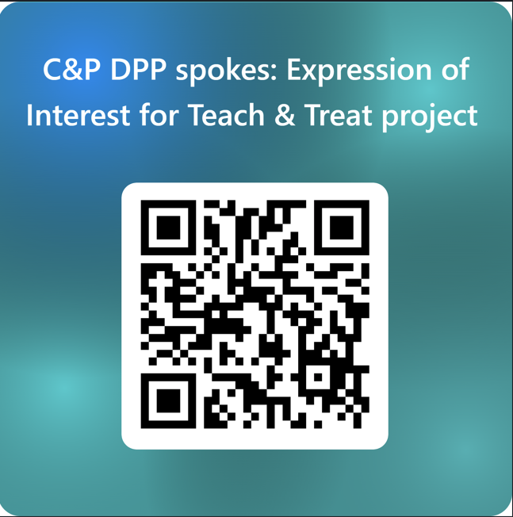
When will we hear the outcome?
We are aiming to shortlist as soon as possible after the EOI closes; you should be informed of the outcome on/before Tuesday 6th January 2026.
Who can I contact for more information regarding this project?
Indira Pillay (ICS Community Pharmacy Clinical Lead – C&P) at: indira.pillay@nhs.net

Further Information for Prospective Designated Prescribing Practitioners (DPPs)
What is a DPP?
A Designated Prescribing Practitioner (DPP) is a workplace-based supervisor who supports the pharmacist in the experiential part of the prescribing course (called learning in practice). The role of a DPP is to oversee, support and assess the competence of Independent Prescribing (IP) trainees, in collaboration with academic and workplace partners, during the period of learning in practice.
Each IP trainee must have one named DPP to support them in their learning in practice time, and who takes the primary responsibility for supervision. Please refer to the NHSE multi-professional Supervision for Pharmacist Independent Prescriber Training page for further information.
What are the criteria for acting as a DPP?
Generally, course providers will refer to the RPS Competency Framework for Designated Prescribing Practitioners when describing their requirements of a DPP. However, the specific requirements will vary between course providers, so we advise that you discuss this in detail with them.
Usually, a DPP must:
- Have current professional registration, be in good standing with their regulatory body and be prescribing within their scope of practice.
- Be an experienced prescriber ‘who would normally have’ at least 3 years of recent prescribing experience.
- Be able to demonstrate they meet all competencies within the Competency Framework for All Prescribers: be an active prescriber who makes prescribing decisions based on clinical assessment with sufficient frequency to maintain competence.
- Have appropriate knowledge and experience relevant to the learner’s scope of clinical practice.
- Be able to evidence Continuous Professional Development (CPD) or revalidation relevant to their role.
- Have experience of, or training in, teaching and/or supervising in practice: be able to demonstrate they meet the competencies within section 1, and have the appropriate support and commitment to the competencies in sections 2 and 3, of the competency framework for Designated Prescribing Practitioners (DPP). This ensures they are suitably experienced and qualified to carry out the role, and can commit to the required time to support the IP trainee.
- Be in a patient-facing role and be able to assess patient-facing clinical and diagnostic skills.
Requirements of a DPP can be found on pages 9 & 10 of the competency framework for Designated Prescribing Practitioners (DPP).
How much time do I need to spend with the Pharmacist as their DPP?
The General Pharmaceutical Council mandates that the academic institutions offering IP courses require the trainee to accrue a minimum of 90 hours of “learning in practice” time over their course. This time must be purposefully planned and consist of activities relevant to the development of the pharmacist. The IP trainee will keep a detailed log of their activities.
You as the DPP, are NOT required to directly supervise all of the 90 hours of learning in practice, the IP trainee may be supervised by other prescribers, but you MUST have a reasonable oversight, as at

the end of the course you will be required to confirm that the pharmacist has completed these hours. The academic institution that the IP trainee has chosen will stipulate the number of direct hours of supervision required.
What types of activities must I undertake in my role as a DPP?
- Working with the academic institution and the IP trainee to establish their baseline skills and knowledge and jointly create a learning contract with the IP trainee.
- Planning a learning programme that will provide the opportunity for the IP trainee to meet their learning objectives and the learning outcomes of their course, supporting them to develop and demonstrate their competence in prescribing. Ideally the learning in practice time includes spending time with other experienced prescribers of the multidisciplinary team.
- Facilitating learning by encouraging critical thinking and reflection.
- Providing supervision, support, and feedback during the period of learning in practice to enable the learner to develop the skills required to prescribe competently, such as consultation, clinical decision making and clinical assessment skills. The learner must spend 90 hours supervised in practice during their course (usually six months). However, the number of hours the DPP is required to supervise the learner themselves varies from 10-90 hours depending on the course provider (usually 25-45 hours).
- Providing dedicated time and opportunities for the IP trainee to observe how the DPP conducts a consultation / interview with patients and / or carers and the development of a management plan.
- Allowing opportunities for the IP trainee to carry out consultations and suggest clinical management and prescribing options, under supervision, which are then discussed with you as the DPP.
- Helping the IP trainee integrate theory with practice.
- Assessing and verifying that, by the end of the course, the IP trainee is competent to assume the prescribing role.
How can I prepare for the DPP Role?
If you do not have any formal training in workplace-based learning, it is recommended that you undertake a DPP training course (free to NHS staff):
- elearning for healthcare have Pharmacy Educational Supervisor Training programme: https://www.e-lfh.org.uk/programmes/pharmacy-educational-supervisor-training/
- NHSE recommend DPPs undertaking both core skills and enhanced skills modules
- Each module takes approximately 2 hours to complete and covers a range of topics with increasing complexity
OR
- Designated Prescribing Practitioners - Health & Education Cooperative (hecooperative.co.uk). This is free - NHS staff considering the role of a DPP can self-register for an account. Modular e-learning (8 modules, approx. 30min each module) and Module Quiz - with certificate for each module. This is useful for new DPPs and focuses on theory of IP and DPP.
You may choose which training course to undertake based on the requirements of any relevant university, the requirements of your professional regulatory body and your own Learning Needs Analysis.

- It is recommended that you familiarise yourself with part 1 (the learning outcomes) of the following document: Standards for the education and training of pharmacist independent prescribers (updated October 2022).
- It is also a requirement of the GPhC (General Pharmaceutical Council) that DPPs supervising pharmacists are aware of their supervision guidance.
What indemnity insurance does a trainee independent prescriber require?
The IP trainee pharmacist is advised to check with their employer and/or their personal insurer before they begin that they are fully covered in their role as an IP trainee and then in their future role as a qualified independent prescriber.
What indemnity insurance does a DPP require?
It is recommended that you confirm with your employing organisation that they have indemnity insurance that allows trainee independent prescribers within your workplace, e.g. Clinical Negligence Scheme for General Practice (CNSGP).
How many IP trainees can I supervise at any one time?
Most universities permit a DPP to support up to 2 IP trainees at the same time. Please note that universities will seek assurance that you have sufficient capacity within your job plan to undertake the required amount of supervision before accepting the learner’s training application.
Benefits of being a DPP include:
- Helping to develop the local workforce and contributing to producing a pharmacist IP who may work in your local neighbourhood in the immediate or near future.
- As a DPP you will have the opportunity to learn more about what a pharmacist professional can do in the healthcare team. Novel ways of working are essential in the challenging times we are facing at present; Pharmacist IPs are well placed to complement healthcare teams in all sectors.
- Your role as a DPP is a great example of preceptorship and can be included in your revalidation portfolio.

Written by Cathy Geeson, Teach & Treat Project Manager, 03 December 2025 (v0.2), adapted by Karen Key, C&P Primary Care Workforce Lead 10 December 2025

